

Department of Supply Chain and Business Technology Management

John Molson MBA Program

**BSTA 678**

**Data Mining Techniques**

Winter 2024

Assignment No. 1

Due March 2

Solve each question individually, discuss with the team and submit one common solution as a team. Don’t partition the work! Instead, everyone should work on every question, then discuss your work together and finalize the submission. Describe who did what in the below. Indicate % contribution for each member of the team. Your mark will be awarded accordingly. In case of disagreement, contact professor.

Write your answers in the Word document between the questions. Copy/paste as needed.

Submit to Moodle as a one zipped file containing EM project, Excel and Word document with your answers.

Assignment No. 1

Name / % contribution / Question you worked on

1. _Shubham Todi__ _100%________________ _all________
2. _______________ _____________________ ____________
3. _______________ _____________________ ____________
4. _______________ _____________________ ____________

**Question** 1

Build a regression model to predict a total value of a house, using housing data in Moodle.

1. Use SAS EM.
   1. Adjust roles and levels of variables.

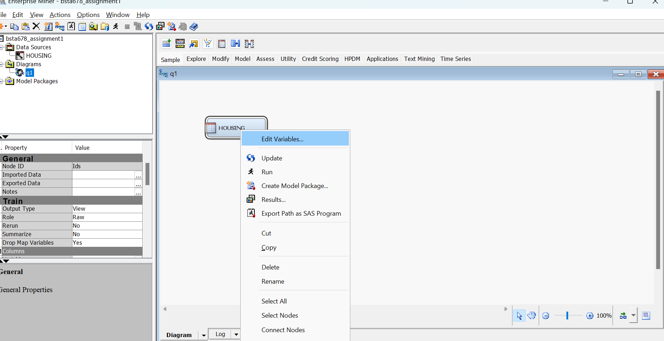

We keep role of “Total Value” column name as “target”, rest can be “input” and levels of variable can be adjusted as per below:

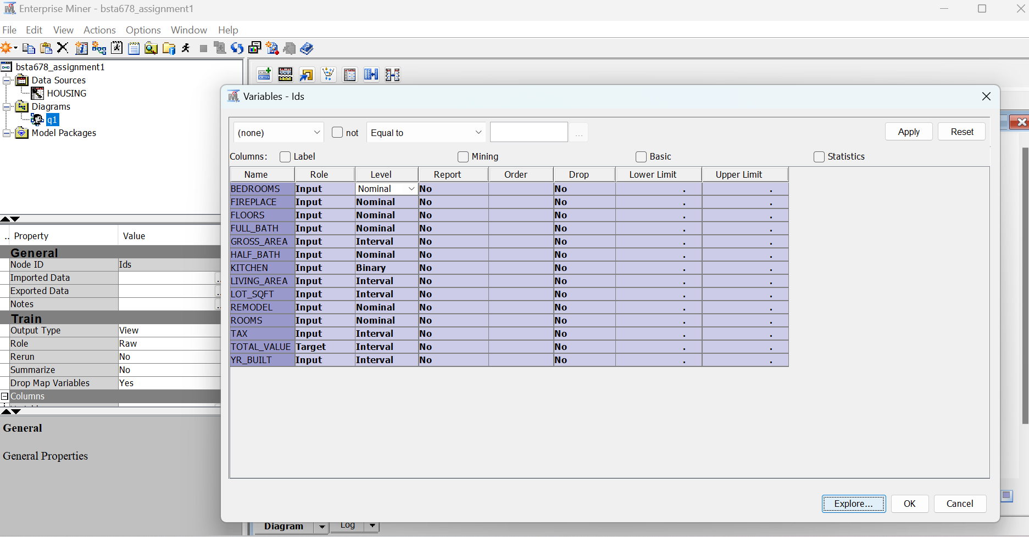

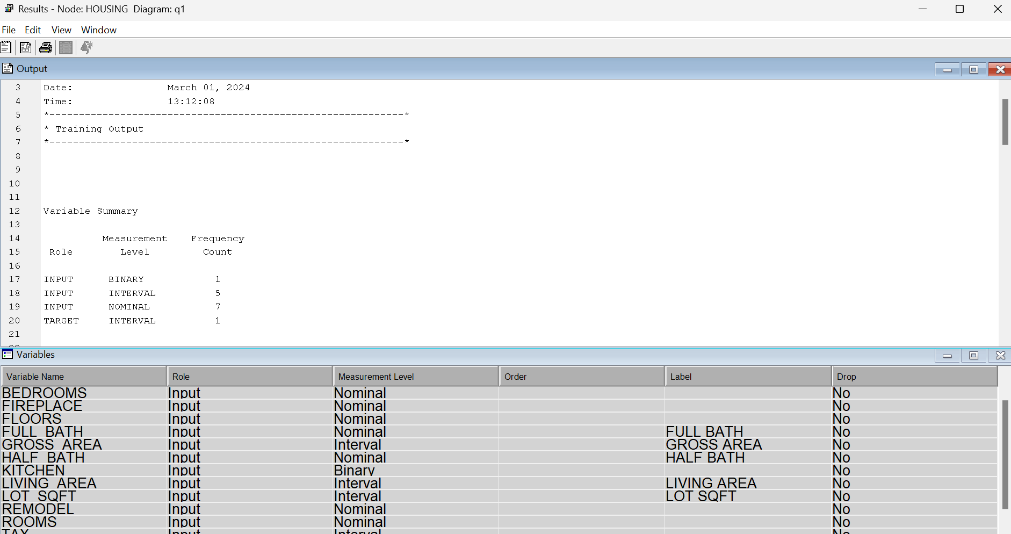

* 1. Partition data. Why do we do it?

Sample 🡪 partition node to the diagram & use bifurcation as Training: 70, Validation: 30 and Test:0

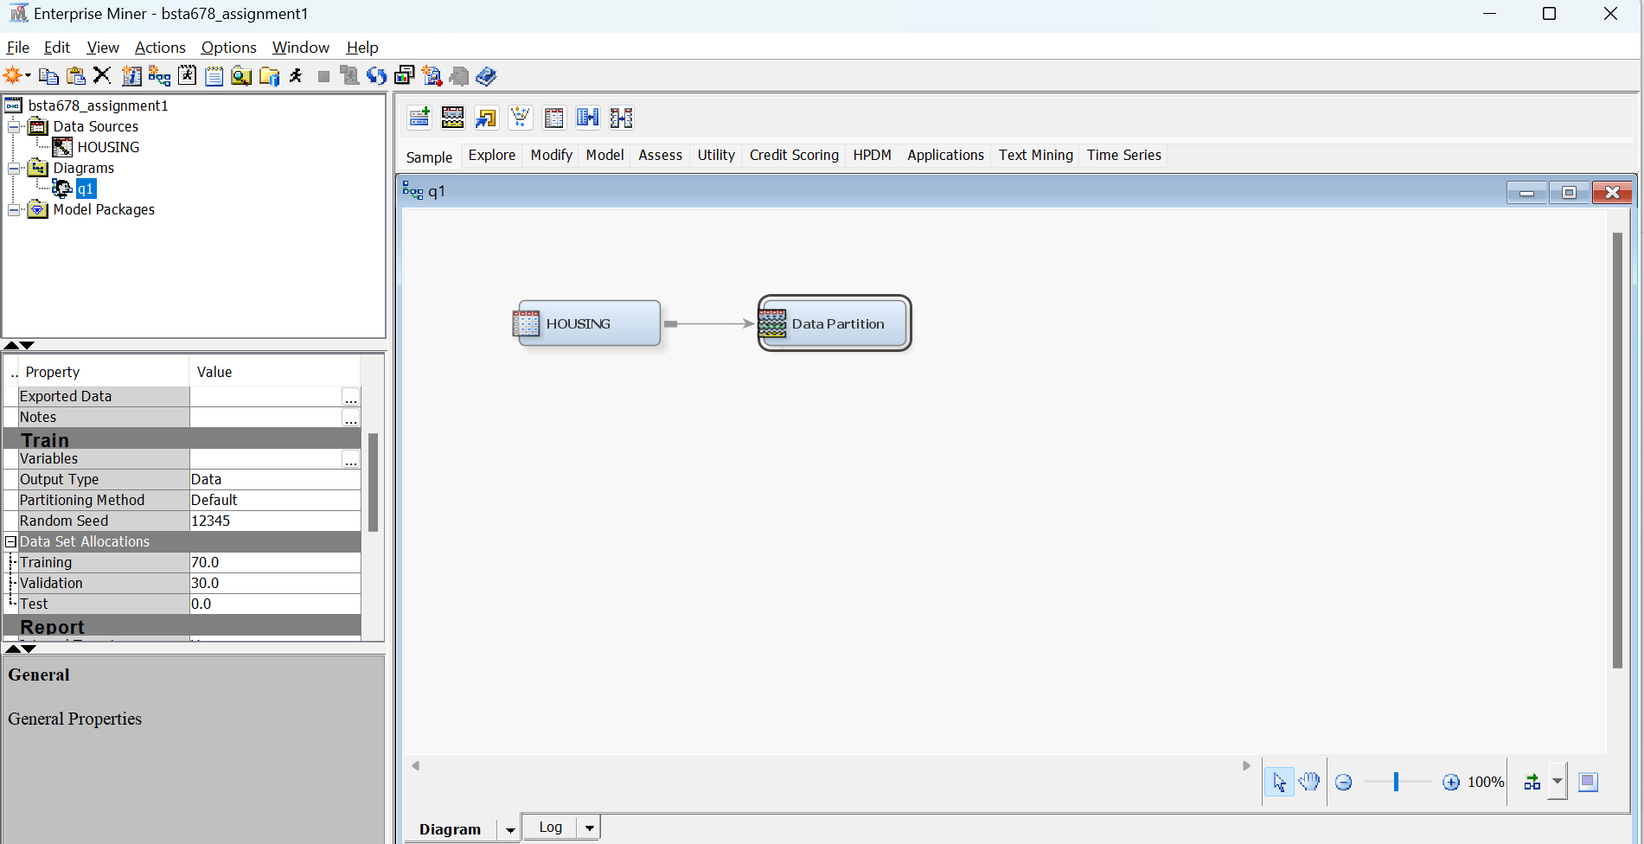

Then link the node to our data set “housing” and run it to see results.

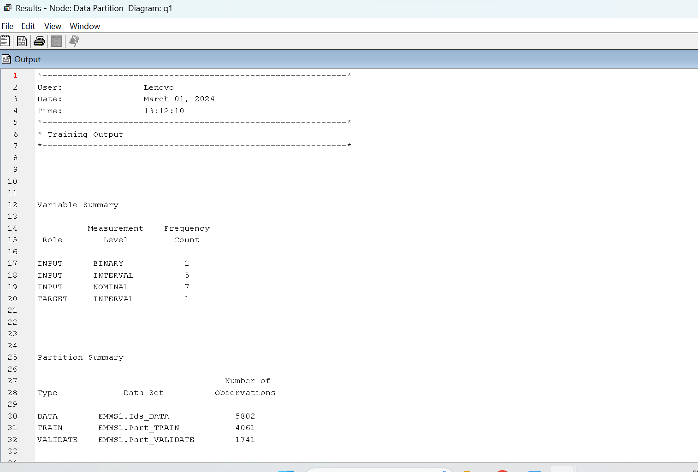

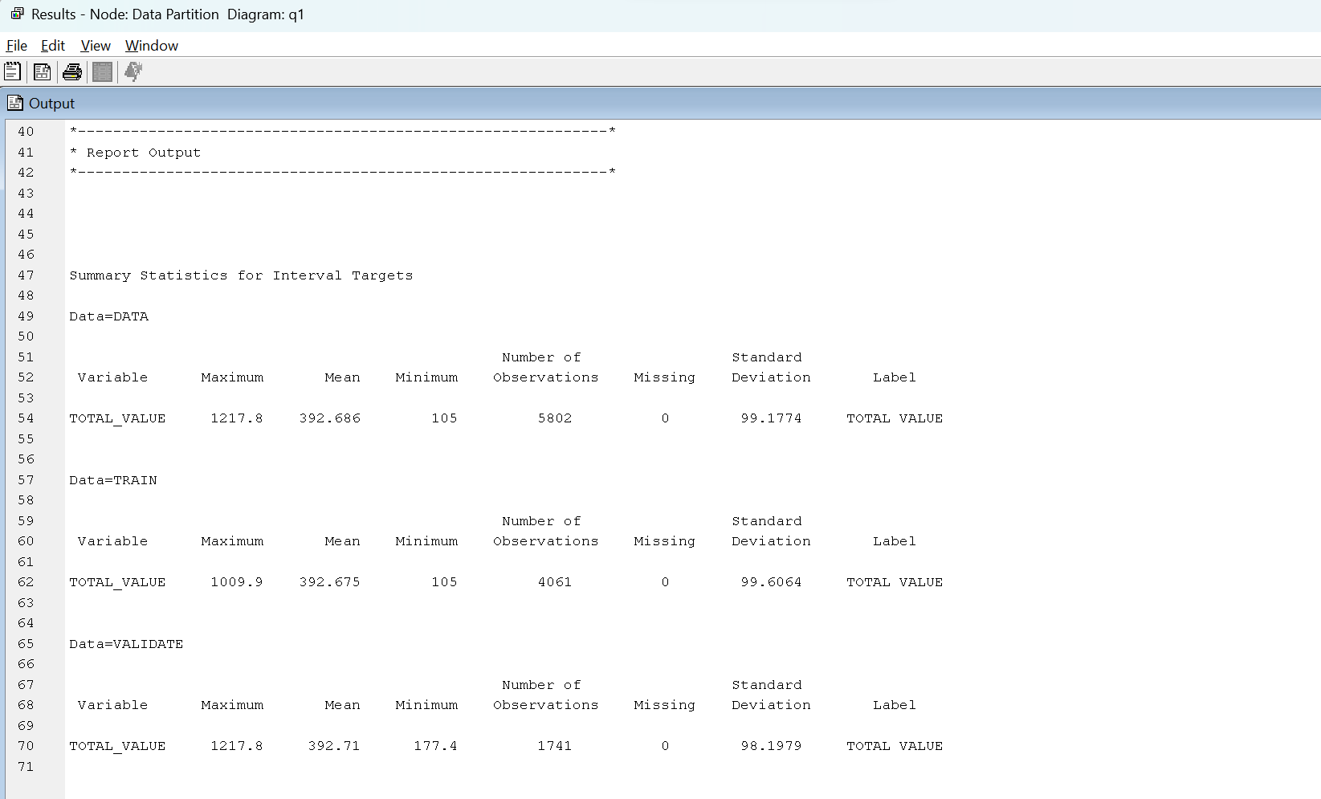

We partition our dataset into 70% training and 30% validation sets to improve our accuracy of the model in the sense that we model the data using training set and verify the results using validation set. It allows us to remove scope of bad judgement based on bias or variability of the model fit and avoid overfitting or underfitting of sample data into the population statistics.

* 1. Provide numerical and graphical summaries for all variables. What can you conclude?

We can select all rows from edit variable & click on explore variables from our data set node to see:

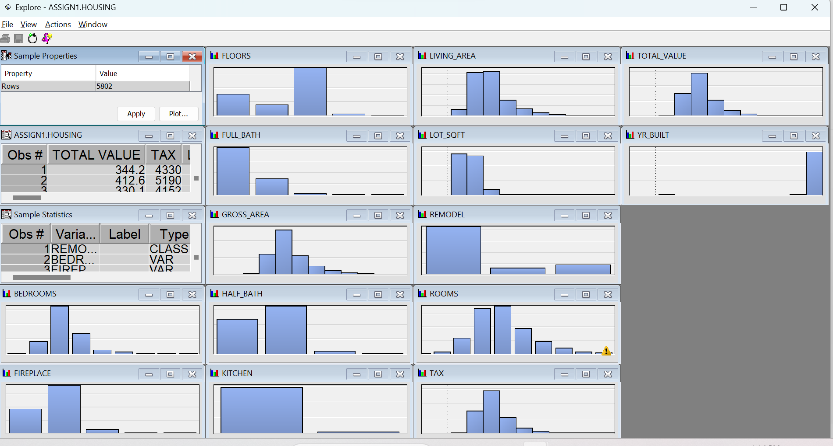

(Graphical summaries of all variables)

From this we expand sample statistics to see:

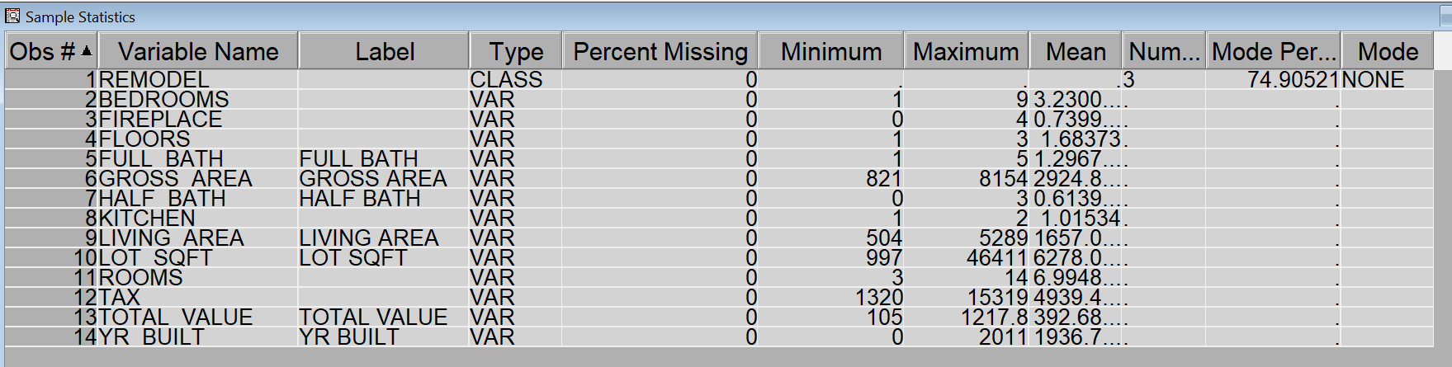

(Numerical summaries of all variables)

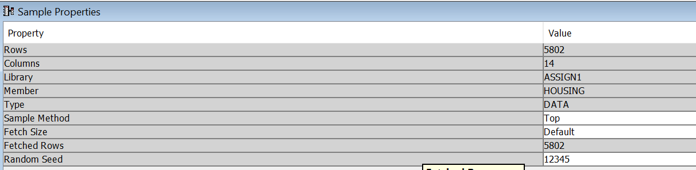

(Properties table)

Conclusion: We can see histograms from data explore option in SAS. It is also worthwhile to see all sample statistics. For example, percentage missing values to know if we need to impute the data or not.

Mean, median and mode gives us an idea about the central tendency aspects of each variable of the data. Similarly, minimum and maximum gives us the range of the data while all histograms give us a fair idea of the distribution of the data for any variable and we can compare it to a normal distribution curve which is a bell-shaped curve to see if the assumptions for linear regression are being met.

* 1. Explore and explain the inputs.

Just expand each section/variable in the previous part to see the inputs chart:

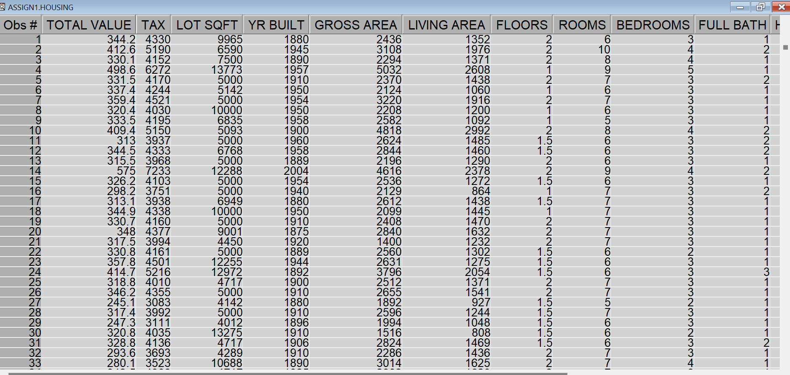

(data set table)

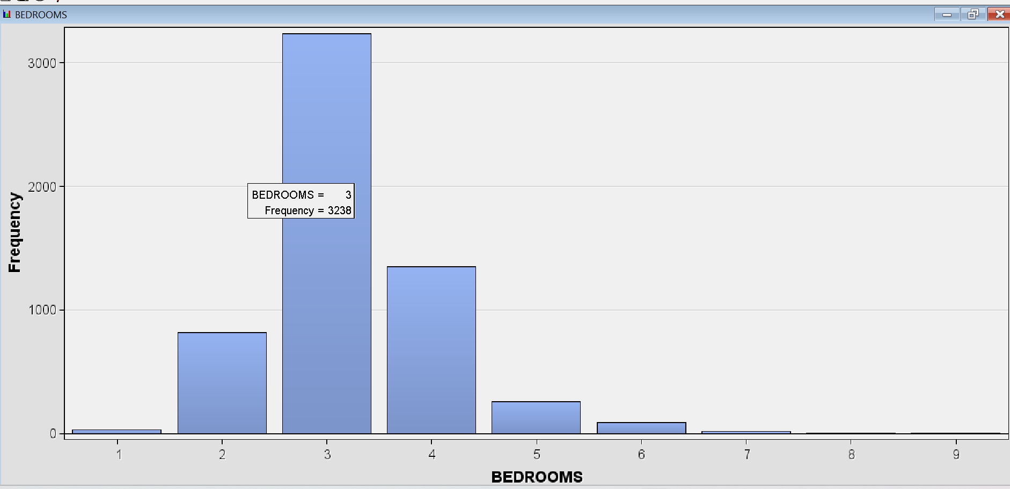

Bedrooms variable/input chart shows the frequency or rather number of observations for each value of bedrooms. Like for 3 bedrooms there are 3238 rows (data points) in the table. Since bedroom is kind of categorical variable ranging from (1-9) all data points must have a defined value among these 9, distribution for which is shown in the input exploration frequency chart. It is almost a bell shaped curve.

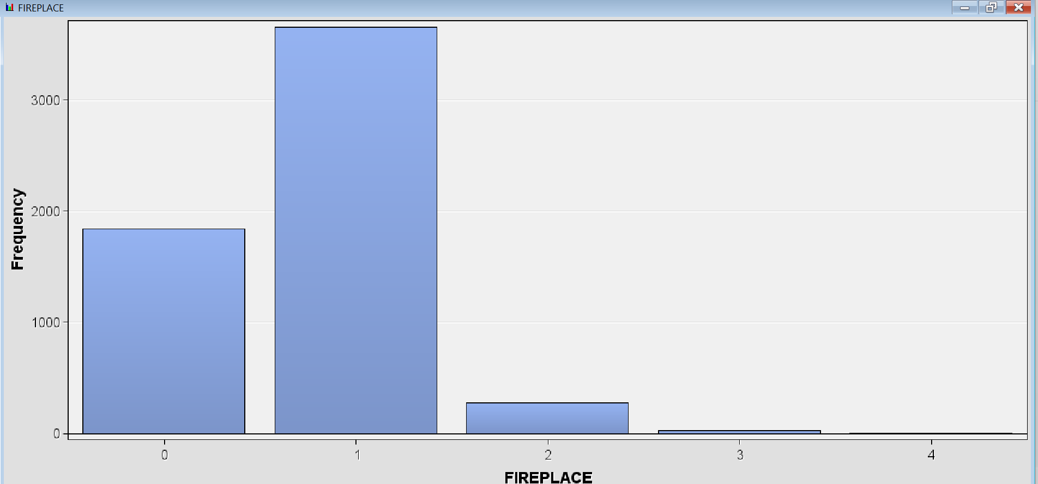

Maximum number of data points has 1(which is also the same as mode in ample statistics chart) fire place and then 0 with bare minimum at 2,3 or 4.

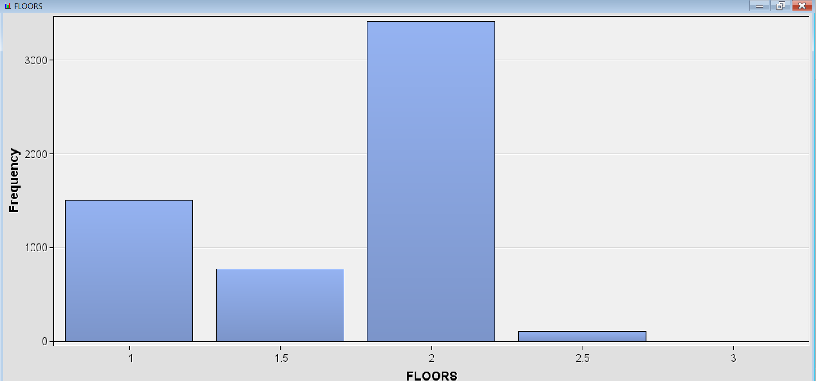

Most prevalent number of floors are 2 then 1 and 1.5 making mostly of the data while 2.5 or 3 are negligible.

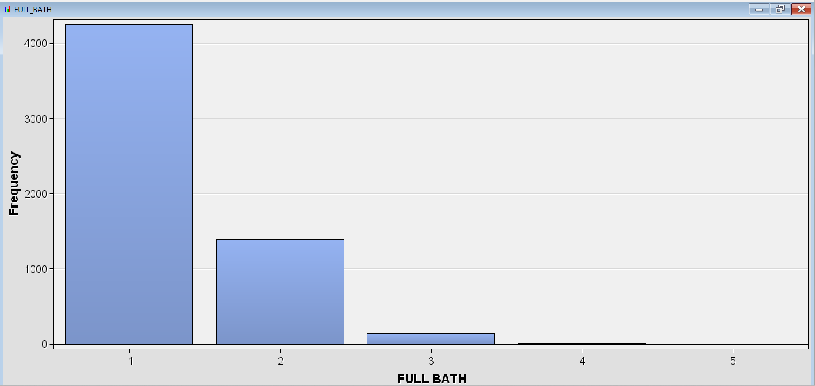

Full bath in housing is a straight downward slope data. With increasing number of bath frequency decreases rapidly.

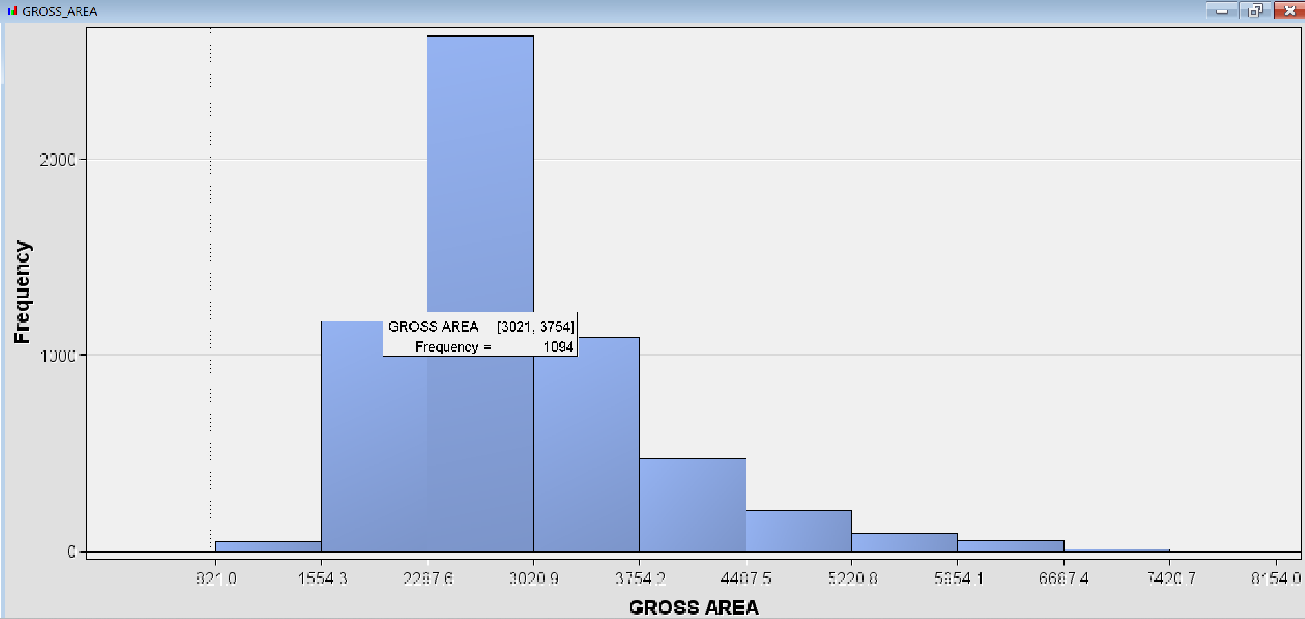

Gross area is a left skewed bell-shaped curve suggesting a rather tendency of leaning of housing gross area to the left of mean. Maximum frequency of 1094 datapoints lie in the range of 3021 - 3754 sq feet.

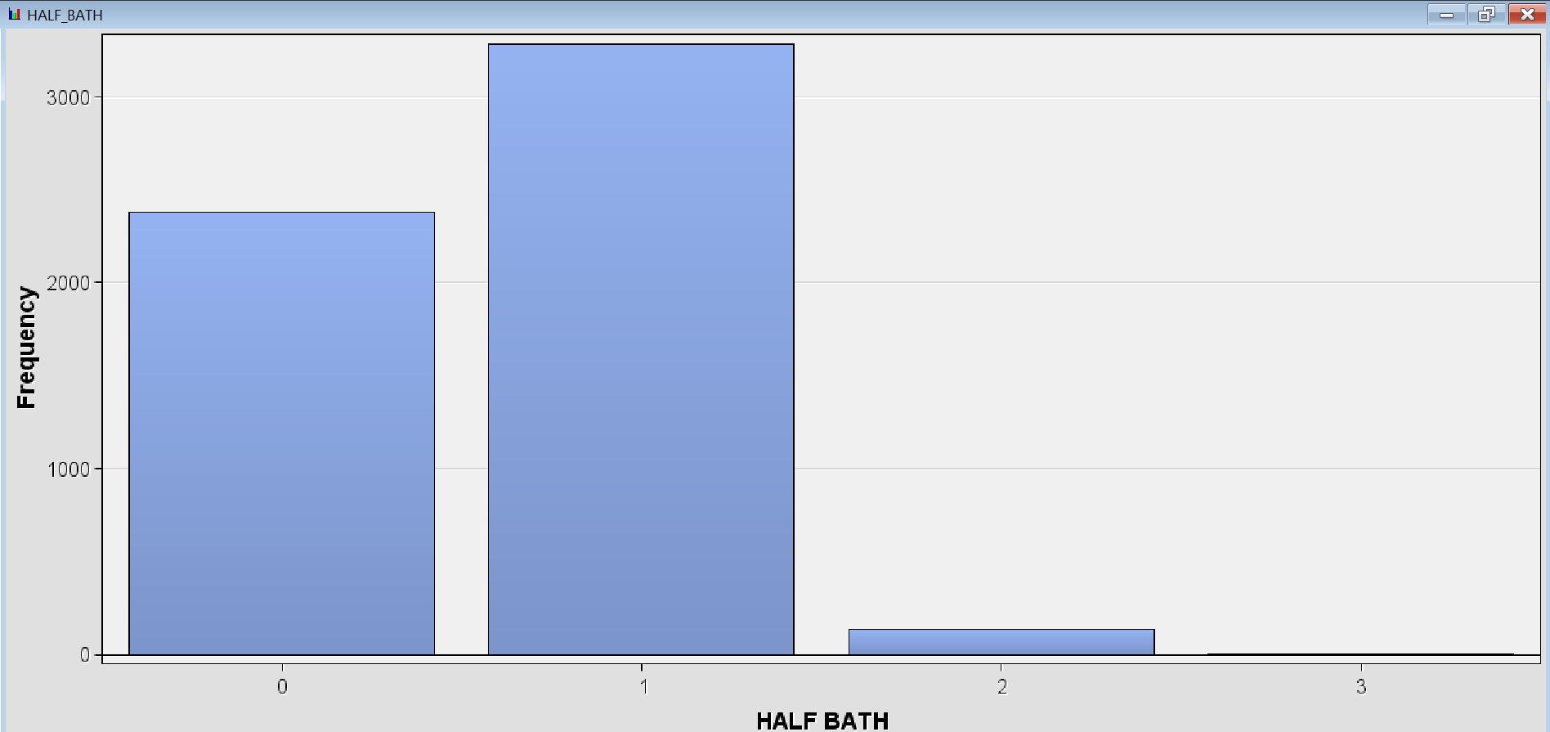

Again 0 and 1 Half baths are more prevalent with little to no exposure on 2 or 3 no of half baths.

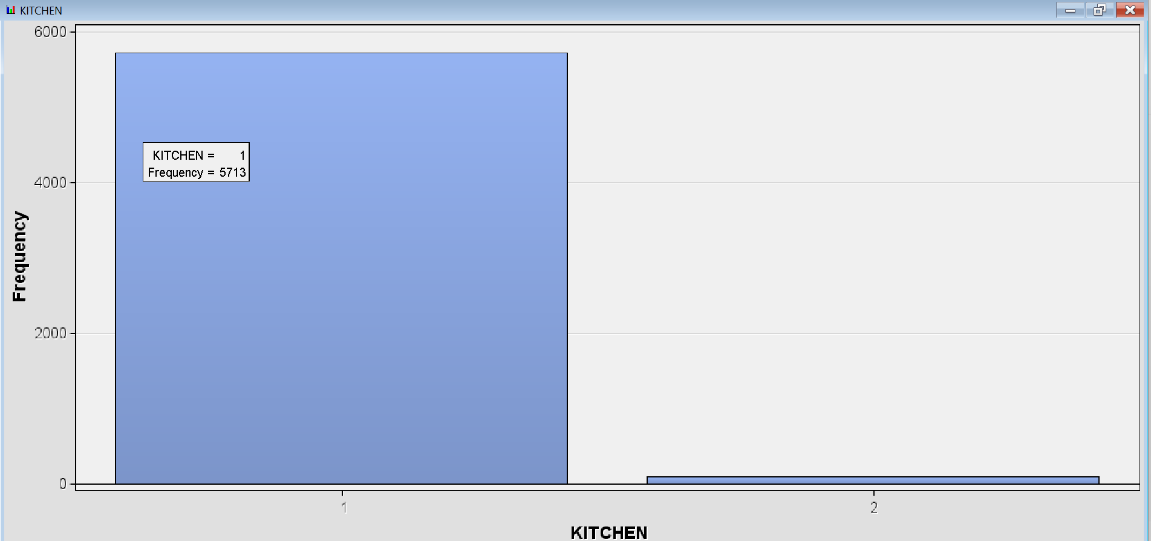

Most of the data has 1 kitchen with a very small portion also having 2 kitchens in their houses

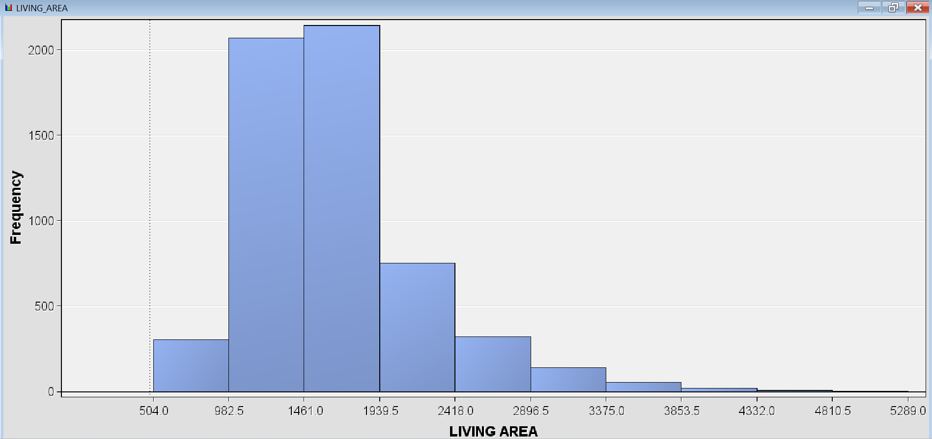

Similar to gross area, living area has a left skewed distribution curve, although it is a bell shaped curve but there is a long right tail and maximum data in 982.5-1939.5 sq ft range.

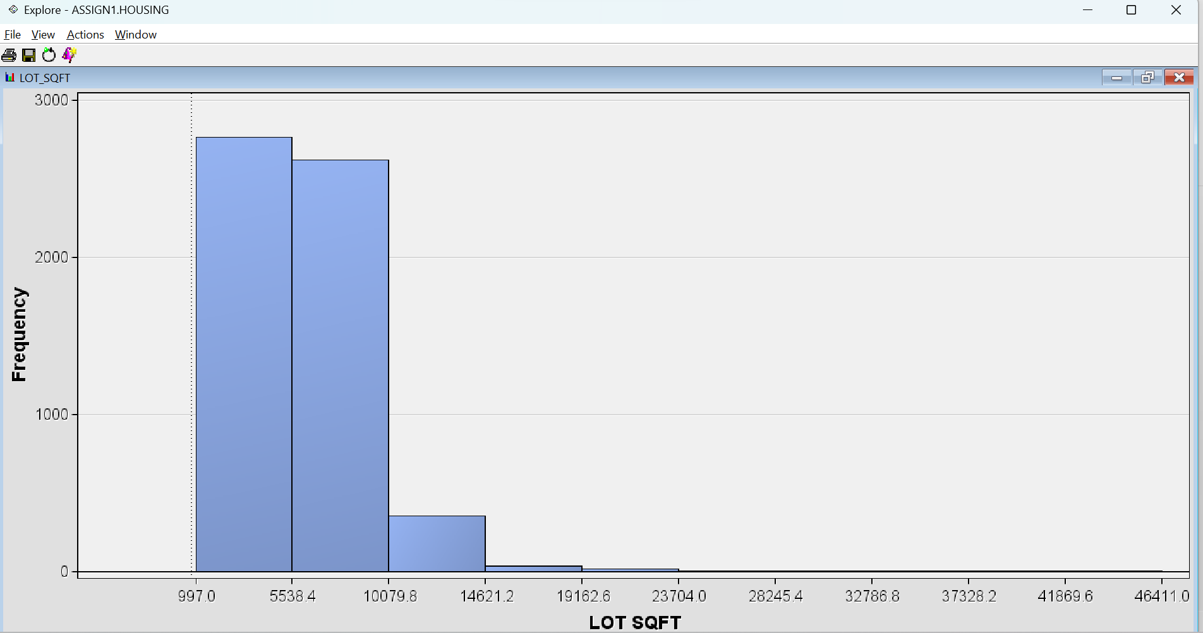

Lot has maximum concentration in first two intervals, entirely left-skewed with never ending right tail

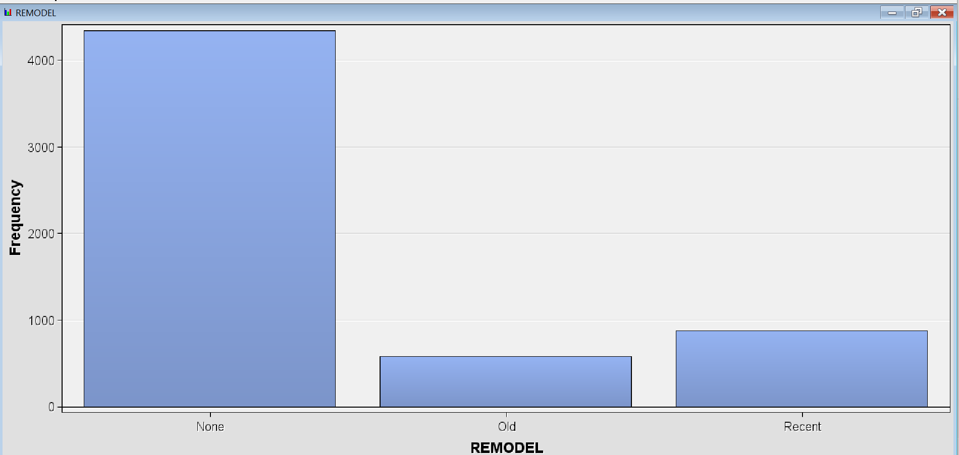

Maximum data has no remodel while very rarely it is old or recent.

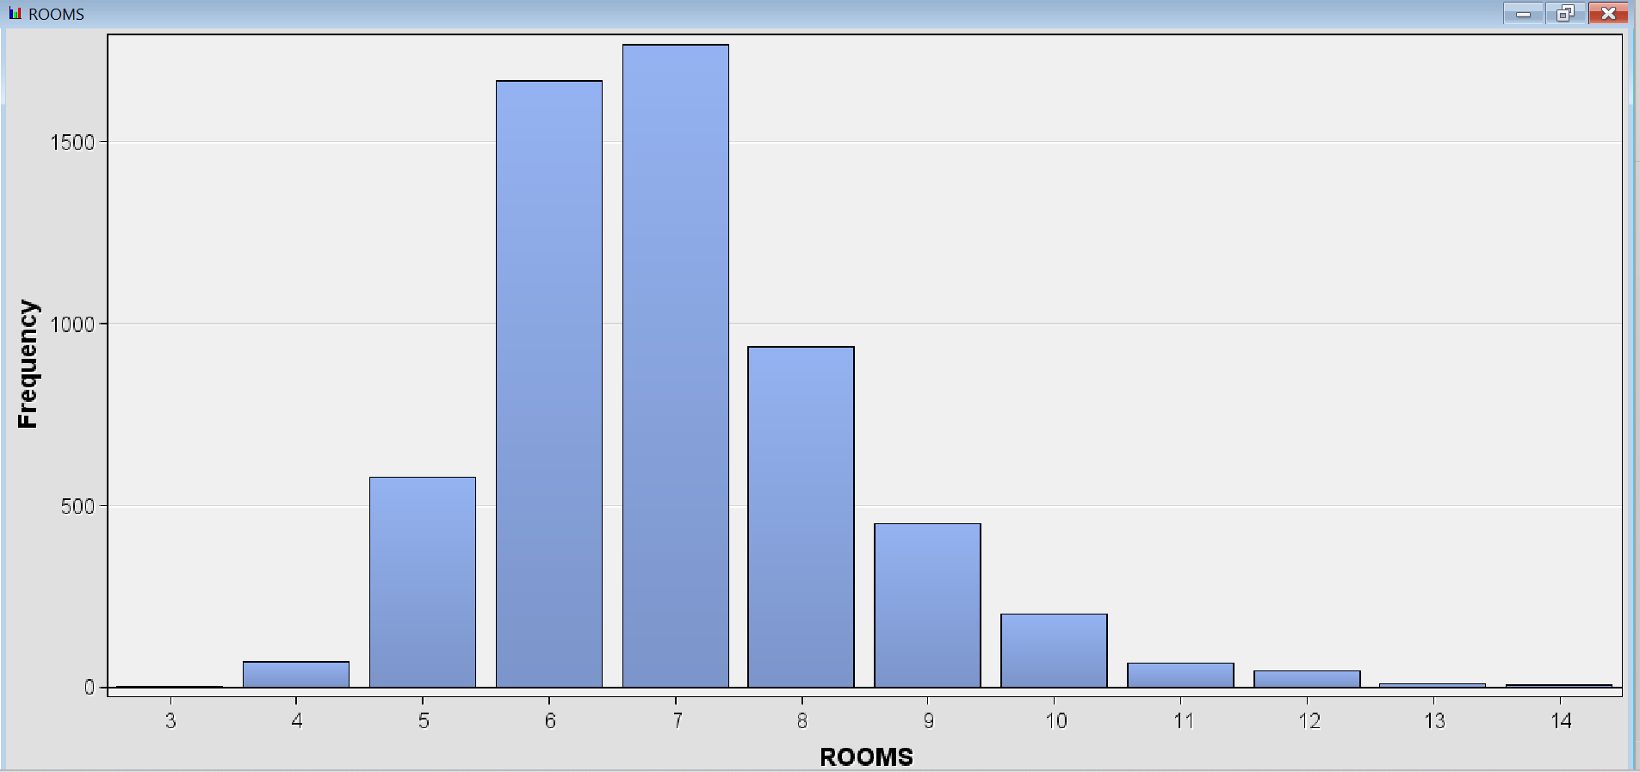

Almost normal distribution(bell shaped curve)

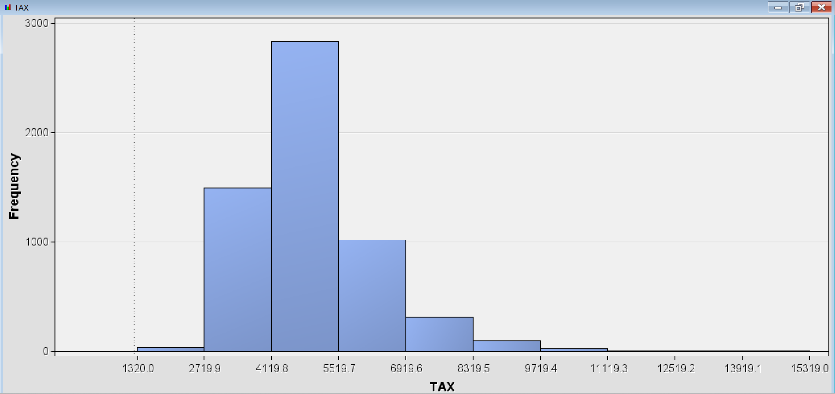

Almost normal distribution (bell shaped curve)

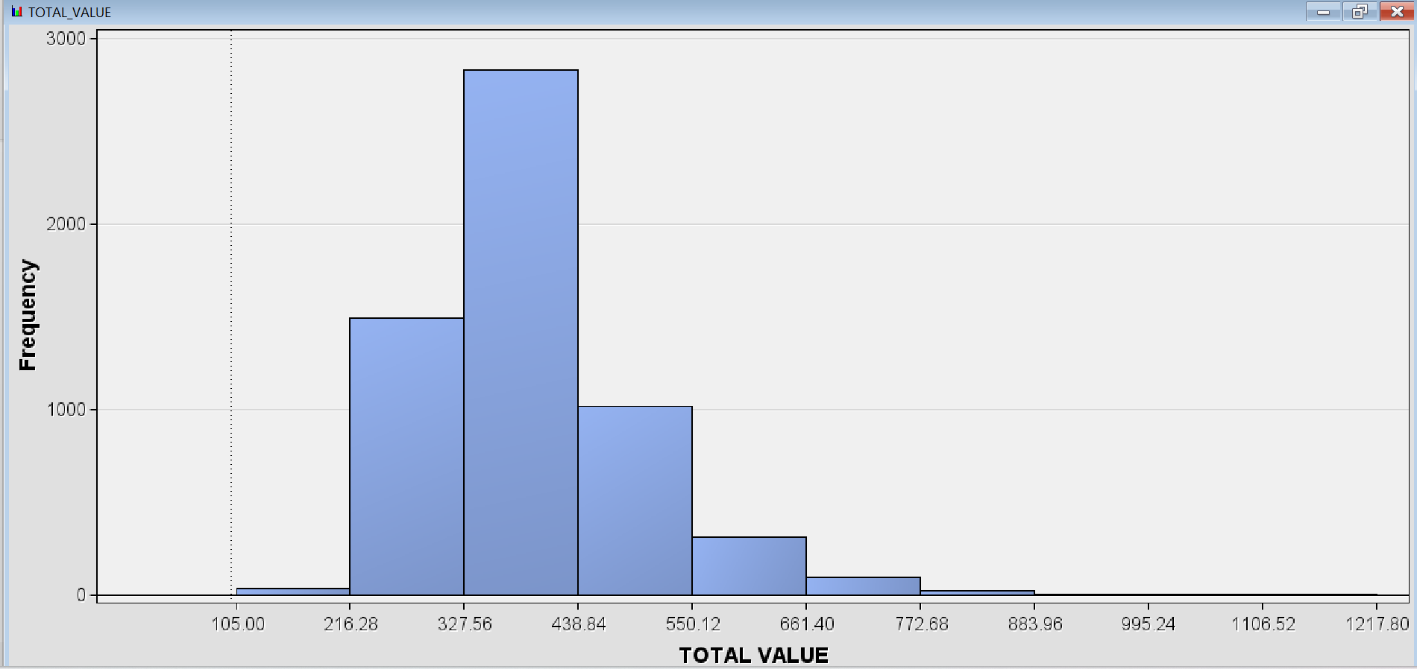

The target data – “Total value” represents almost a bell-shaped curve or normal distribution. This will be our dependent variable in the study of linear regression and we are going to predict its value based on other input/independent variables.

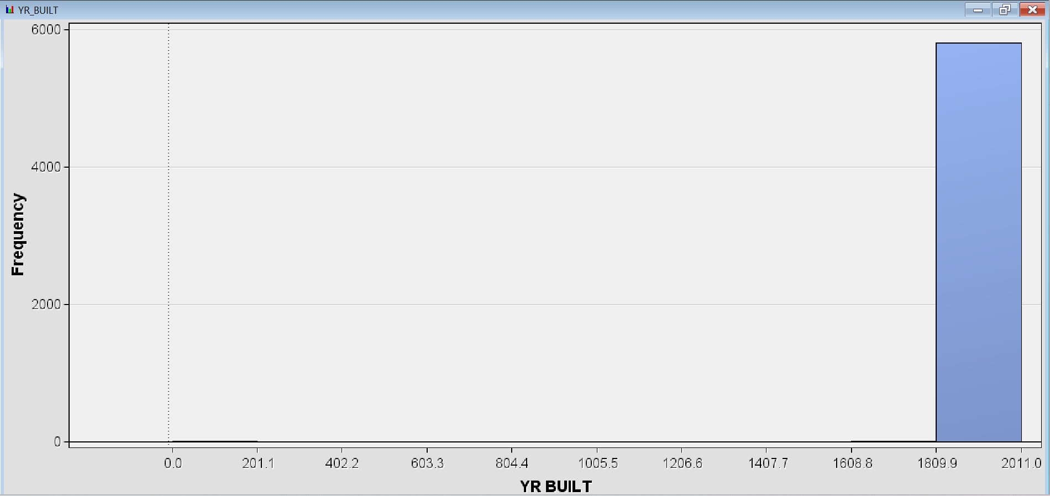

The entire data model has been taken from 1810-2011 year-built column.

* 1. Explore and explain relationship between total value and independent variables. Using SAS EM Multiplot, plot target against input variables. Describe your findings.

Using the Multiplot node basically shows us bar charts for each input variable on x axis and their corresponding Total value component in y axis. We can see from below SAS output screenshots:

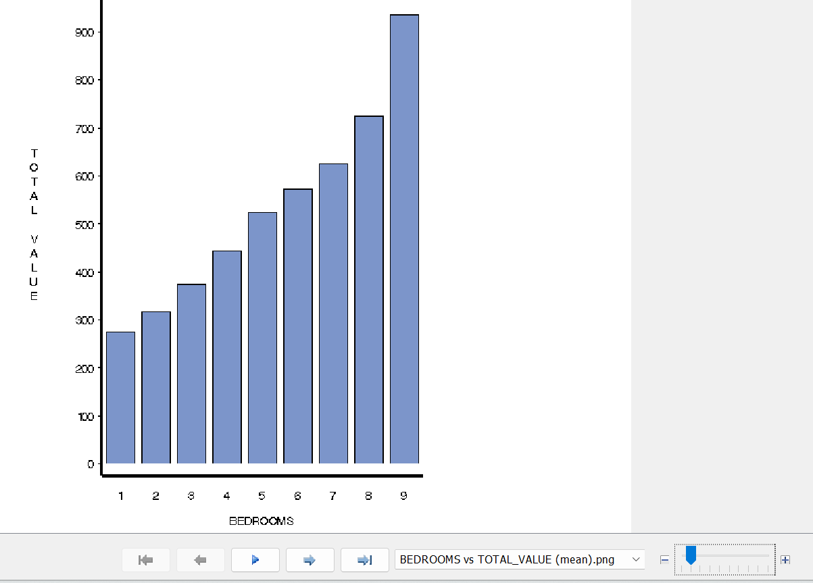

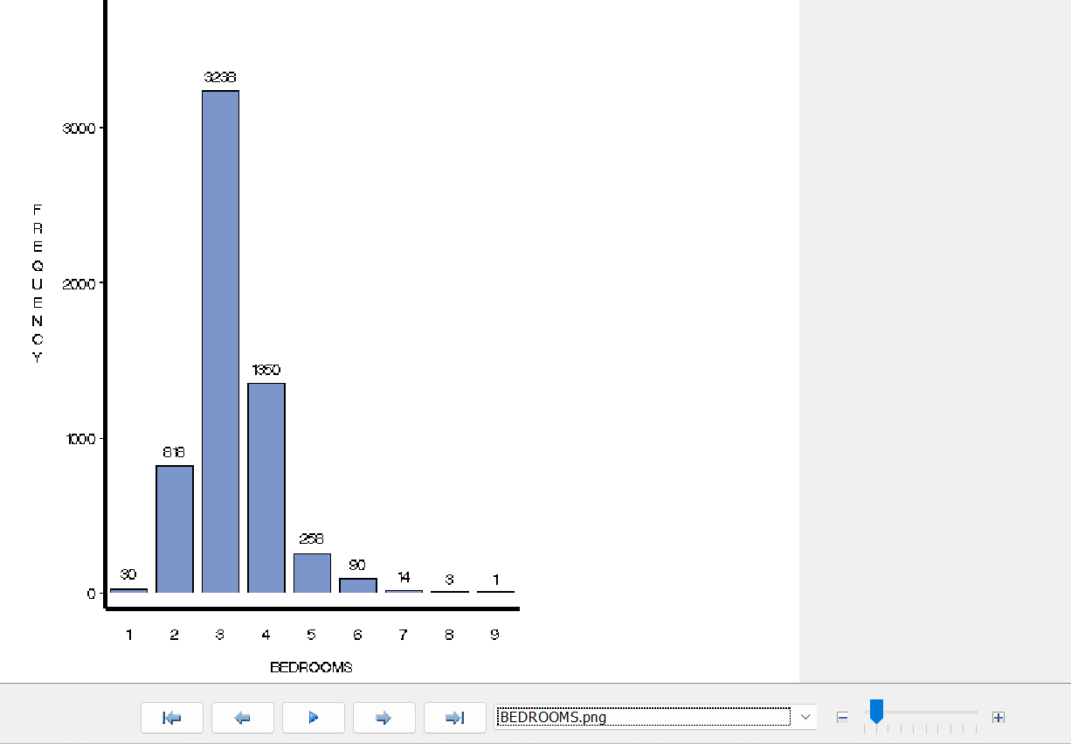

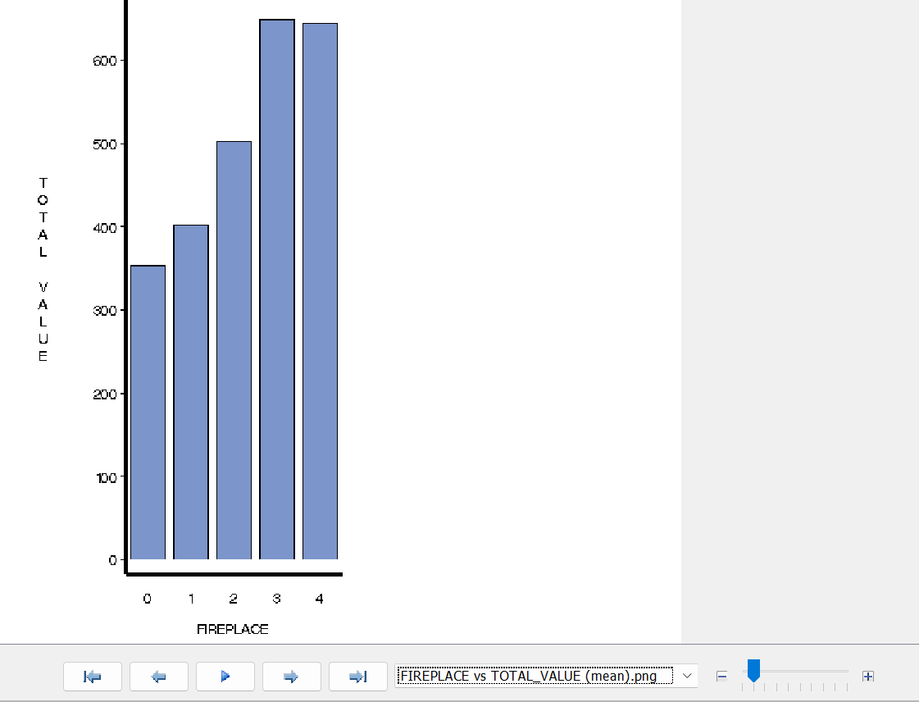

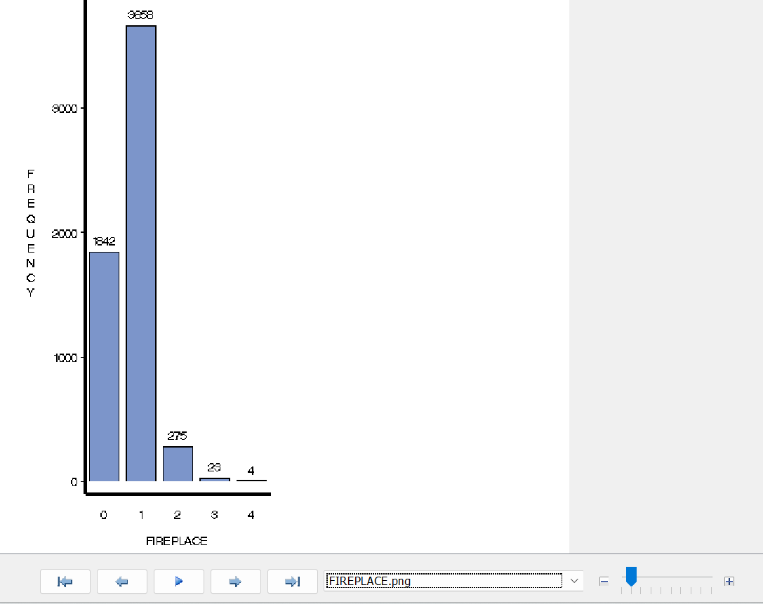

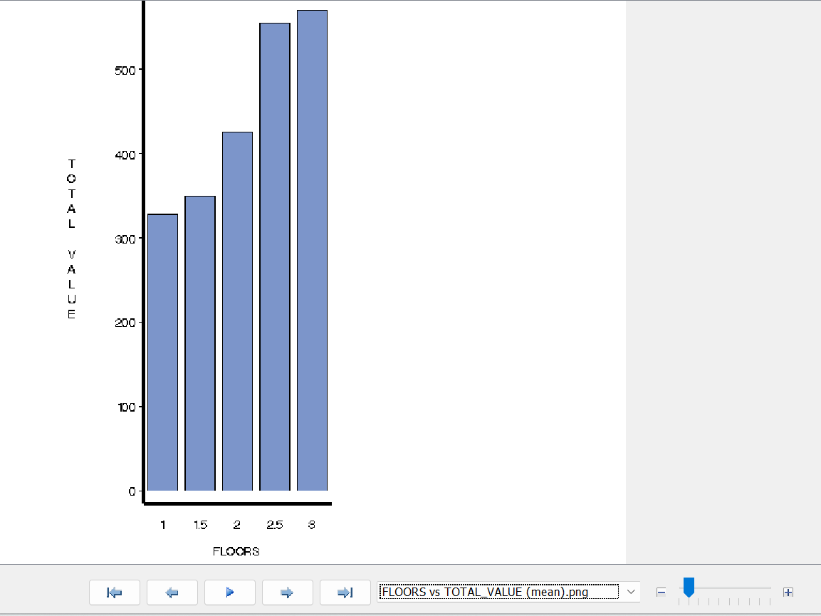

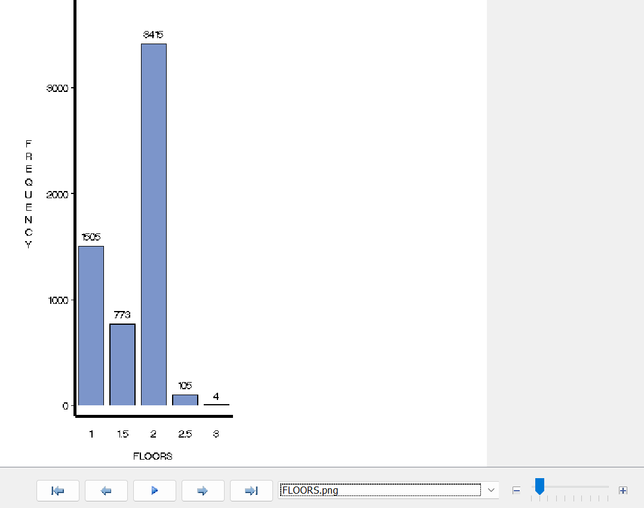

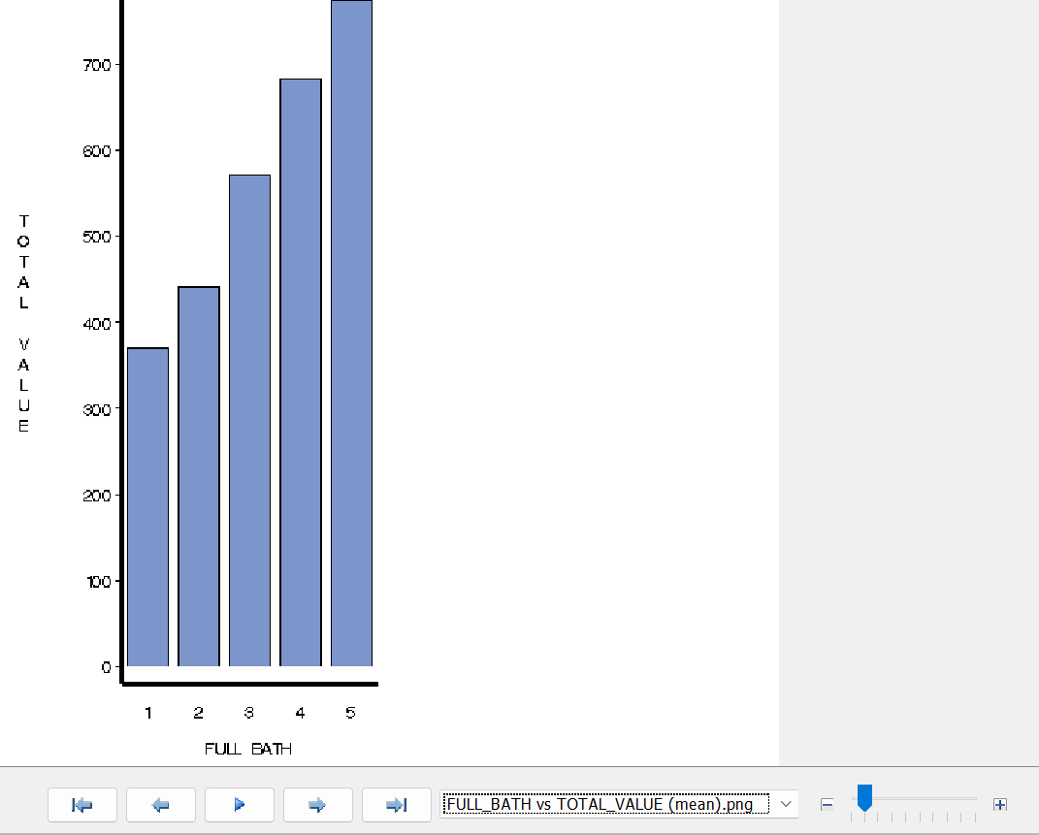

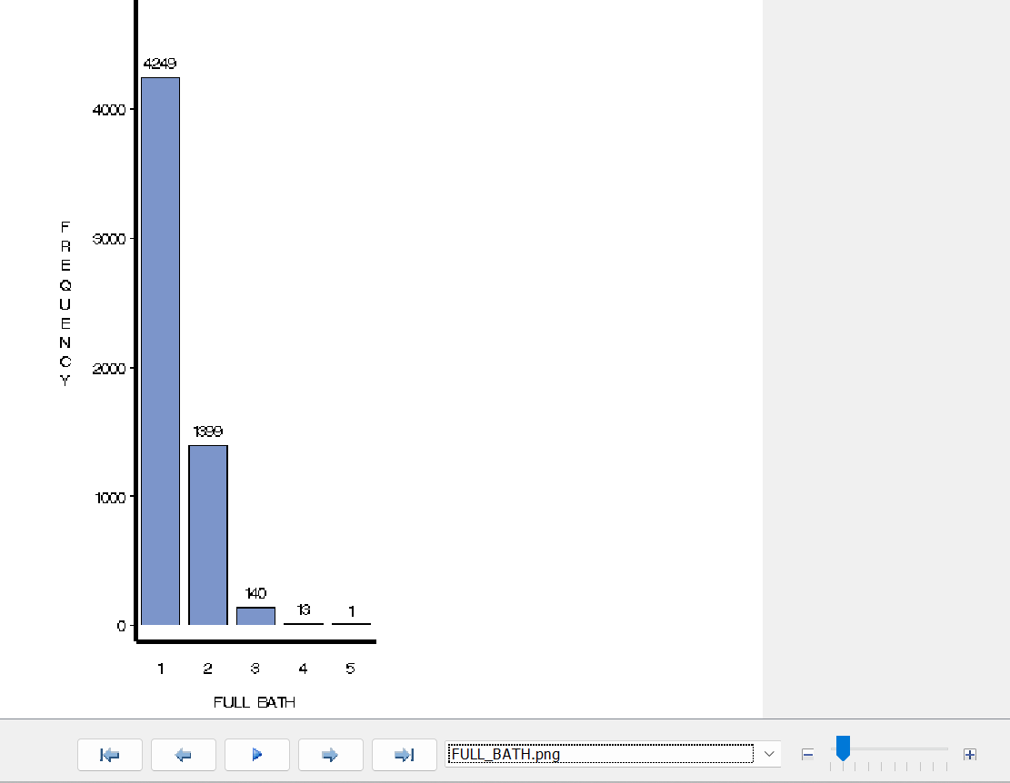

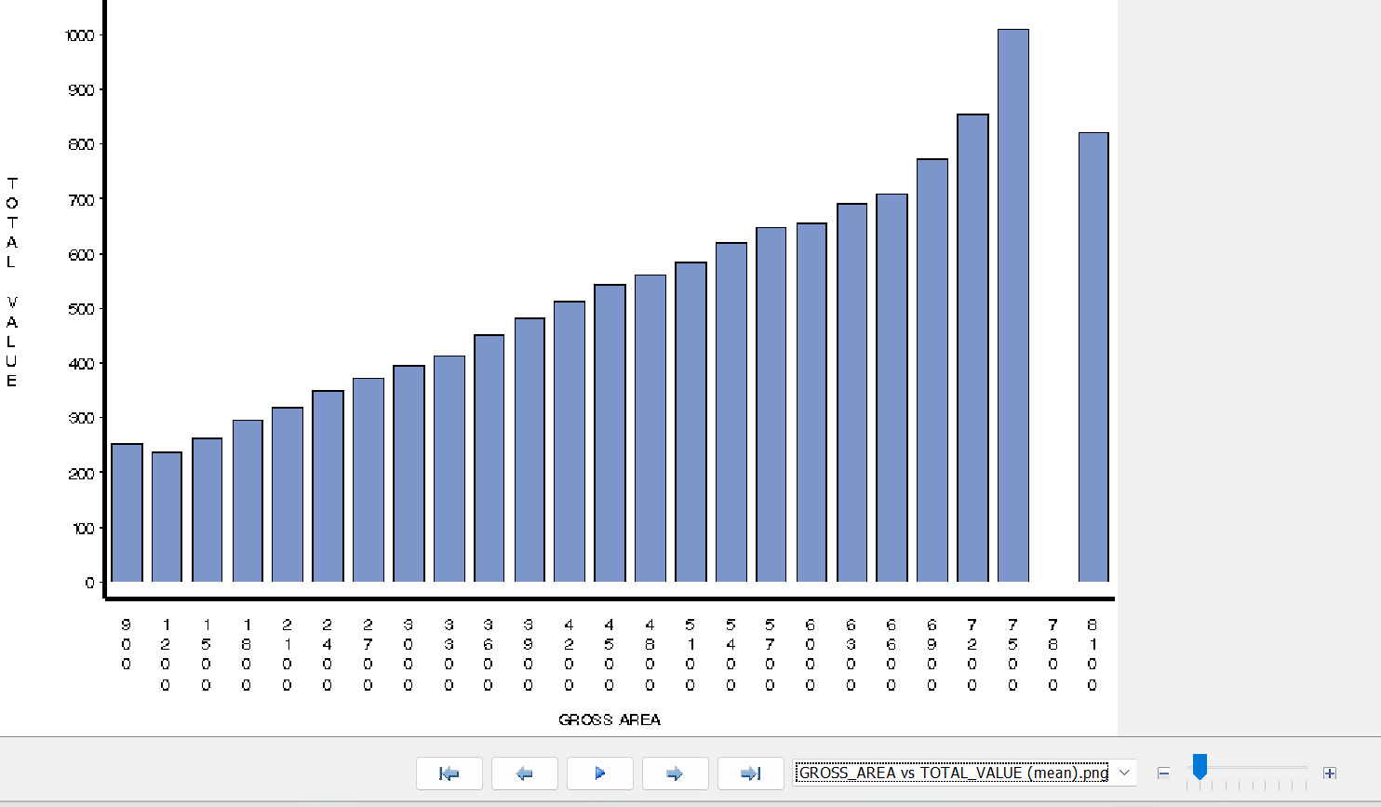

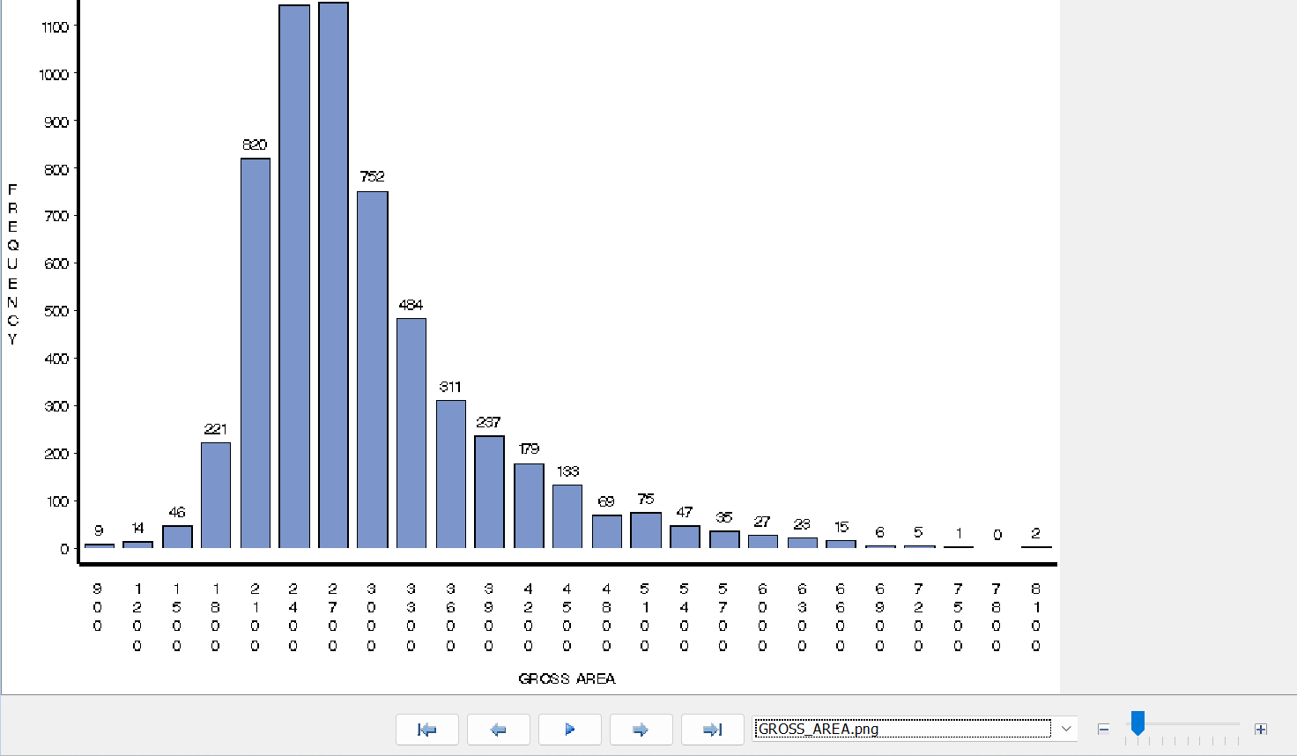

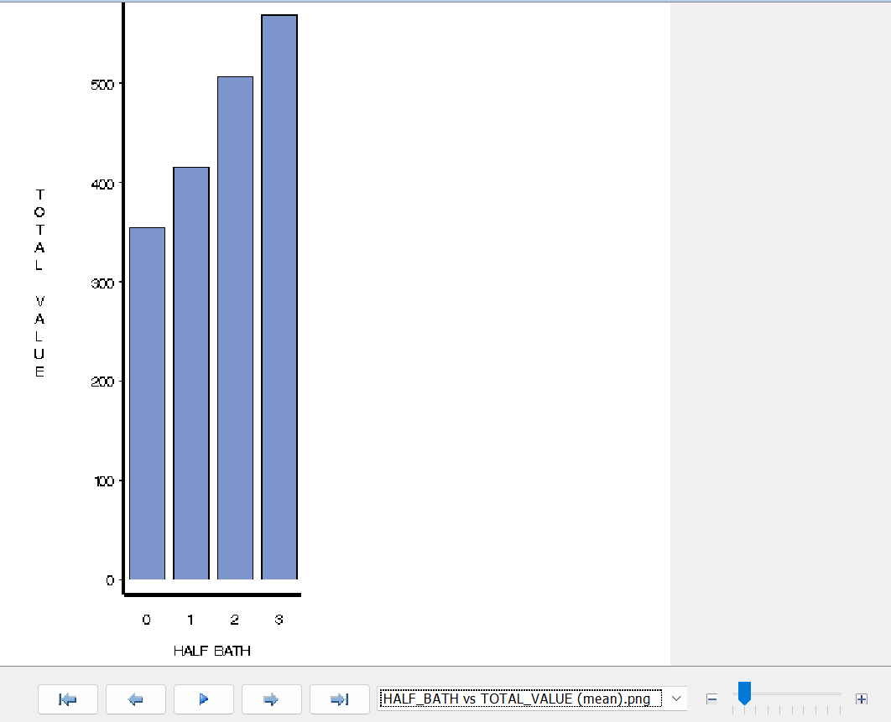

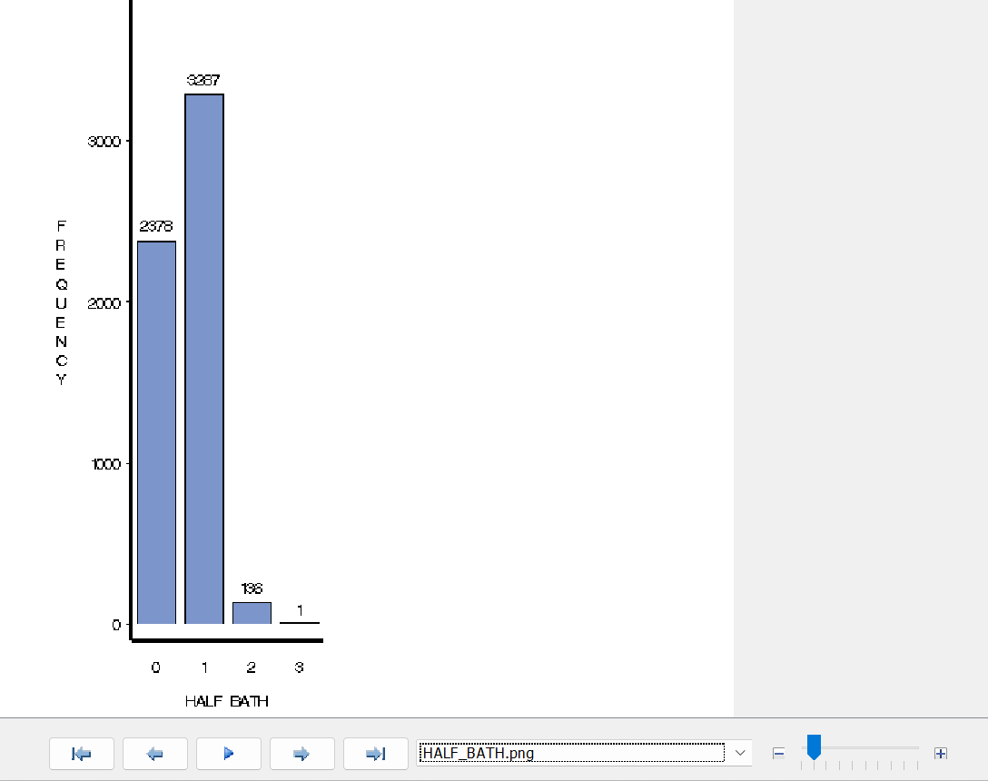

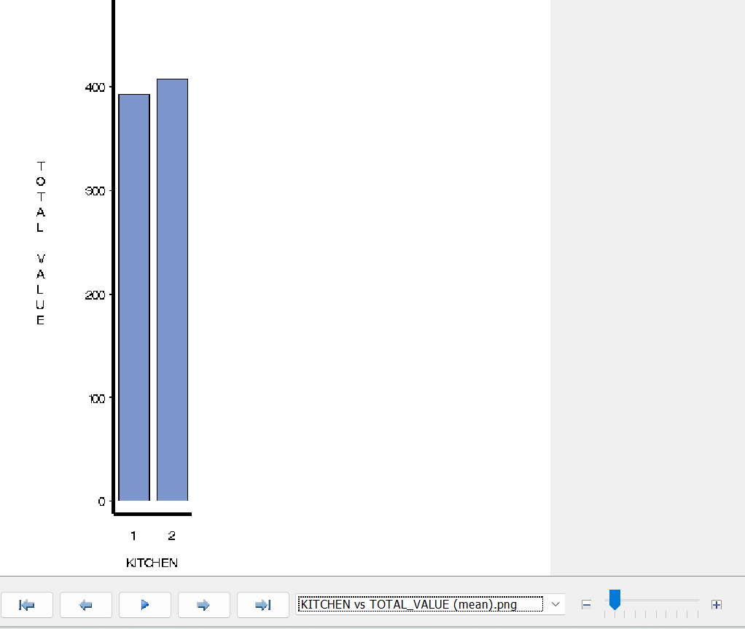

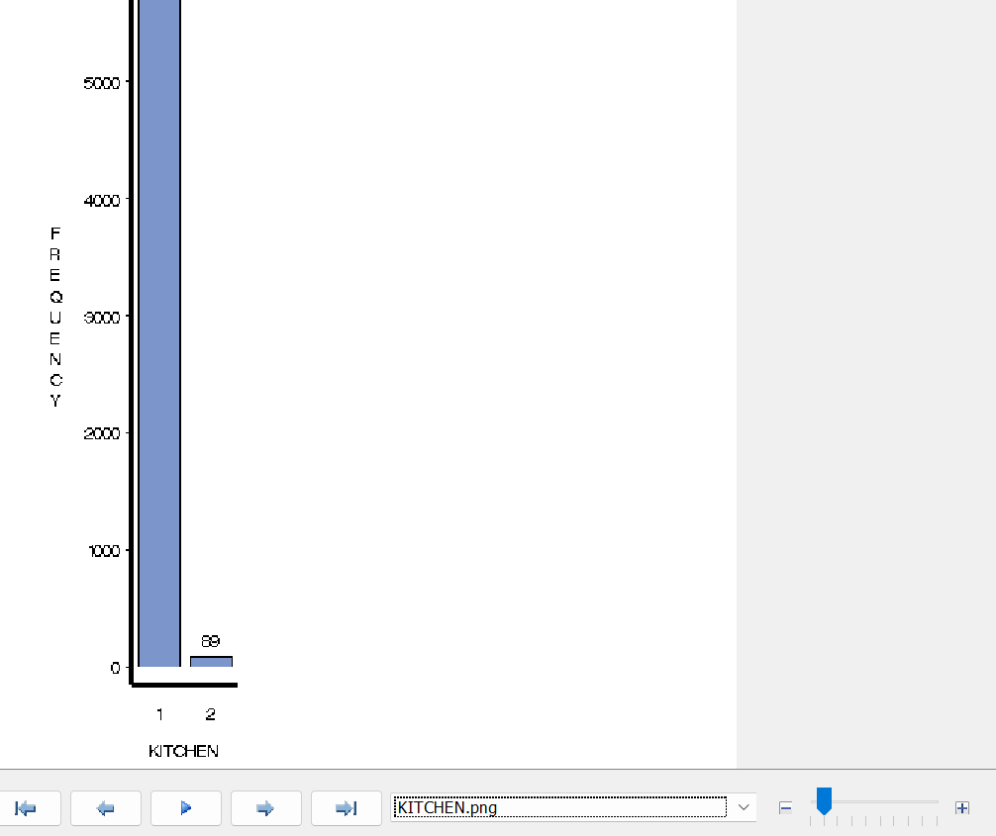

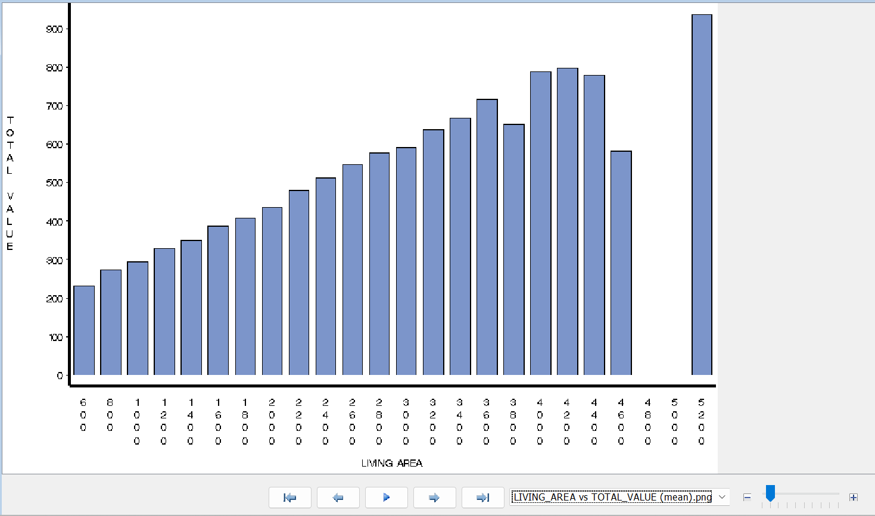

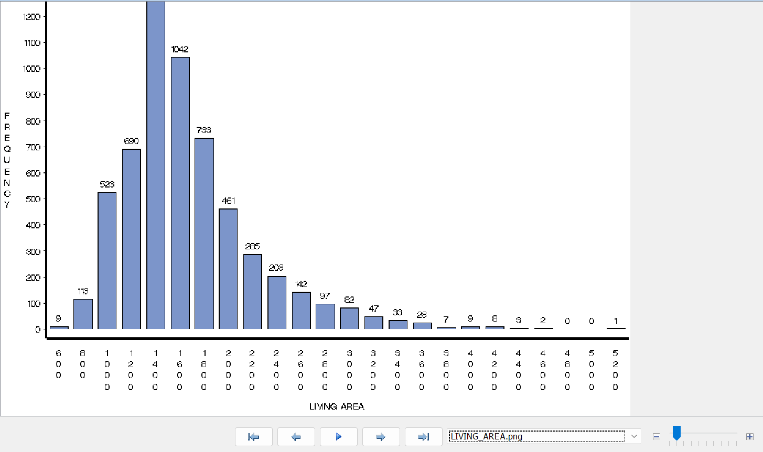

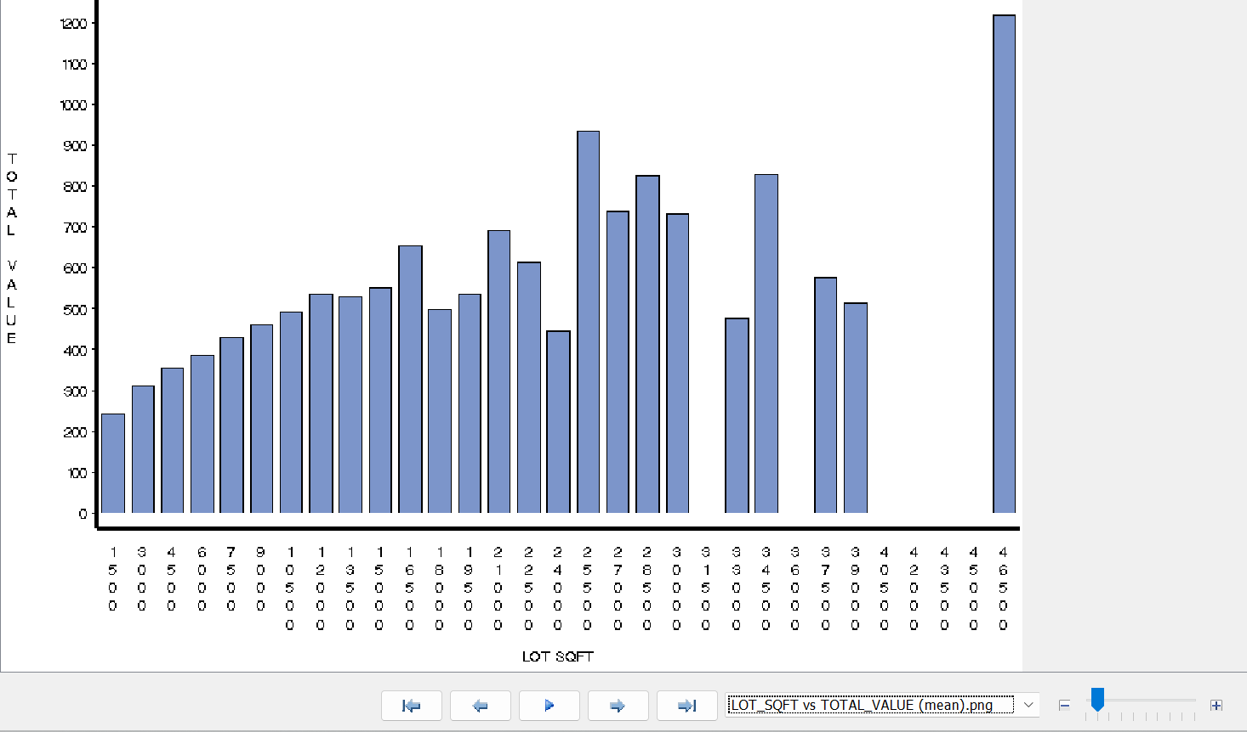

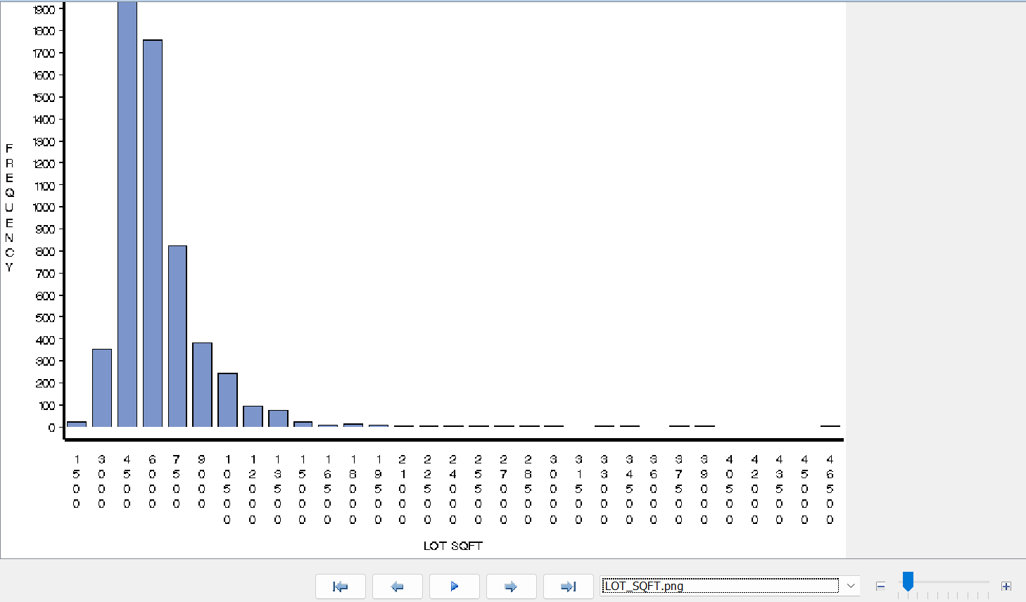

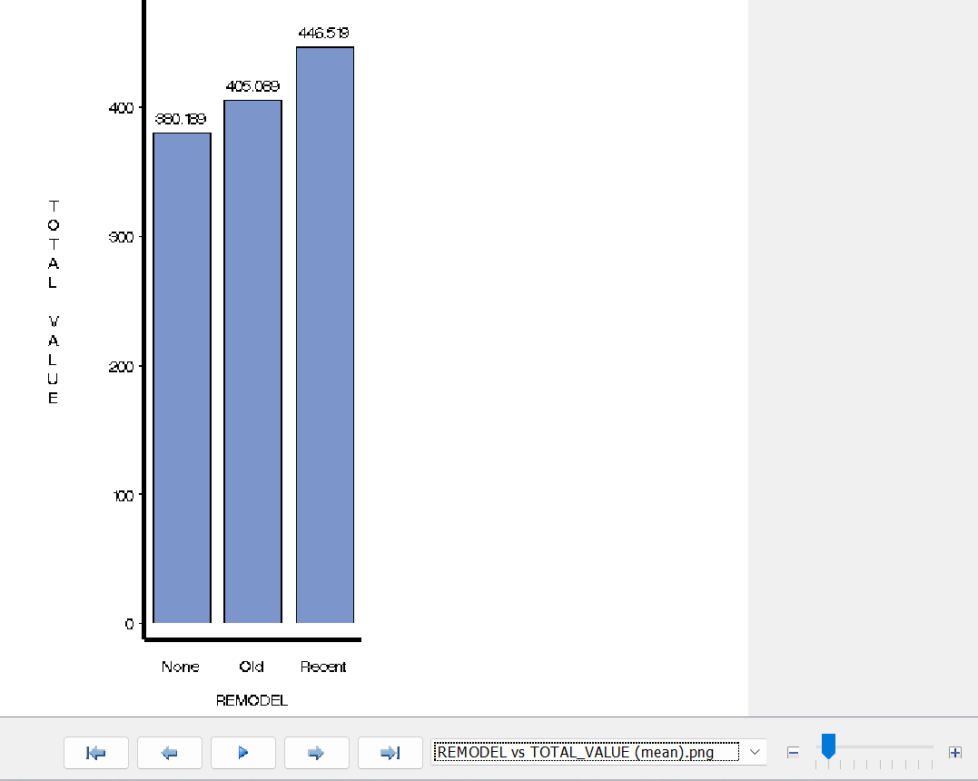

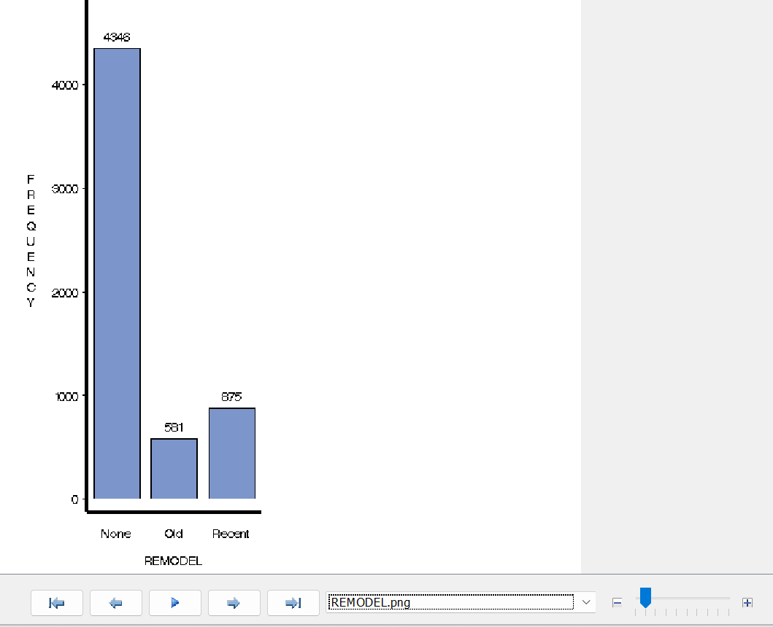

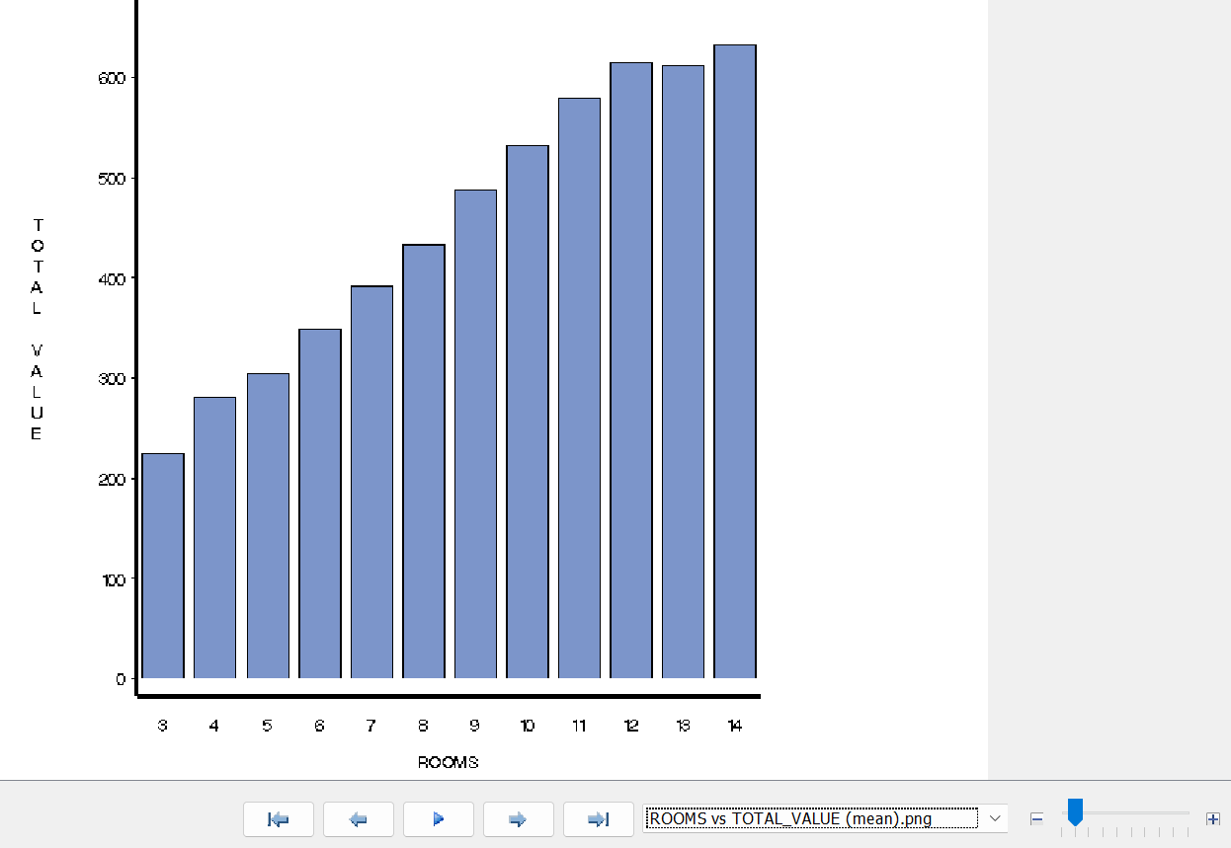

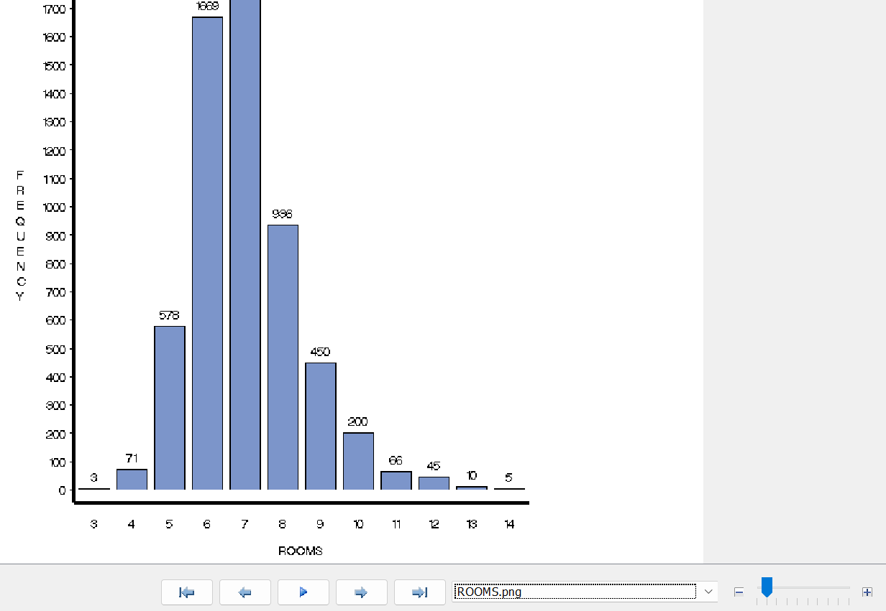

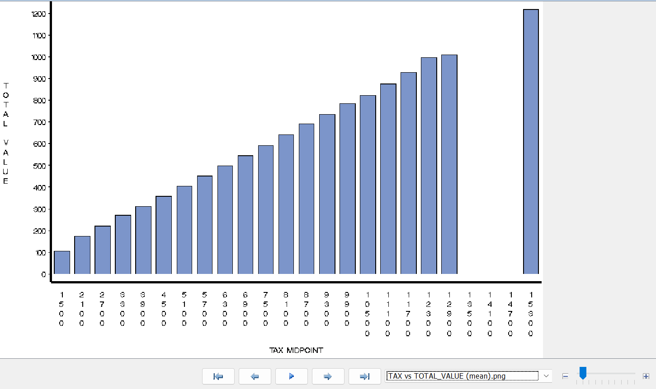

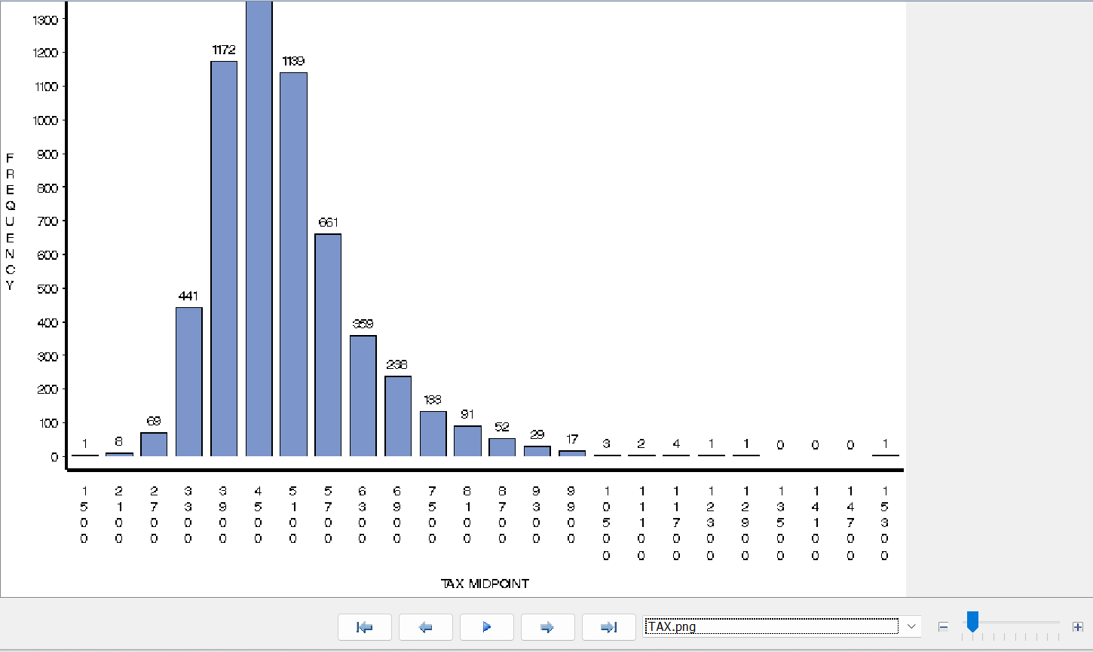

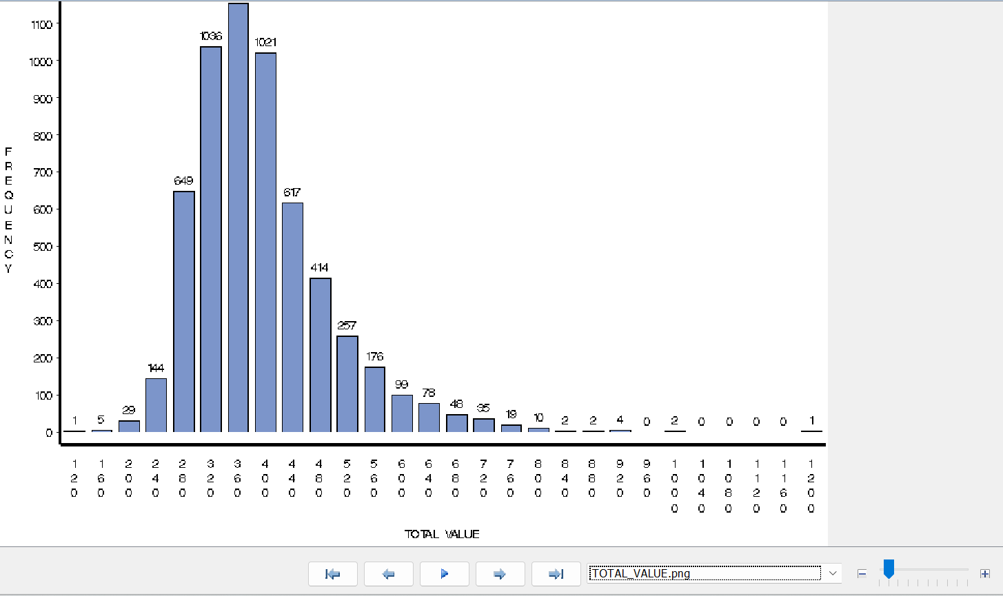

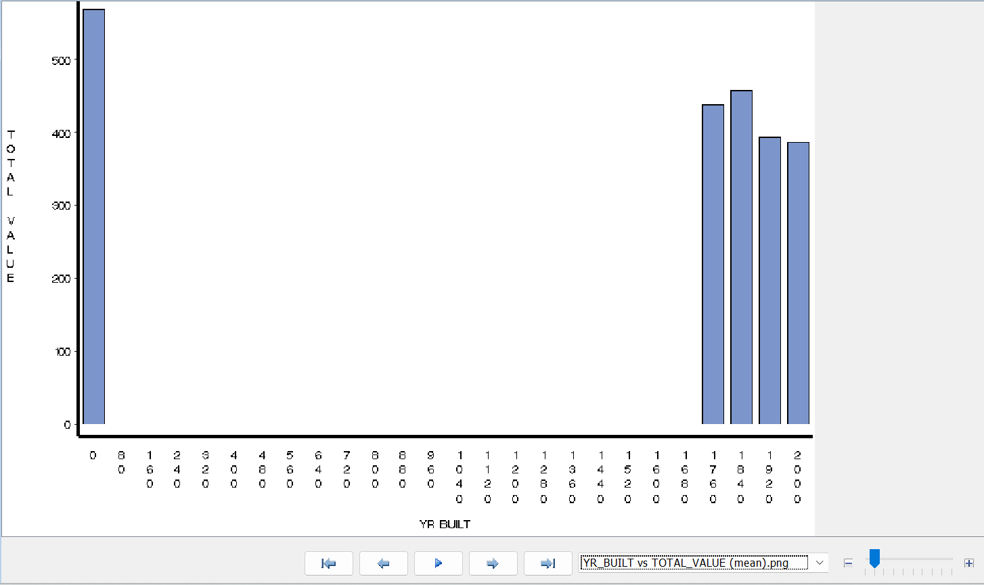

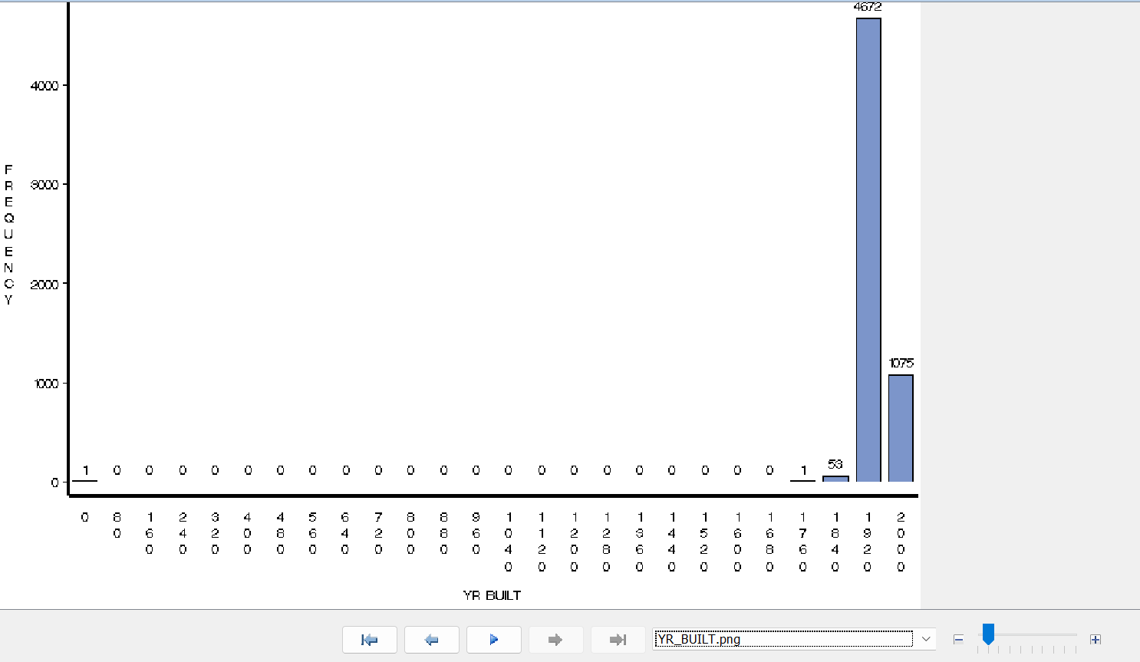

* 1. Based on your analysis, do you need to exclude any variables from the model? Explain and do it if you deem it justified.

Based on the analysis, we may choose to exclude certain independent variables which have little or no effect on Total Value. i.e. for different values of independent variable values of Total Value doesn’t seem to alter or vary. It may vary depending on various factors for instance if a greater number of room/bedrooms may mean more total value, more area may imply higher Total Value. Similarly, some variables like Yr Built/lot are redundant based on insufficient data points or no relation with Total Value.

Hence, we may deem it justified to remove (from start) – kitchen, lot sqft, remodel and yr built.

* 1. Use stepwise variable selection method. Explain how it works. Describe your final model and significance of variables.

We choose regression node. After data partition, choose linear regression type and stepwise model.

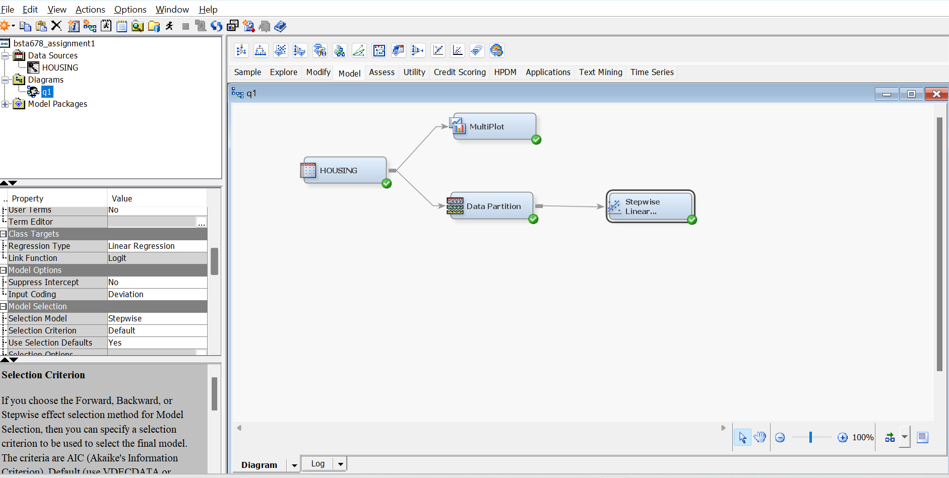

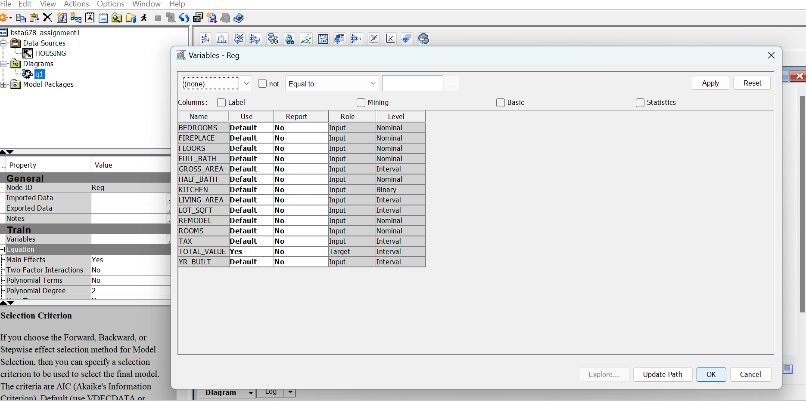

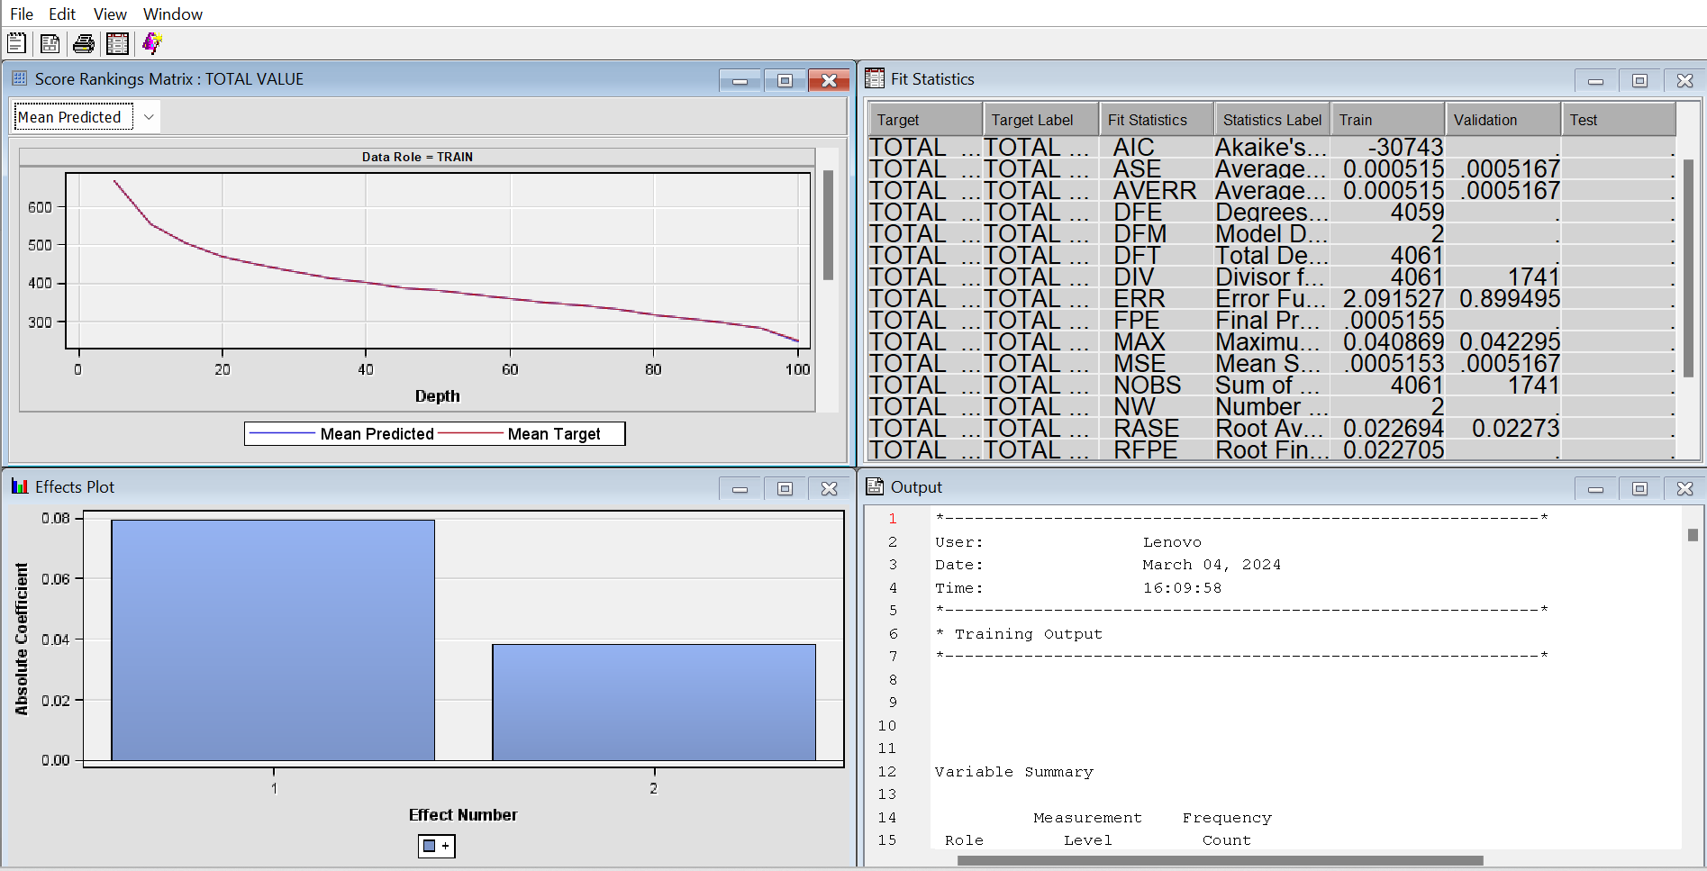

It added in steps based on 0.05 level of significance variable(s) from input data to make a regression model used to predict Total Value (Target or output variable). After each step it checks if all variables in the equation are still significant at 0.05 level of significance (known as stay) to leave the equation for next iteration of adding next significant variable.

According to preselected default selections we get regression output equation as:

**TOTAL_VALUE = 0.0380 + 0.0795 TAX**

* + 1. What are the 3 most significant variables?

Based on the output, there is only 1 significant variable being selected. So, we need to alter some Model selection Default values such as below (by clicking on 3 dots beside Selection Options in Model Selection toolbar):

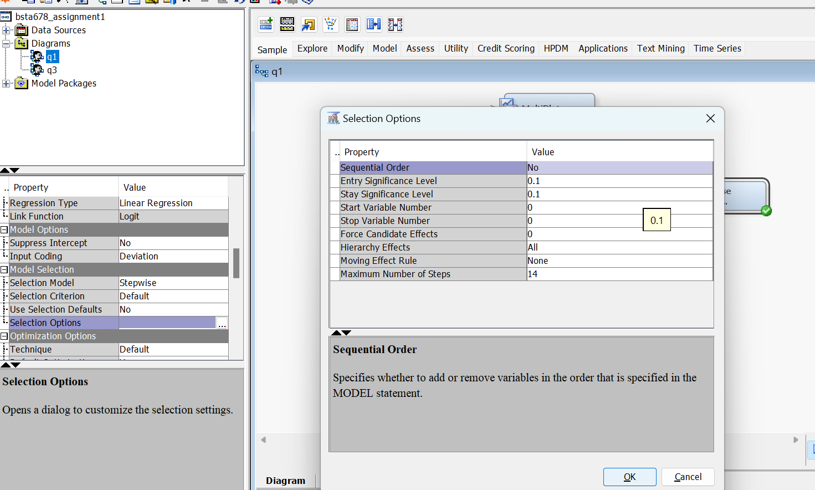

So basically, reducing the model confidence level to 90% from 95% thus making entry and stay significance levels to 0.1 from 0.05(1-Confidence level) also taking maximum number of steps as number of input available to us.

First step: Tax is added.

Second step: Floors

Third step: Rooms

Then we get a note that No (additional) effects met the 0.1 significane level and hence our model is subjected to change if we change more significance levels

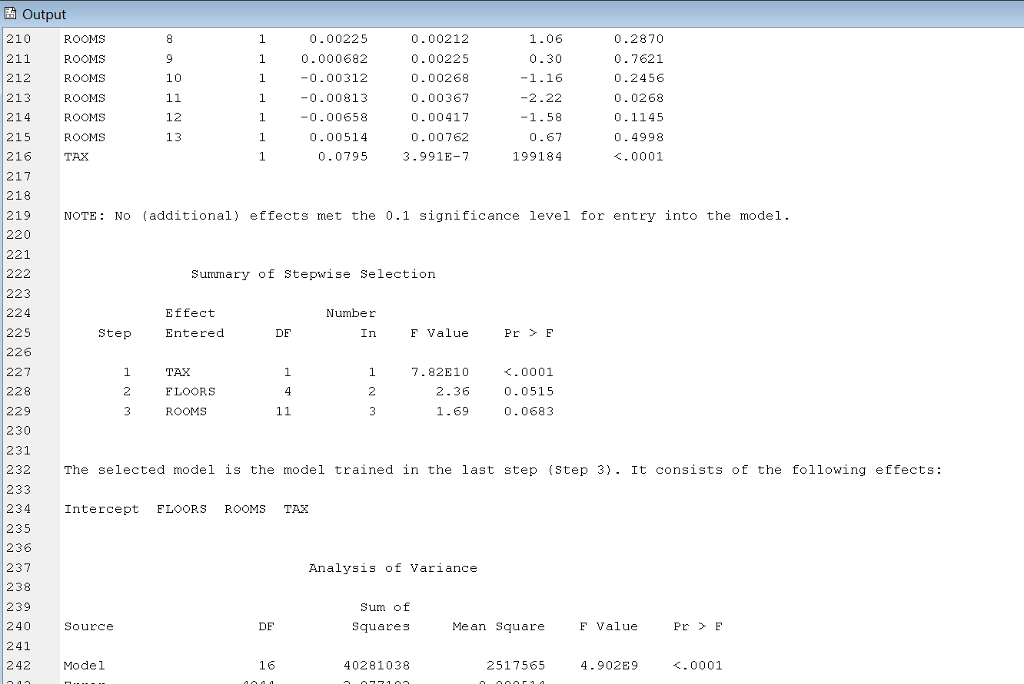

**So 3 most important variables based on this selection model are Tax, Floors and Rooms.**

* + 1. What is R-square of your model? Interpret it.

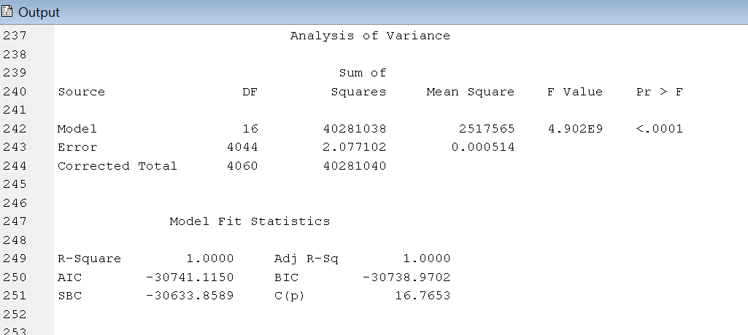

R-square of the model thus is 1.00 or 100%. i.e. 100% of the variation in dependent/target variable House cost is explained by the regression equation:

* + 1. Interpret the effect of Floors and Remodel in the regression model.

Variable effects is explained by:

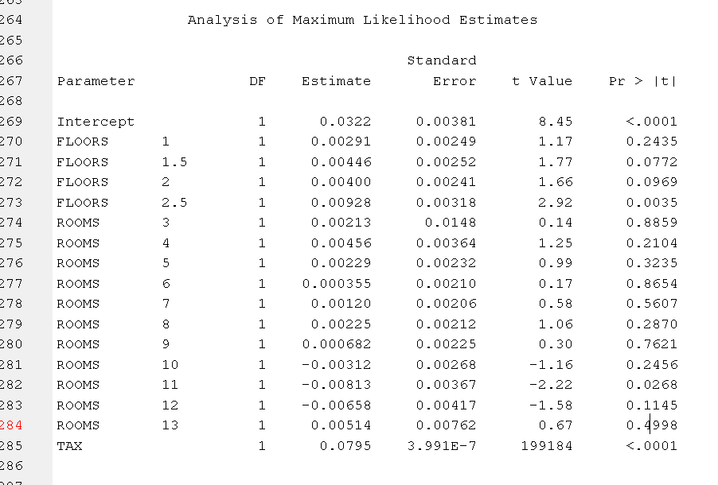

If the no of floors is 1 The total value is changed by 0.00291*1 = 0.00291 units in the positive direction (or added to total value)

If the no of floors is 1.5 The total value is changed by 0.00446*1.5 = 0.00669 units in the positive direction (or added to total value)

If the no of floors is 2 The total value is changed by 0.00400*2 = 0.008 units in the positive direction (or added to total value)

If the no of floors is 2.5 The total value is changed by 0.0098*2.5 = 0.0245 units in the positive direction (or added to total value)

There is no effect of Remodel in this particular regression model.

* + 1. Predict the observation given below in Excel

|  |  |  |  |  |  |  |  |  |  |  |  |  |  |
| --- | --- | --- | --- | --- | --- | --- | --- | --- | --- | --- | --- | --- | --- |
| **TOTAL_VALUE** | **TAX** | **LOT_SQFT** | **YR_BUILT** | **GROSS_AREA** | **LIVING_AREA** | **FLOORS** | **ROOMS** | **BEDROOMS** | **FULL_BATH** | **HALF_BATH** | **KITCHEN** | **FIREPLACE** | **REMODEL** |
| 500 | 3000 | 10000 | 1900 | 2000 | 1400 | 1 | 4 | 3 | 1 | 1 | 1 | 10 | None |

Predicted Total Value is obtained by putting input variables values into final linear regression equation obtained.

**Predicted TOTAL_VALUE = 0.0322 + 0.00291*F1 + 0.00456*R4 + 0.0795*TAX**

Predicted Total value = 0.0322 + (0.00291 * 1) + (0.00456 * 4) + (0.0795 * 3000)

= 0.0322 + 0.00291 + 0.01824 + 238.5

**Answer: 238.55335 (based on this model)**

(note floors like floor 1 is represented by F1 , floor 2 is represented by F2 and so on, since there is data point in context we use only those variables since F2 F1.5 etc becomes 0 and so on)

* 1. Define a model lift? Interpret it. Explain the lift curve you obtained with SAS EM. Using data from SAS EM, construct SAS EM lift curve in Excel.

Lift is a concept for categorizing output as True or False which is predicted by Logistic Regression in later parts, this linear regression shows us mean predictions

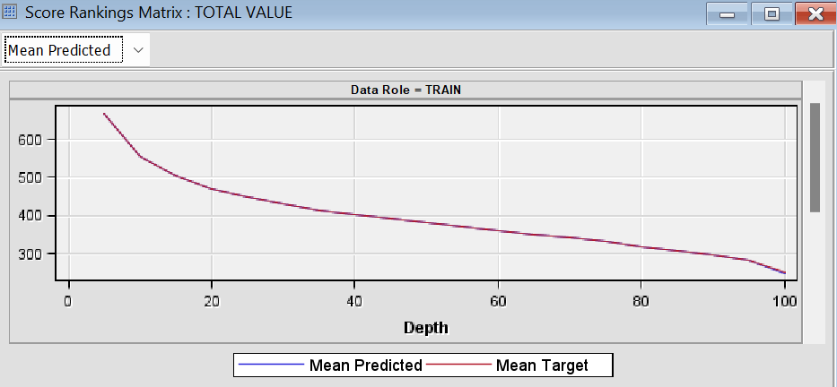very good fit

* 1. Based on plot of residuals versus predicted values can you conclude that the model assumptions are satisfied?

The mean predicted and mean target lies ontop of each other overlapping values :

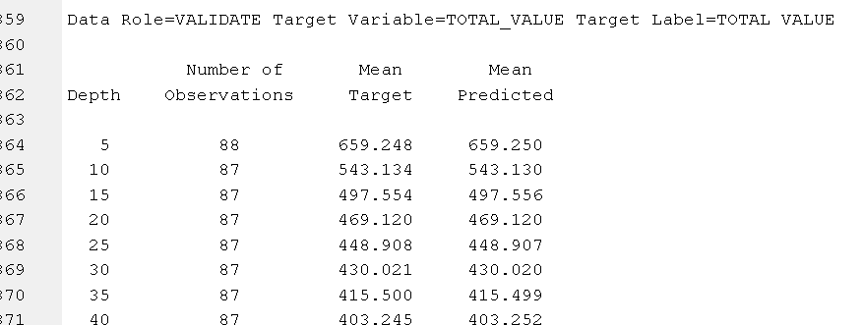

Hence we may conclude that model assumptions which states random distributions of residuals normal distributed data curve etc are being met.

**Question 2.**

From SAS Skillbuilder for Students site,

<https://vle.sas.com/course/view.php?id=1379>

select the course: [Applied Analytics Using SAS Enterprise Miner 15.1](https://vle.sas.com/course/view.php?id=8015)

## Complete and submit quizzes for:

## Lesson 4: Introduction to Predictive Modeling: Regressions

## Lesson 6: Model Assessment

## Lesson 3: Introduction to Predictive Modeling: Predictive Modeling and Decision Trees

## Hint – redo the quiz if you didn’t get 100%







**Question 3**

**German Credit**

GermanCredit.csv is the dataset for this case study and is located Moodle. Import it into SAS EM.

**Background**

Money-lending has been around since the advent of money; it is perhaps the world’s second-oldest profession. The systematic evaluation of credit risk, though, is a relatively recent arrival, and lending was largely based on reputation and very incomplete data. Thomas Jefferson, the third President of the United States, was in debt throughout his life and unreliable in his debt payments, yet people continued to lend him money. It wasn’t until the beginning of the 20th century that the Retail Credit Company was founded to share information about credit. That company is now Equifax, one of the big three credit scoring agencies (the other two are Transunion and Experion).

Individual and local human judgment are now largely irrelevant to the credit reporting process. Credit agencies and other big financial institutions extending credit at the retail level collect huge amounts of data to predict whether defaults or other adverse events will occur, based on numerous customer and transaction information.

**Data**

This case deals with an early stage of the historical transition to predictive modeling, in which humans were employed to label records as either good or poor credit. The German Credit dataset[22](https://jigsaw.vitalsource.com/books/9781118879337/epub/OPS/c21.xhtml#c21-note-0002) has 30 variables and 1000 records, each record being a prior applicant for credit. Each applicant was rated as “good credit” (700 cases) or “bad credit” (300 cases). [Table 21.2](https://jigsaw.vitalsource.com/books/9781118879337/epub/OPS/c21.xhtml#table21-2) shows the values of these variables for the first four records. All the variables are explained in [Table 21.5](https://jigsaw.vitalsource.com/books/9781118879337/epub/OPS/c21.xhtml#table21-5). New applicants for credit can also be evaluated on these 30 predictor variables and classified as a good or a bad credit risk based on the predictor values.

First four records from German Credit dataset

| **OBS#** | **CHK_ACCT** | **DURATION** | **HISTORY** | **NEW_CAR** | **USED_CAR** | **FURNITURE** | **RADIO/TV** | **EDUCATION** | **RETRAINING** | **AMOUNT** | **SAV_ACCT** | **EMPLOYMENT** | **INSTALL_RATE** | **MALE_DIV** | **MALE_SINGLE** | **MALE_MAR_WID** | **CO-APPLICANT** | **GUARANTOR** |
| --- | --- | --- | --- | --- | --- | --- | --- | --- | --- | --- | --- | --- | --- | --- | --- | --- | --- | --- |
| 1 | 0 | 6 | 4 | 0 | 0 | 0 | 1 | 0 | 0 | 1169 | 4 | 4 | 4 | 0 | 1 | 0 | 0 | 0 |
| 2 | 1 | 48 | 2 | 0 | 0 | 0 | 1 | 0 | 0 | 5951 | 0 | 2 | 2 | 0 | 0 | 0 | 0 | 0 |
| 3 | 3 | 12 | 4 | 0 | 0 | 0 | 0 | 1 | 0 | 2096 | 0 | 3 | 2 | 0 | 1 | 0 | 0 | 0 |
| 4 | 0 | 42 | 2 | 0 | 0 | 1 | 0 | 0 | 0 | 7882 | 0 | 3 | 2 | 0 | 1 | 0 | 0 | 1 |
|  | PRESENT_RESIDENT | REAL_ESTATE | PROP_UNKN_NONE | AGE | OTHER_INSTALL | RENT | OWN_RES | NUM_CREDITS | JOB | NUM_DEPENDENTS | TELEPHONE | FOREIGN | RESPONSE |  |  |  |  |  |
|  | 4 | 1 | 0 | 67 | 0 | 0 | 1 | 2 | 2 | 1 | 1 | 0 | 1 |  |  |  |  |  |
|  | 2 | 1 | 0 | 22 | 0 | 0 | 1 | 1 | 2 | 1 | 0 | 0 | 0 |  |  |  |  |  |
|  | 3 | 1 | 0 | 49 | 0 | 0 | 1 | 1 | 1 | 2 | 0 | 0 | 1 |  |  |  |  |  |
|  | 4 | 0 | 0 | 45 | 0 | 0 | 0 | 1 | 2 | 2 | 0 | 0 | 1 |  |  |  |  |  |

List of variables for the German Credit Dataset

| **Var.** | **Variable Name** | **Description** | **Variable Type** | **Code Description** |
| --- | --- | --- | --- | --- |
| 1 | OBS# | Observation numbers | Categorical | Sequence number in dataset |
| 2 | CHK−ACCT | Checking account | Categorical | 0: <0 DM |
|  |  | status |  |  |
|  |  |  |  | 1: 0−200 DM |
|  |  |  |  | 2 : >200 DM |
|  |  |  |  | 3: No checking account |
| 3 | DURATION | Duration of | Numerical |  |
|  |  | credit in months |  |  |
| 4 | HISTORY | Credit history | Categorical | 0: No credits taken |
|  |  |  |  | 1: All credits at this bank |
|  |  |  |  | paid back duly |
|  |  |  |  | 2: Existing credits paid |
|  |  |  |  | back duly until now |
|  |  |  |  | 3: Delay in paying |
|  |  |  |  | off in the past |
|  |  |  |  | 4: Critical account |
| 5 | NEW−CAR | Purpose of | Binary | Car (new), 0: No, 1: Yes |
|  |  | credit |  |  |
| 6 | USED−CAR | Purpose of | Binary | Car (used), 0: No, 1: Yes |
|  |  | credit |  |  |
| 7 | FURNITURE | Purpose of | Binary | Furniture/equipment, |
|  |  | credit |  | 0: No, 1: Yes |
| 8 | RADIO/TV | Purpose of | Binary | Radio/television, |
|  |  | credit |  | 0: No, 1: Yes |
| 9 | EDUCATION | Purpose of | Binary | Education, 0: No, 1: Yes |
|  |  | credit |  |  |
| 10 | RETRAINING | Purpose of | Binary | Retraining, 0: No, 1: Yes |
|  |  | credit |  |  |
| 11 | AMOUNT | Credit amount | Numerical |  |
| 12 | SAV−ACCT | Average balance | Categorical | 0: <100 DM |
|  |  | in savings |  | 1 : 101−500 DM |
|  |  | account |  | 2 : 501−1000 DM |
|  |  |  |  | 3 : >1000 DM |
|  |  |  |  | 4 : Unknown/ no |
|  |  |  |  | savings account |
| 13 | EMPLOYMENT | Present | Categorical | 0 : Unemployed |
|  |  | employment |  | 1: <1 year |
|  |  | since |  | 2: 1−3 years |
|  |  |  |  | 3: 4−6 years |
|  |  |  |  | 4: ≥7 years |
| 14 | INSTALL−RATE | Installment | Numerical |  |
|  |  | rate as |  |  |
|  |  | % of disposable |  |  |
|  |  | income |  |  |
| 15 | MALE−DIV | Applicant is male | Binary | 0: No, 1: Yes |
|  |  | and divorced |  |  |
| **Var.** | **Variable Name** | **Description** | **Variable Type** | **Code Description** |
| 16 | MALE−SINGLE | Applicant is male | Binary | 0: No, 1: Yes |
|  |  | and single |  |  |
| 17 | MALE−MAR−WID | Applicant is male | Binary | 0: No, 1: Yes |
|  |  | and married |  |  |
|  |  | or a widower |  |  |
| 18 | CO-APPLICANT | Application has | Binary | 0: No, 1: Yes |
|  |  | a coapplicant |  |  |
| 19 | GUARANTOR | Applicant has | Binary | 0: No, 1: Yes |
|  |  | a guarantor |  |  |
| 20 | PRESENT−RESIDENT | Present resident | Categorical | 0: ≤1 year |
|  |  | since (years) |  | 1: 1−2 years |
|  |  |  |  | 2: 2−3 years |
|  |  |  |  | 3: ≥3 years |
| 21 | REAL−ESTATE | Applicant owns | Binary | 0: No, 1: Yes |
|  |  | real estate |  |  |
| 22 | PROP−UNKN−NONE | Applicant owns no | Binary | 0: No, 1: Yes |
|  |  | property (or unknown) |  |  |
| 23 | AGE | Age in years | Numerical |  |
| 24 | OTHER−INSTALL | Applicant has | Binary | 0: No, 1: Yes |
|  |  | other installment |  |  |
|  |  | plan credit |  |  |
| 25 | RENT | Applicant rents | Binary | 0: No, 1: Yes |
| 26 | OWN−RES | Applicant owns | Binary | 0: No, 1: Yes |
|  |  | residence |  |  |
| 27 | NUM−CREDITS | Number of | Numerical |  |
|  |  | existing credits |  |  |
|  |  | at this bank |  |  |
| 28 | JOB | Nature of job | Categorical | 0 : Unemployed/ |
|  |  |  |  | unskilled— |
|  |  |  |  | non-resident |
|  |  |  |  | 1 : Unskilled— |
|  |  |  |  | resident |
|  |  |  |  | 2 : Skilled employee/ |
|  |  |  |  | official |
|  |  |  |  | 3 : Management/ |
|  |  |  |  | self-employed/ |
|  |  |  |  | highly qualified |
|  |  |  |  | employee/officer |
| 29 | NUM−DEPENDENTS | Number of people | Numerical |  |
|  |  | for whom liable to |  |  |
|  |  | provide maintenance |  |  |
| 30 | TELEPHONE | Applicant has | Binary | 0: No, 1: Yes |
|  |  | phone in his |  |  |
|  |  | or her name |  |  |
| 31 | FOREIGN | Foreign worker | Binary | 0: No, 1: Yes |
| 32 | RESPONSE | Credit rating | Binary | 0: No, 1: Yes |
|  |  | is good |  |  |

(**Note**: The original dataset had a number of categorical variables, some of which were transformed into a series of binary variables, and some ordered categorical variables were left as is, to be treated as numerical).

Answer the following questions. Copy your results into Word document.

1. Use SAS EM to build logistic regression to predict a good Credit Rating.
   1. Adjust roles and levels of variables.

We File Import the appropriate path of the dataset and select Yes for Advance Advisor. After which following:

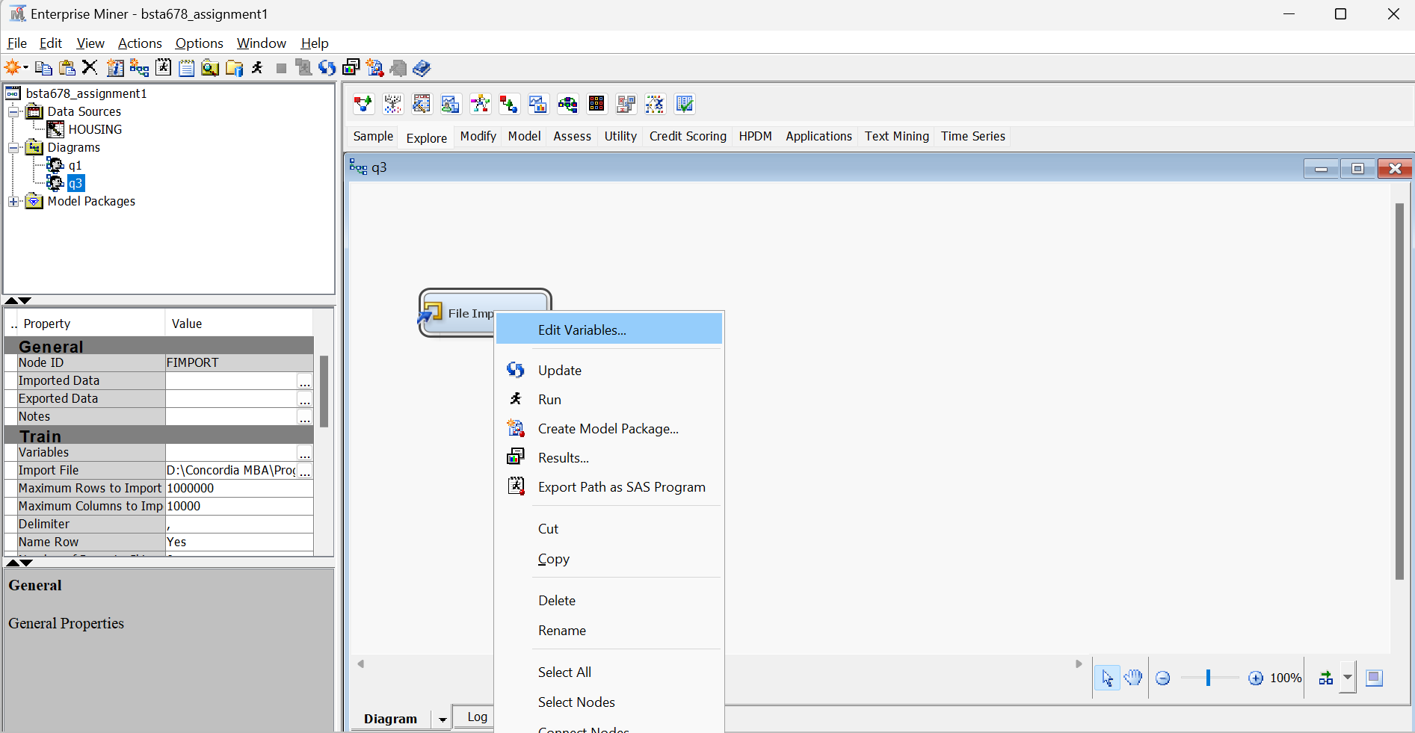

Here the target variable is set to “Response” (i.e. dependent variable which needs to be predicted by the model), others independent variables are input while OBS_ column needs to be set as “ID”. Most values are in interval level as detected by SAS which we change from the variable info provided in above table.

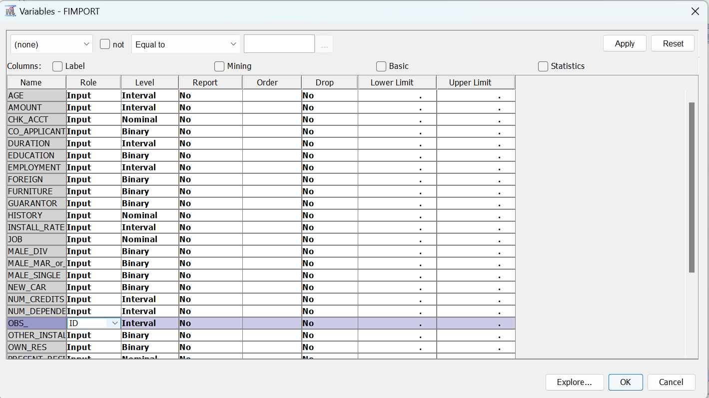

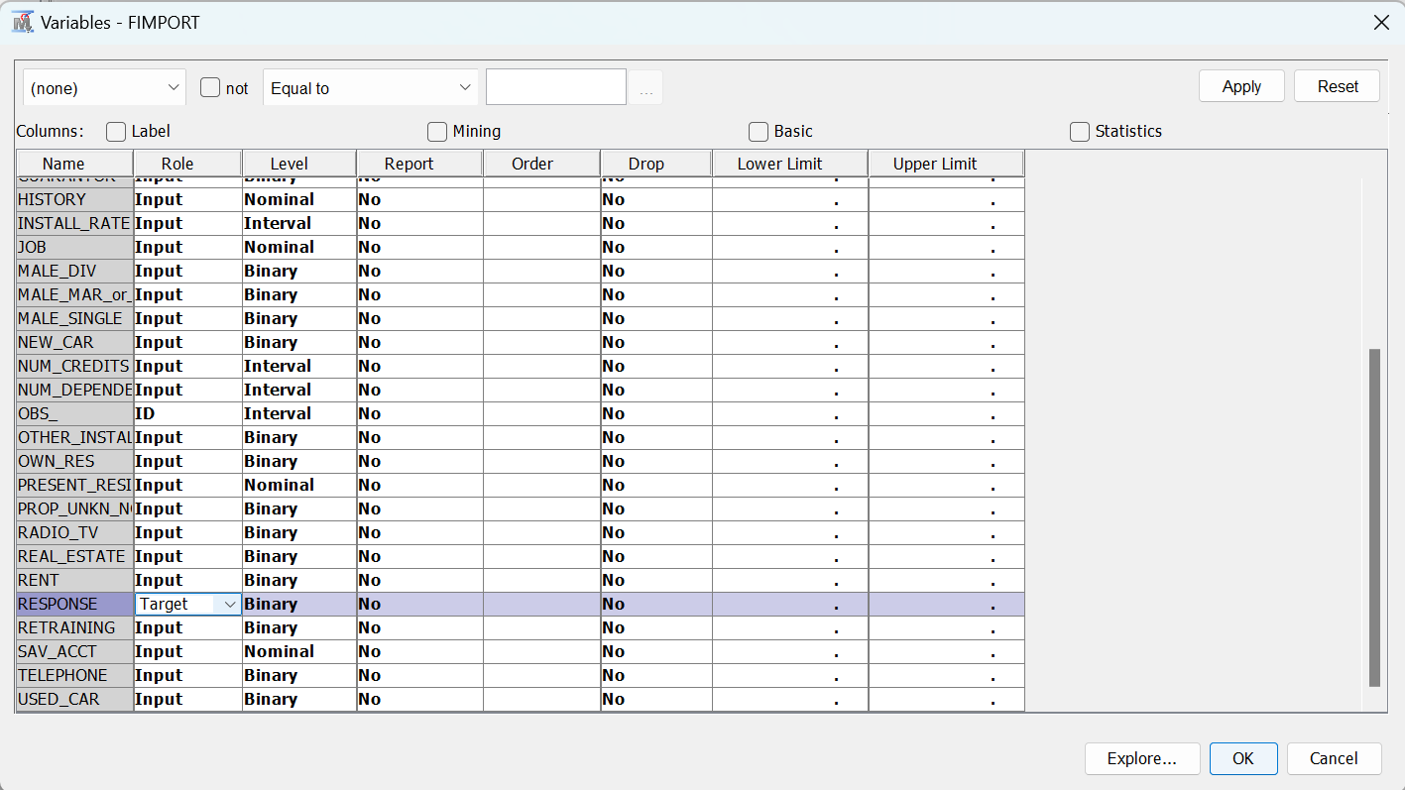

Now we run the node.

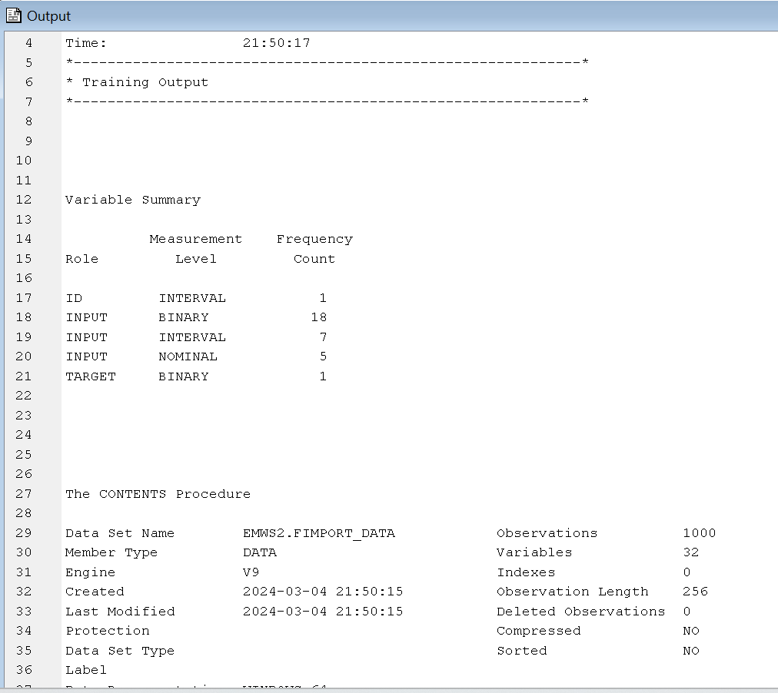

* 1. Provide numerical and graphical summaries for all variables. What can you conclude?

We now select all variables in edit variables and click explore.

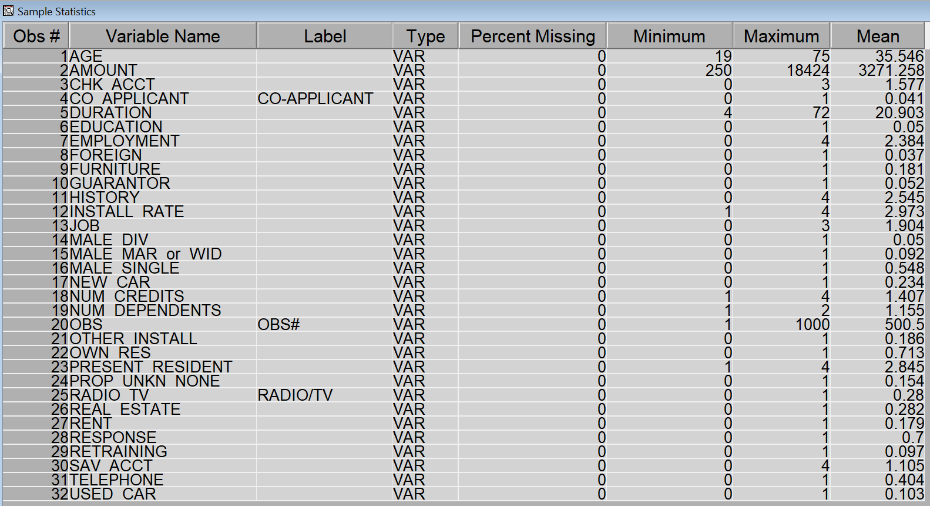

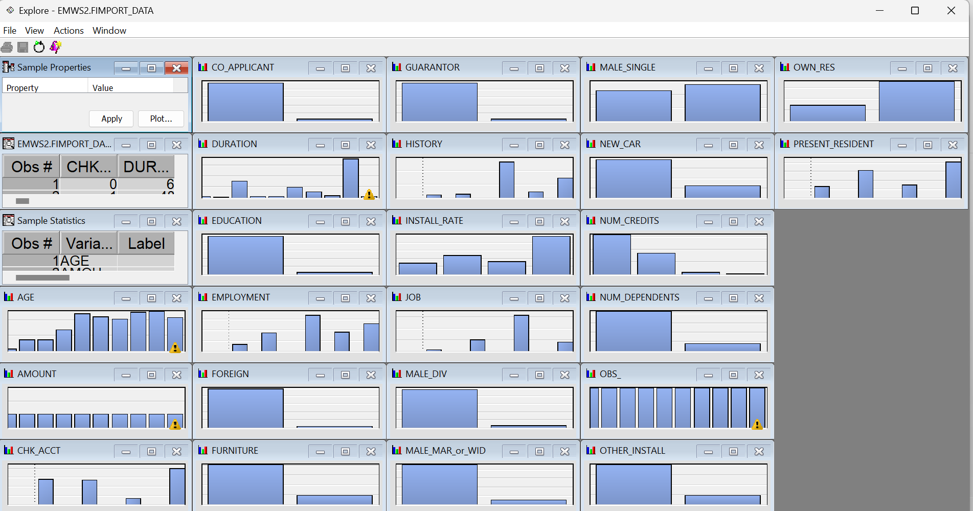

* 1. Explore and explain relationship between credit rating and independent variables. What do you conclude?

We can use StatExplore Node for this and show various relationships.

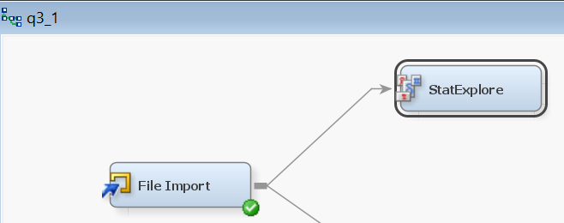

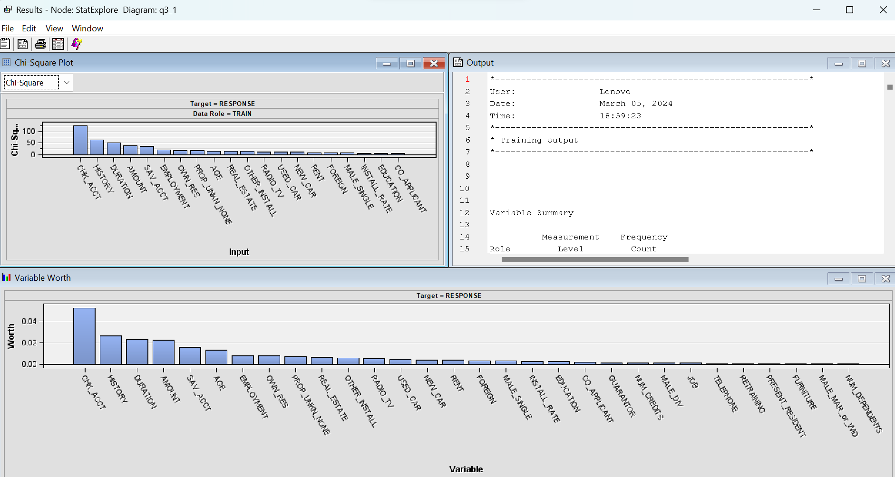

We get:

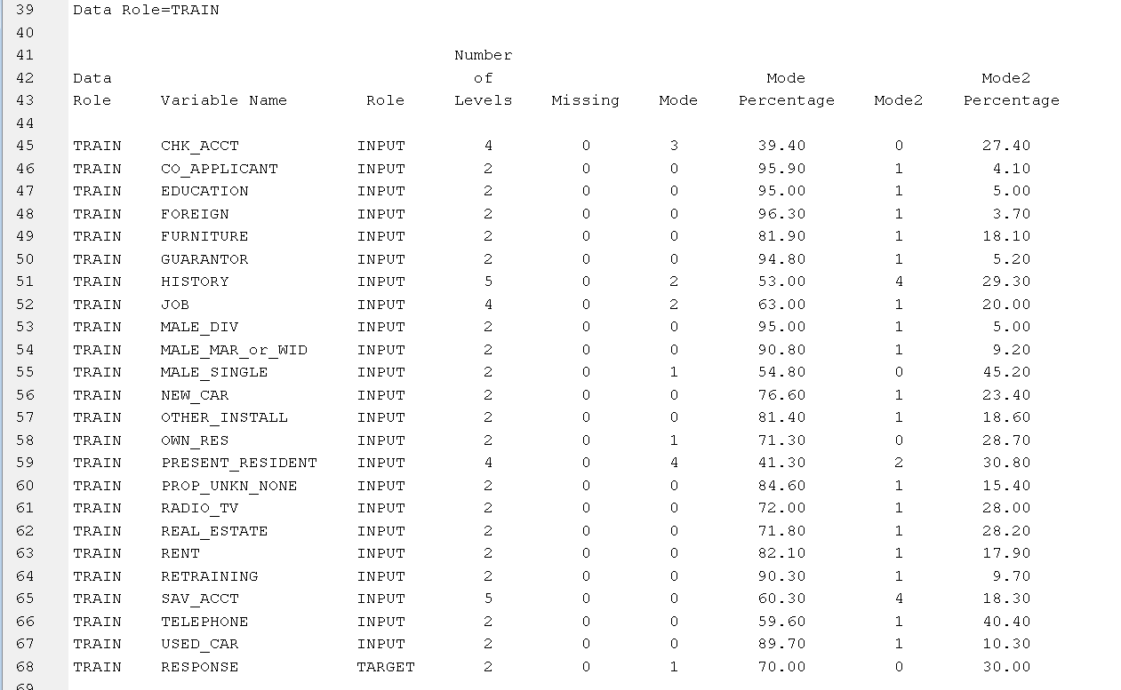

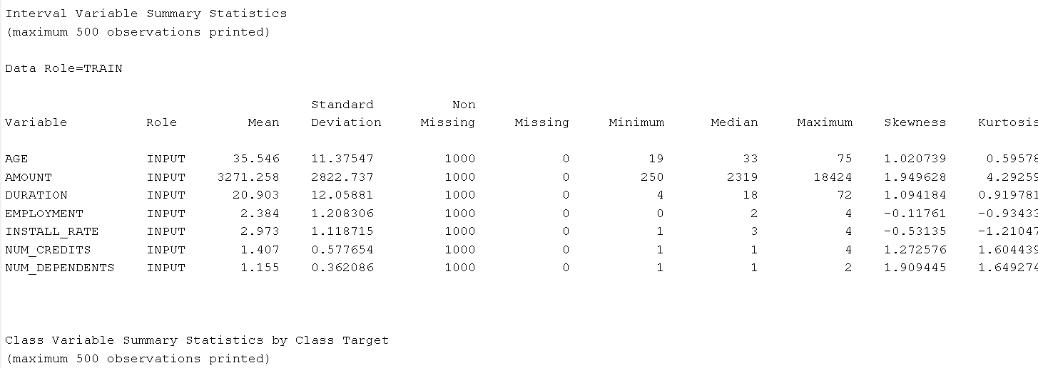

Final answer:

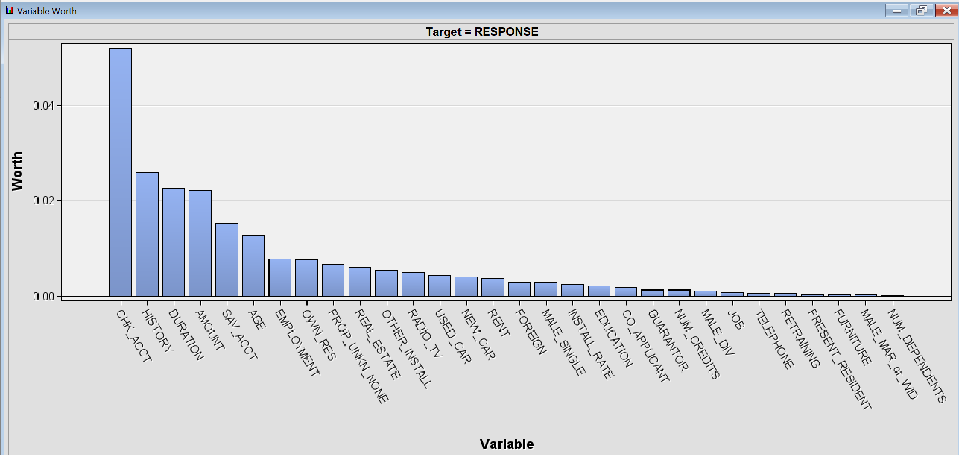

* 1. Build a logistic regression model for the target variable. Use 3 variable selection methods. Explain how they work. Select the best model. Explain your choice.

We partition the data into 70% test and 30% validation sets for further model building:

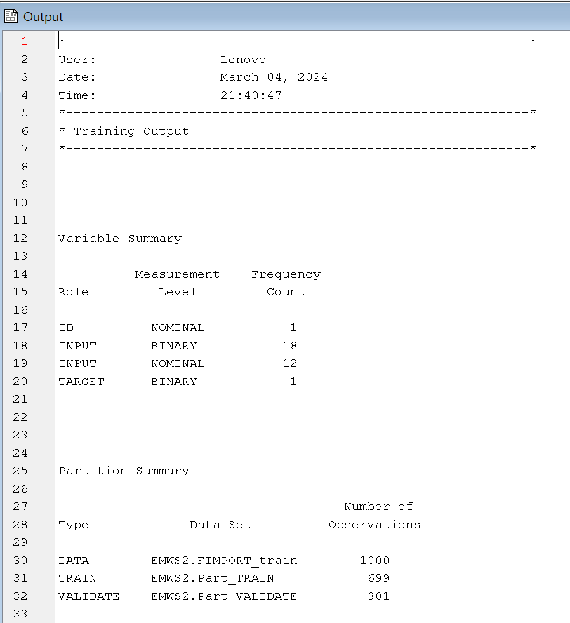

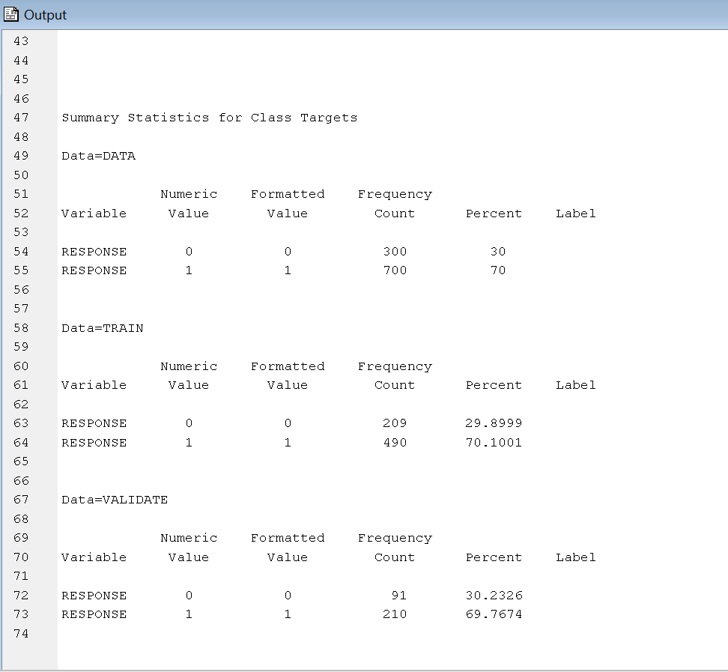

Full Regression Model:

Selection Model – None

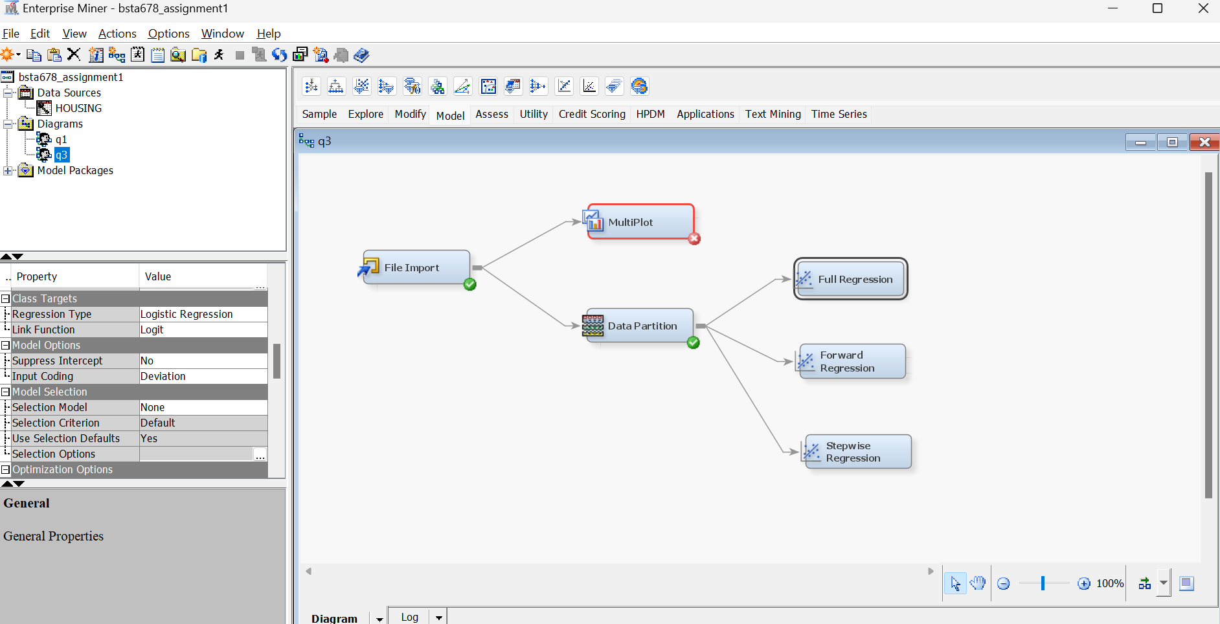

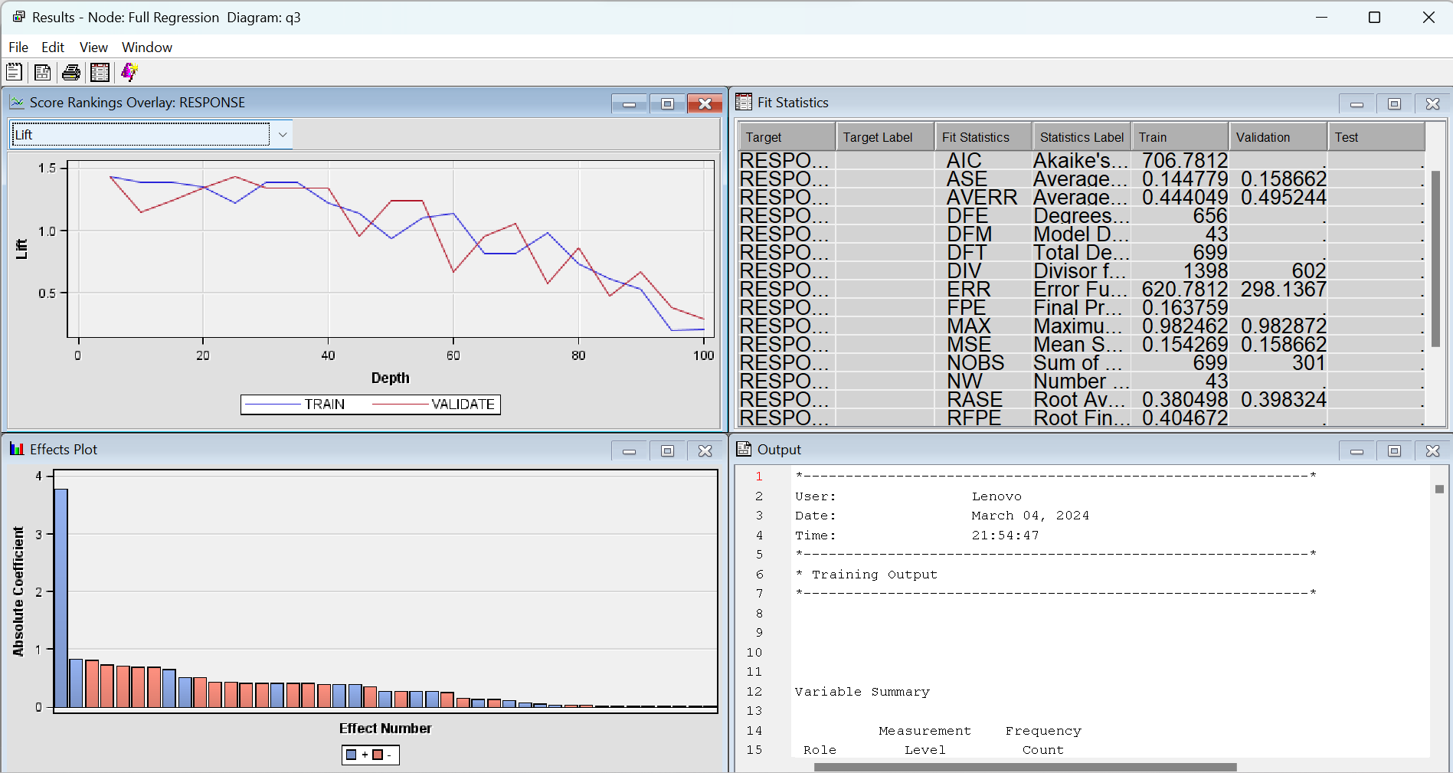

This model takes all the input variables and compute a model to predict the target variable.

We can check the respective statistics for knowing the best model.

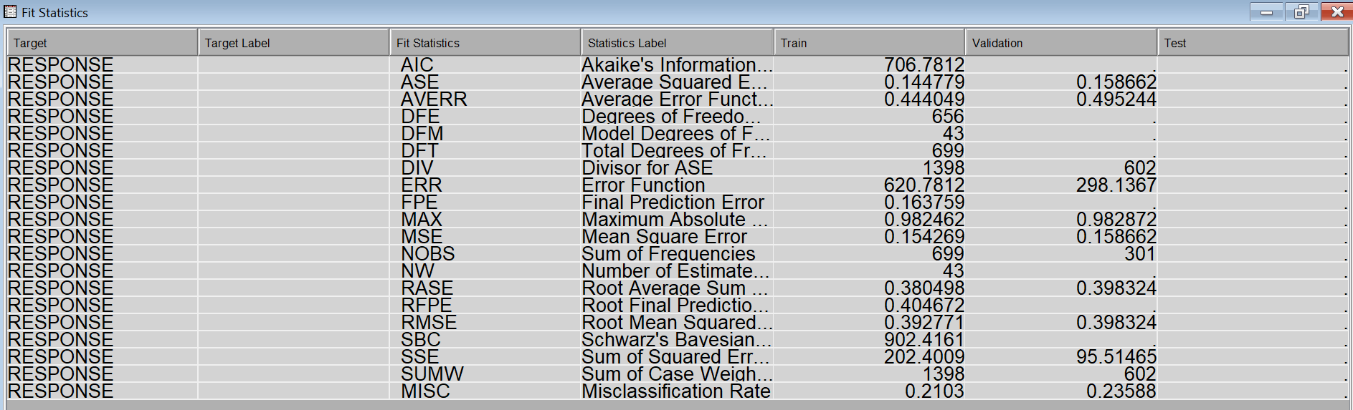

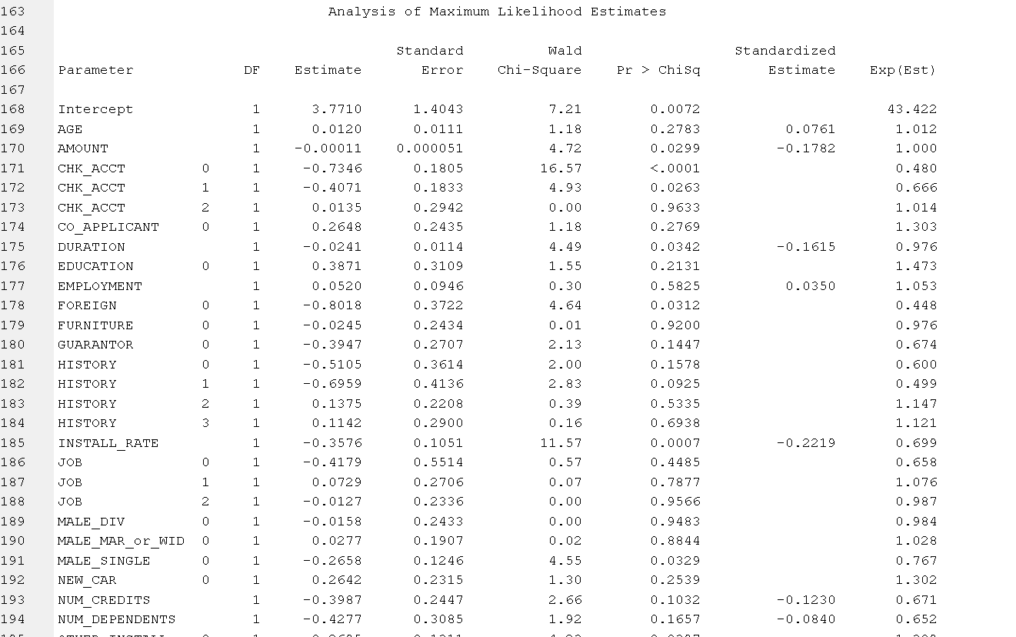

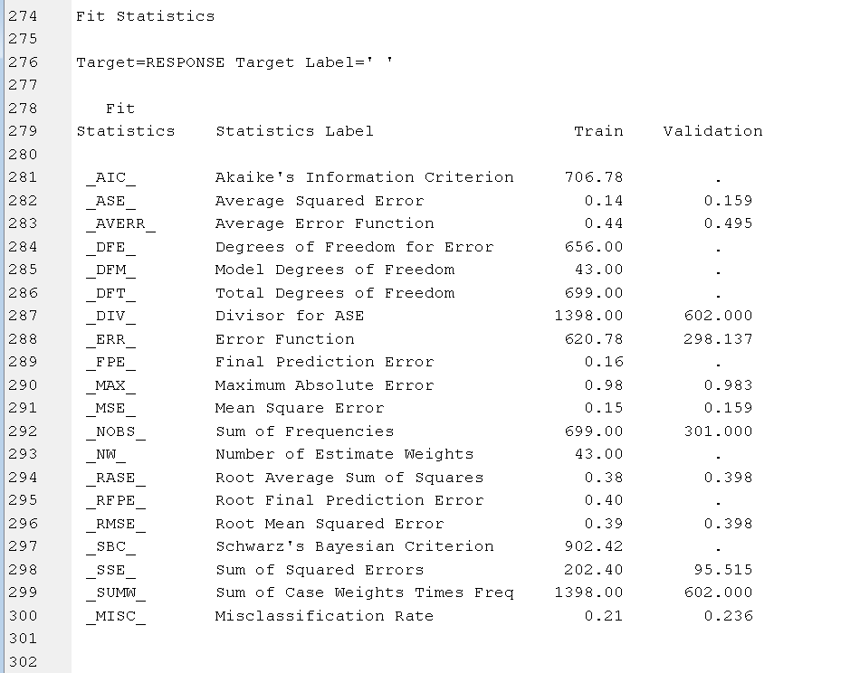

Forward selection Regression Model:

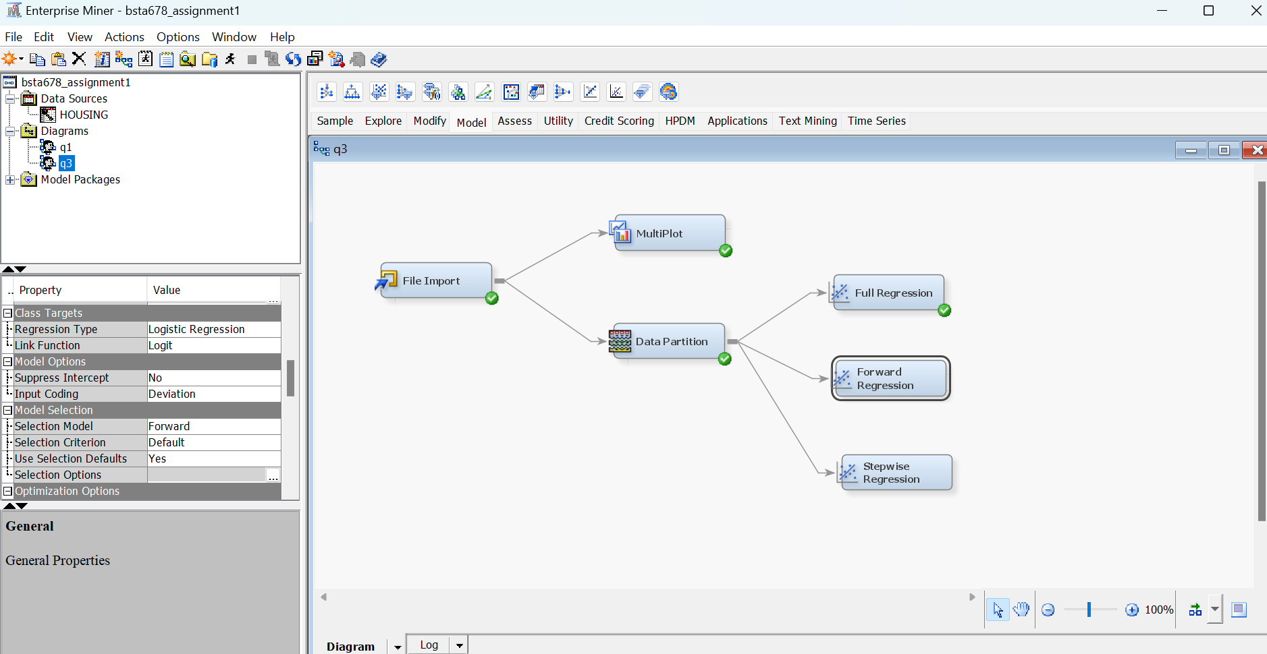

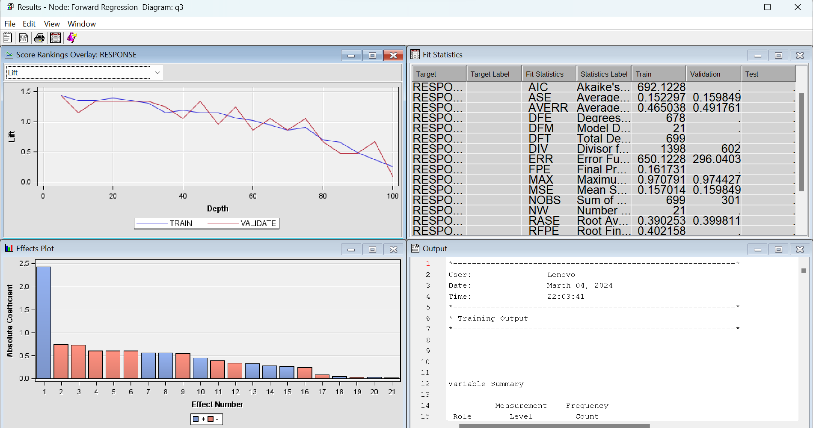

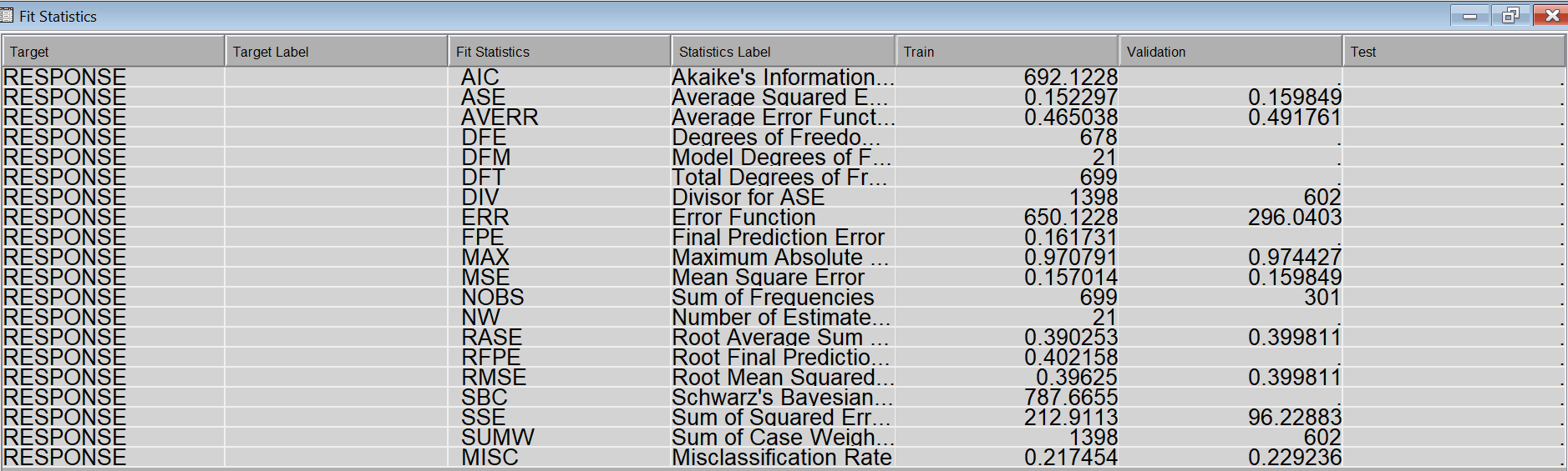

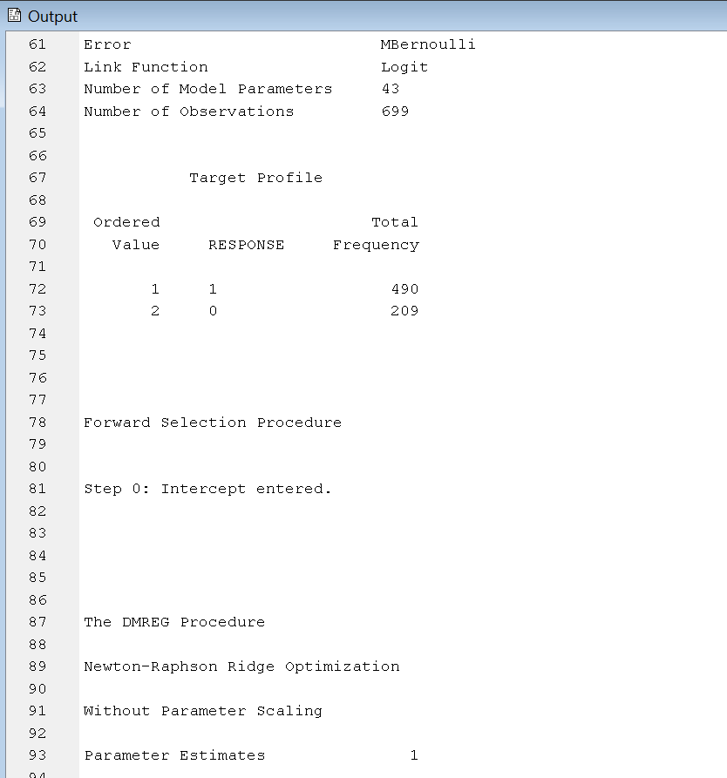

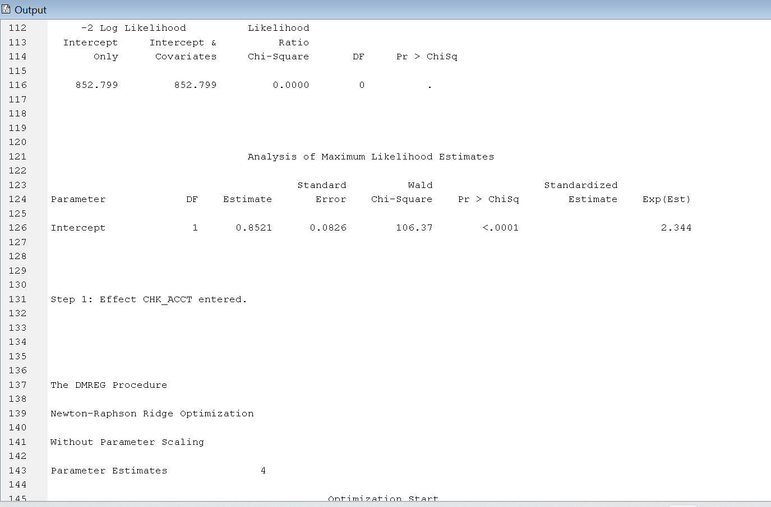

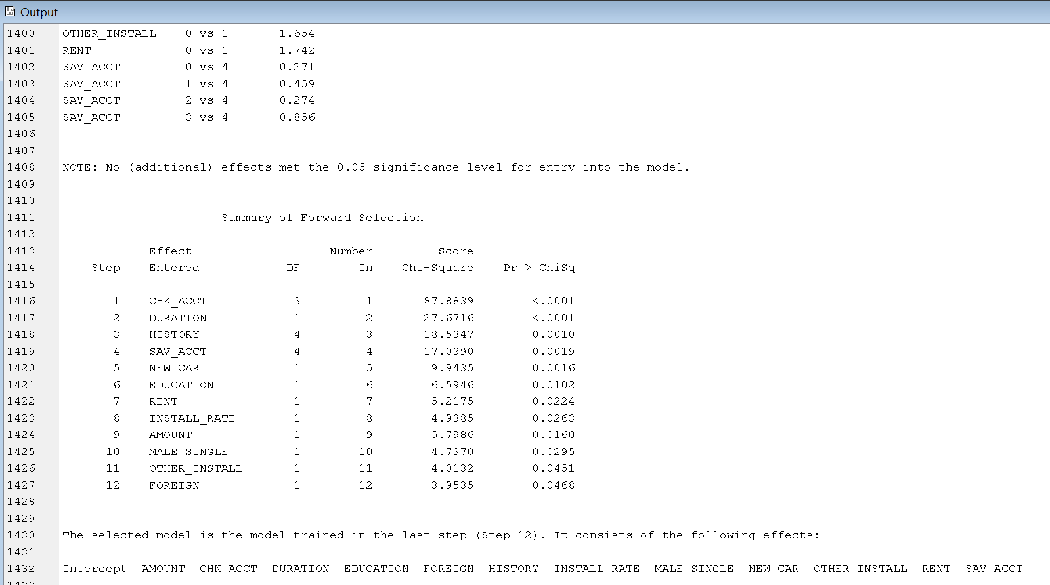

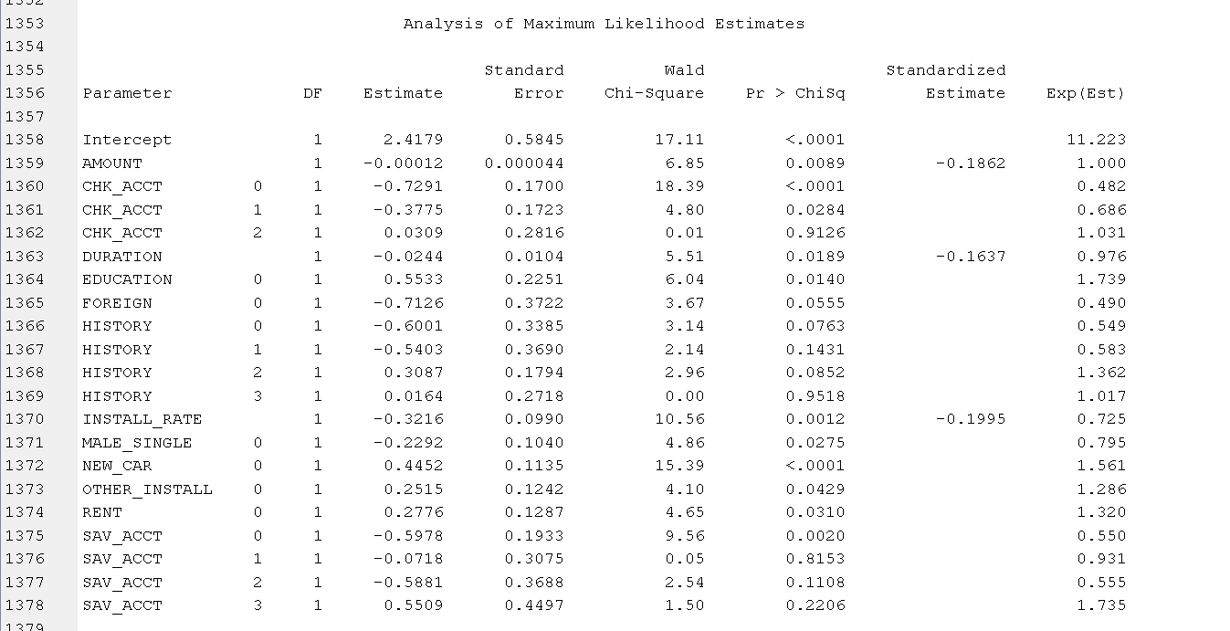

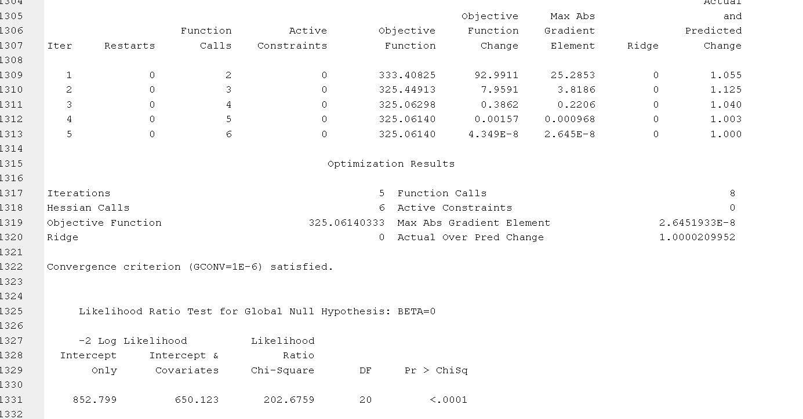

Stepwise Regression Model:

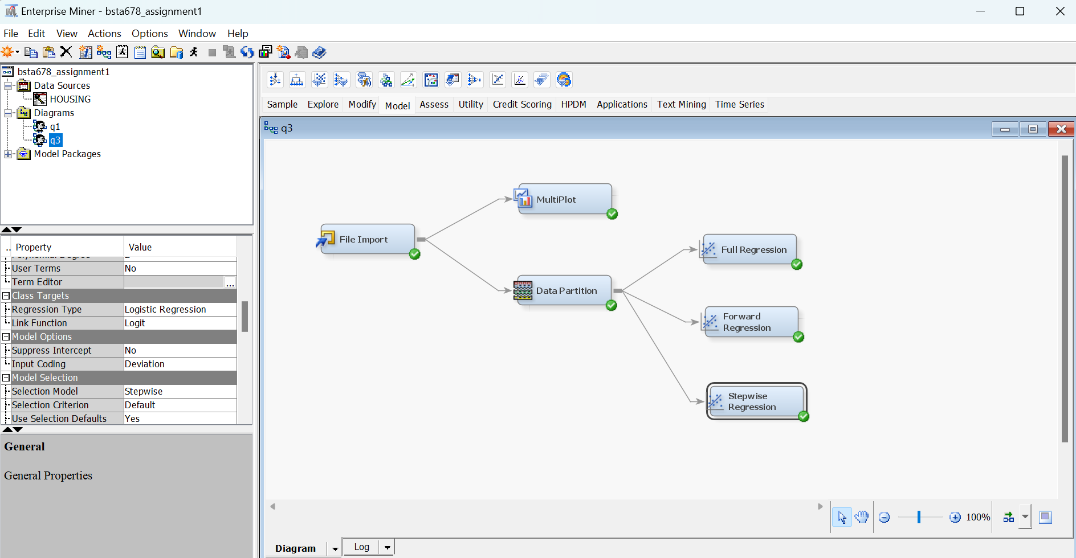

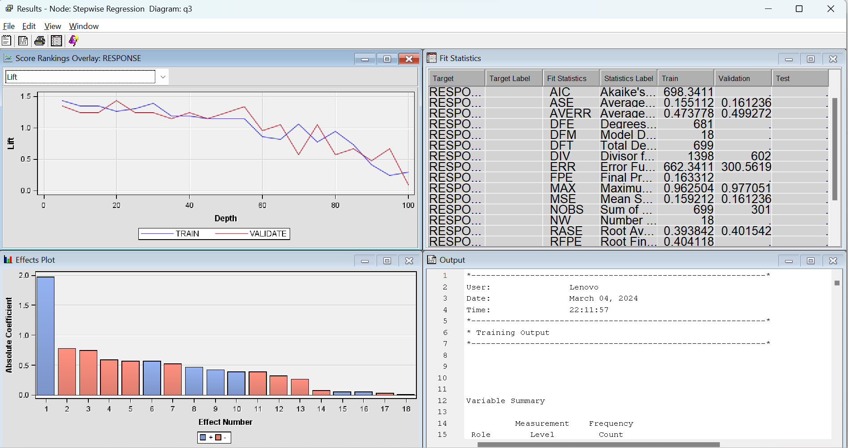

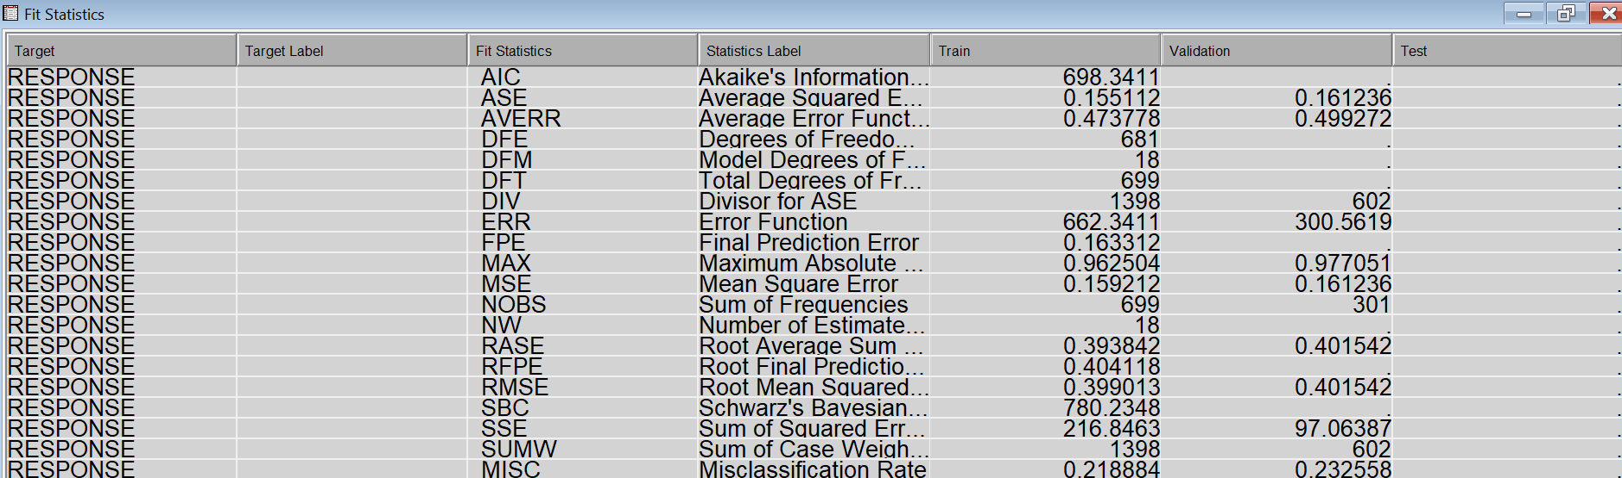

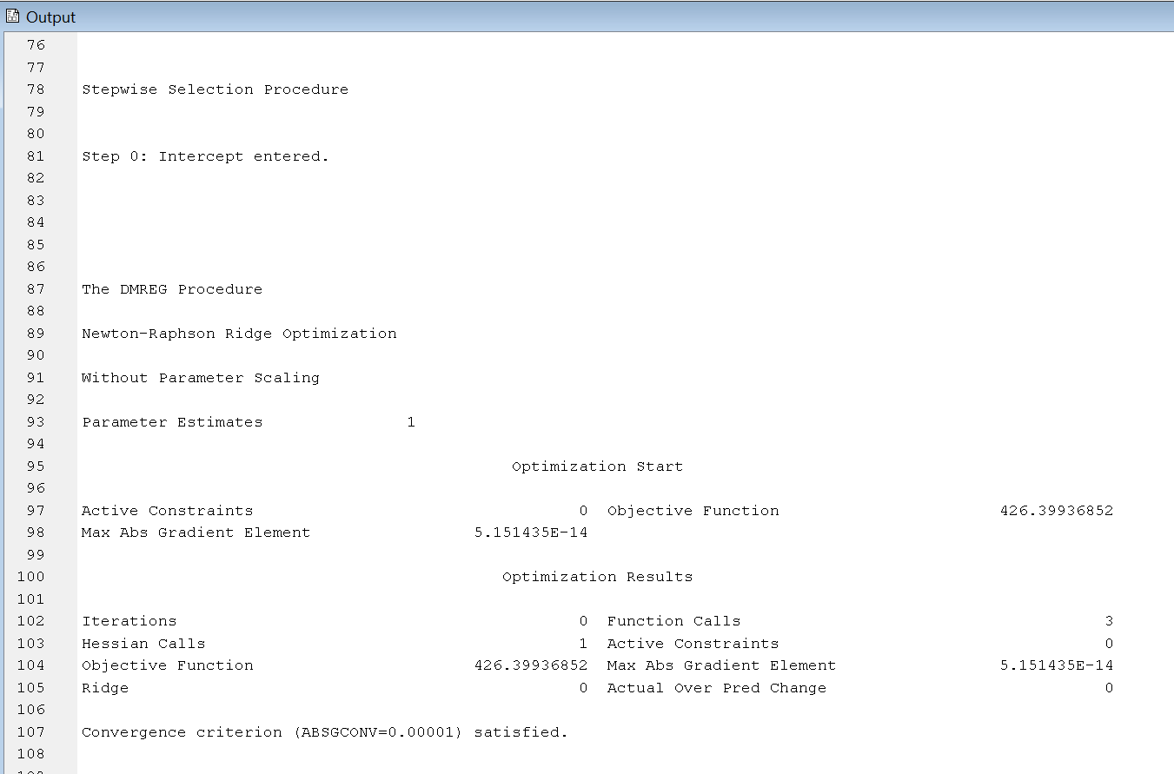

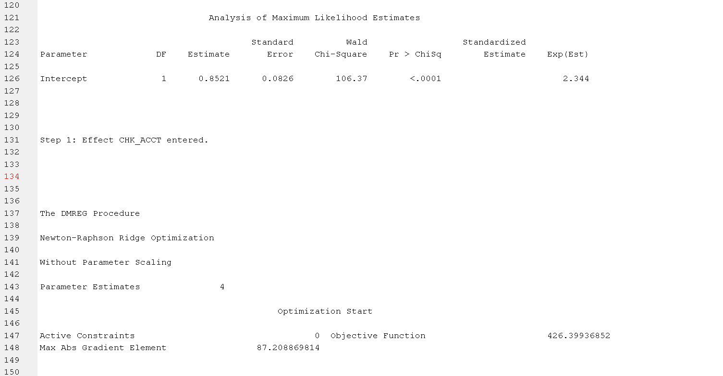

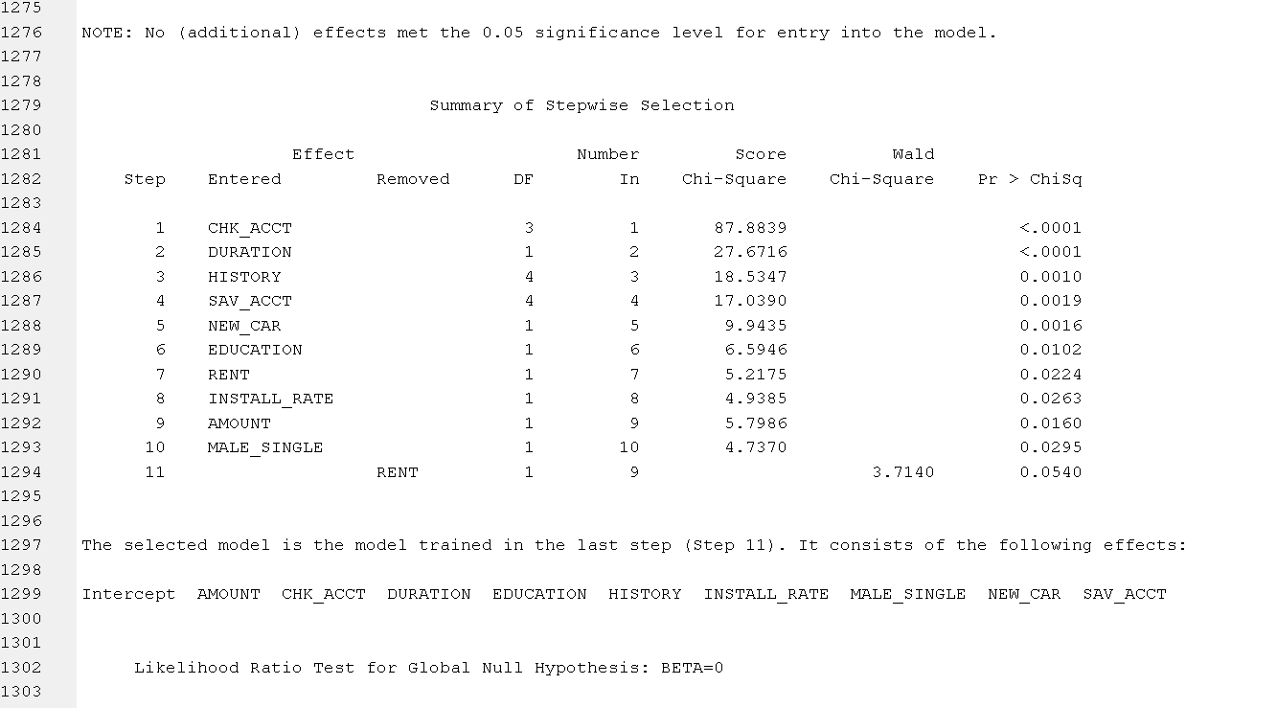

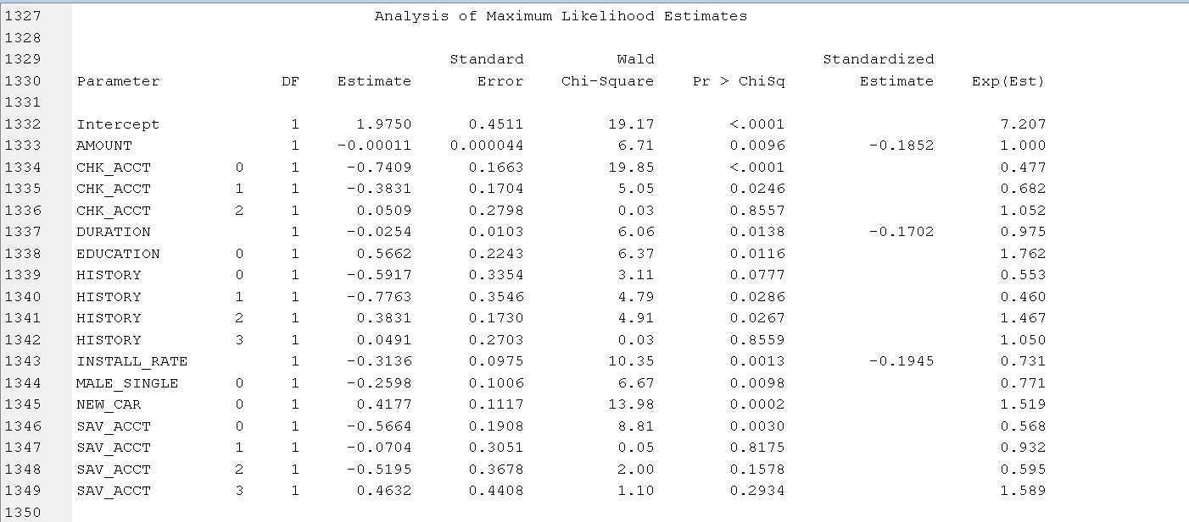

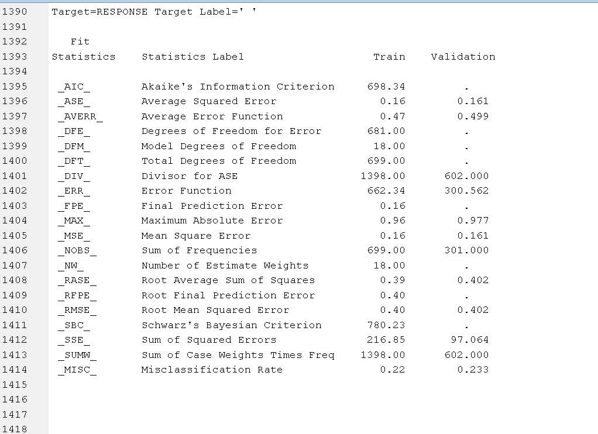

Best model may be based on least RMSE(root mean squared error) or MISC(misclassification rate). Here, for validation :

|  |  |  |
| --- | --- | --- |
| **Model name** | **RMSE** | **MISC** |
| Full | 0.3983 | 0.2359 |
| Forward variable selection | 0.3998 | 0.2292 |
| Stepwise | 0.4015 | 0.2325 |

Other general method used is We add model comparison node with all three models as input node. We select Selection statistic as misclassification rate since it is logistic regression, then selection table as validation and run.

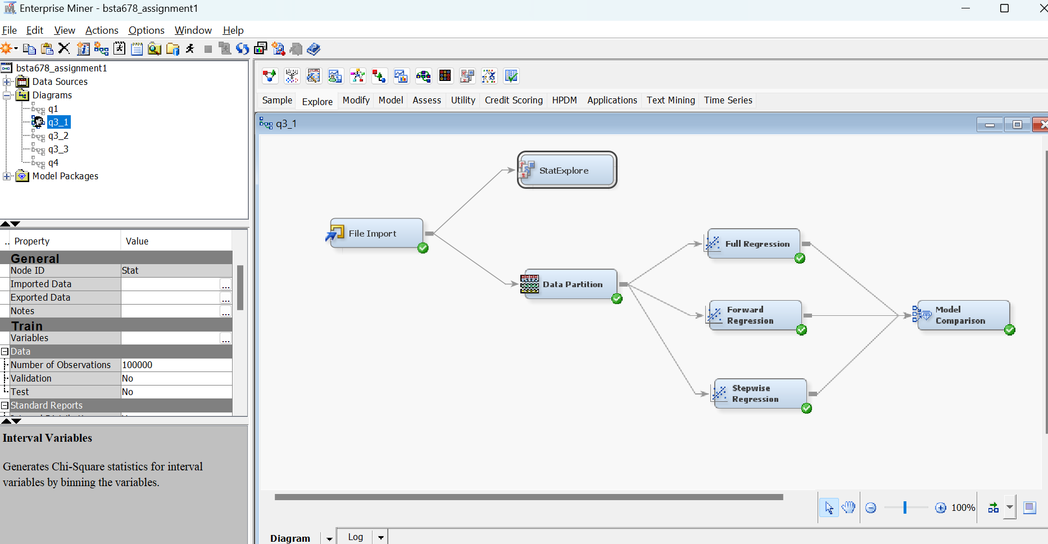

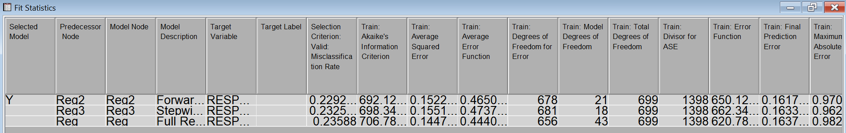

Based on this best model which seems fit is forward model (Reg2). Since it shows least misclassification rate for valid dat

* 1. Is your model overfitting? Explain what overfitting is and why it is important in model selection.

We find following stats model comparison output:

Statistics **Reg2** Reg3 Reg

Train: Misclassification Rate **0.22** 0.22 0.21

Valid: Misclassification Rate **0.229** 0.233 0.236

We can see that misclassification rate for both train and validation sets are almost same, for all three models of regression so we can conclude there is no issue of model overfitting.

Overfitting a model is a condition where a statistical model begins to describe the random error in the data rather than the relationships between variables. This problem occurs when the model is too complex. In regression analysis, overfitting can produce misleading R-squared values, regression coefficients, and p-values. If you fit a logistic regression model with 100 parameters (one for each example plus one for each feature), you may be overfitting to the training data. This is because the model has more parameters than examples, which can lead to a model that fits the training data too closely and is not generalizable to new data.

* 1. Define a model lift? Interpret it. Explain the lift curve you obtained with SAS EM. Using data from SAS EM, construct SAS EM lift curve in Excel.

In data mining and association rule learning, lift is a measure of the performance of a targeting model (association rule) at predicting or classifying cases as having an enhanced response (with respect to the population as a whole), measured against a random choice targeting model. A targeting model is doing a good job if the response within the target (T) is much better than the baseline (B) average for the population. Lift is simply the ratio of these values: target response divided by average response. Mathematically,

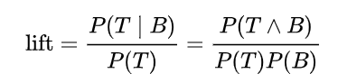

For example, suppose a population has an average response rate of 5%, but a certain model (or rule) has identified a segment with a response rate of 20%. Then that segment would have a lift of 4.0 (20%/5%)

the following lift curve(s) are output from SAS.

For our best model Reg2 or Forward Selection -

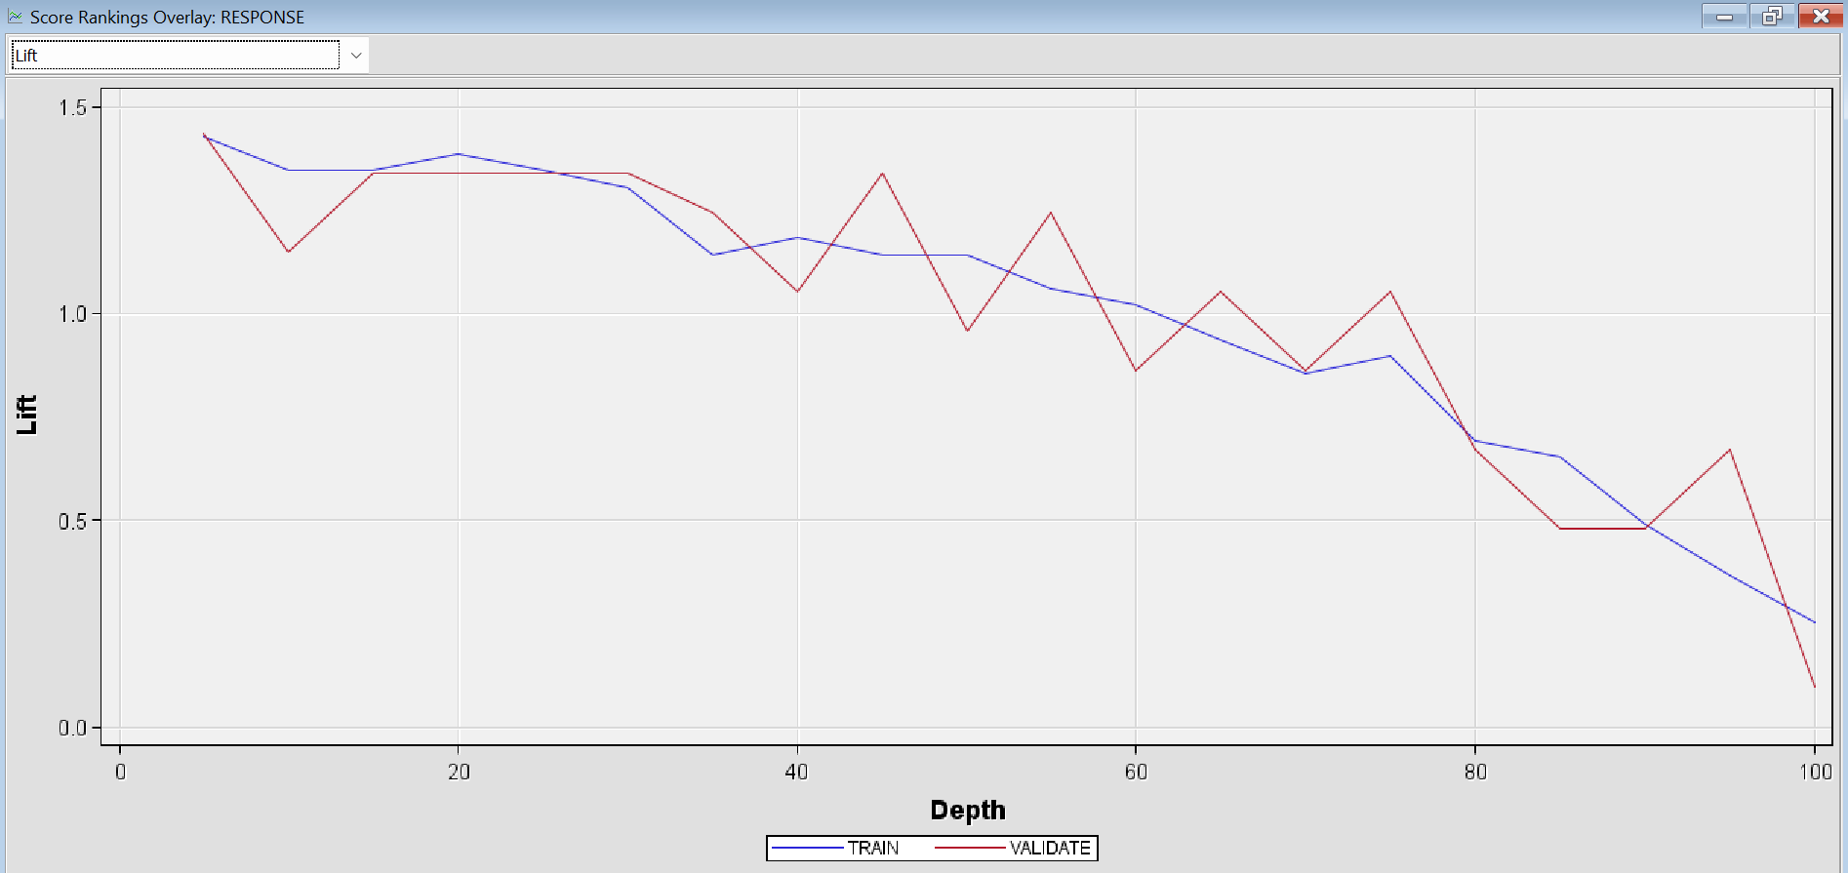

This lift explains us that around 1.5 times of classified data which is our event, is present in first 20% to 40% of processed data table. Then next 20% has equal numbers of event as can be expected in the whole population which reduces as we go to the bottom of the data table created by SAS.

For all 3 models-

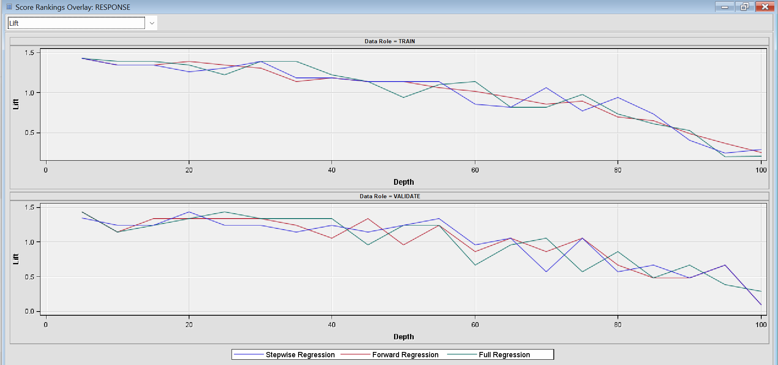

Cumulative lift:

Best Model Reg2 or Forward selection

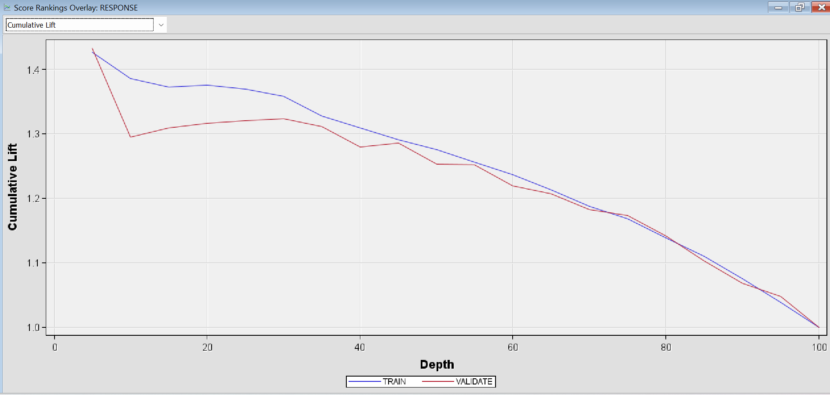

For all 3 models-

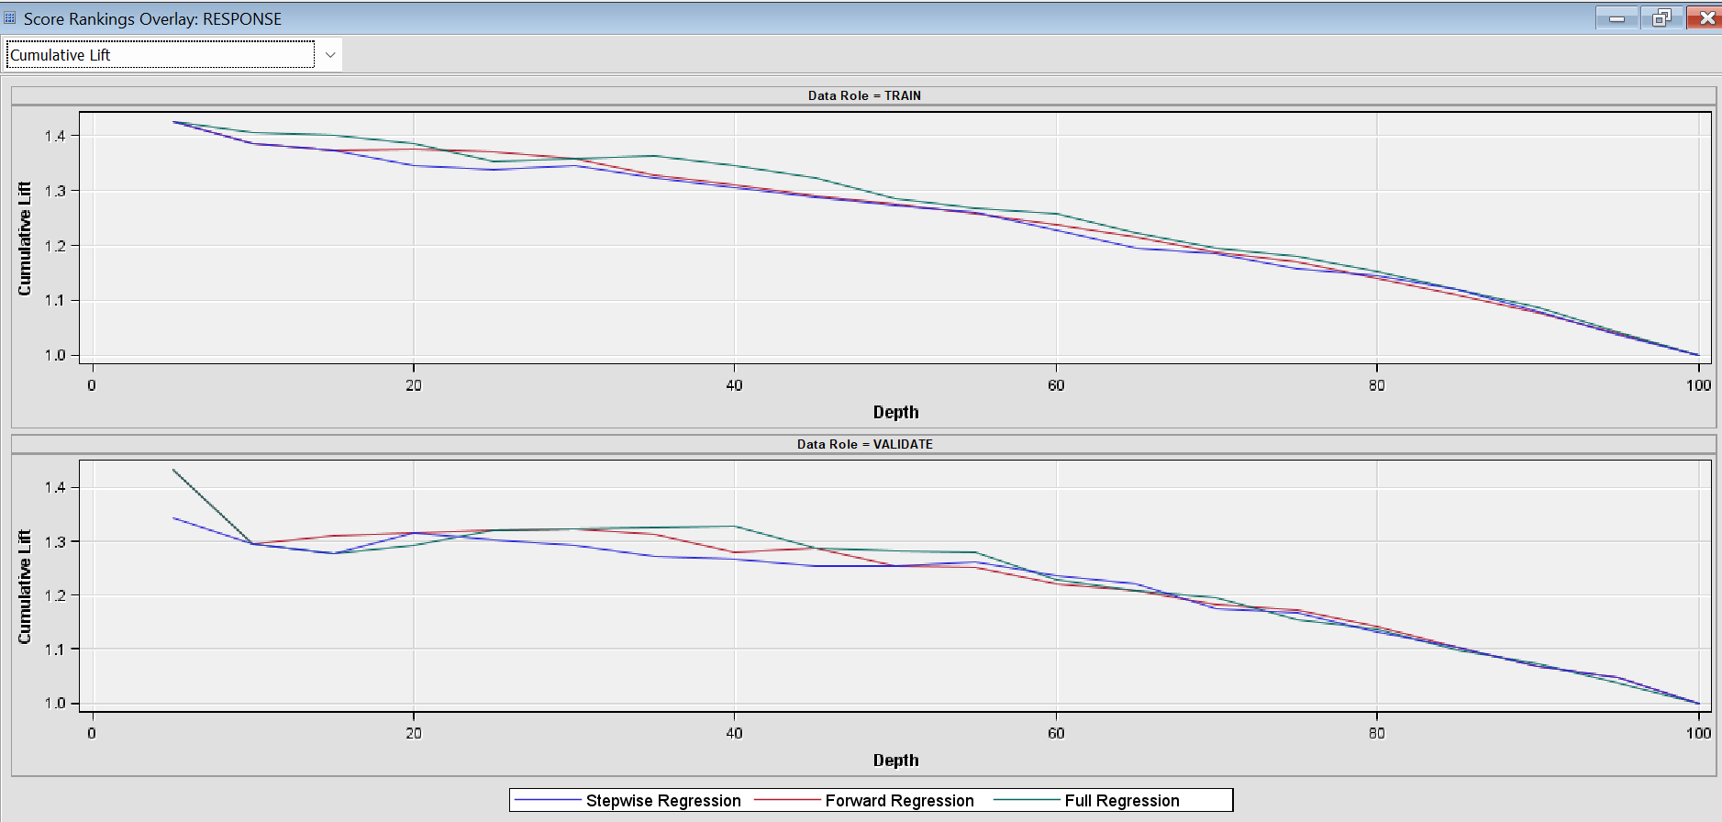

Excel plot (Exported validation data points and use formulas as per attached sheet):

* 1. What is the model ROC? Interpret it for the selected model. Using data from SAS EM construct SAS EM ROC curve in Excel.

An ROC curve (receiver operating characteristic curve) is a graph showing the performance of a classification model at all classification thresholds. This curve plots two parameters:

* Sensitivity
* 1-Specificity

Sensitivity is a synonym for recall and is therefore defined as follows:

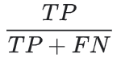

1-Specificity is defined as follows:

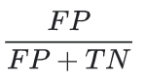

An ROC curve plots Sensitivity vs. 1-Specificity at different classification thresholds. Lowering the classification threshold classifies more items as positive, thus increasing both False Positives and True Positives.

ROC chart from SAS model comparison output:

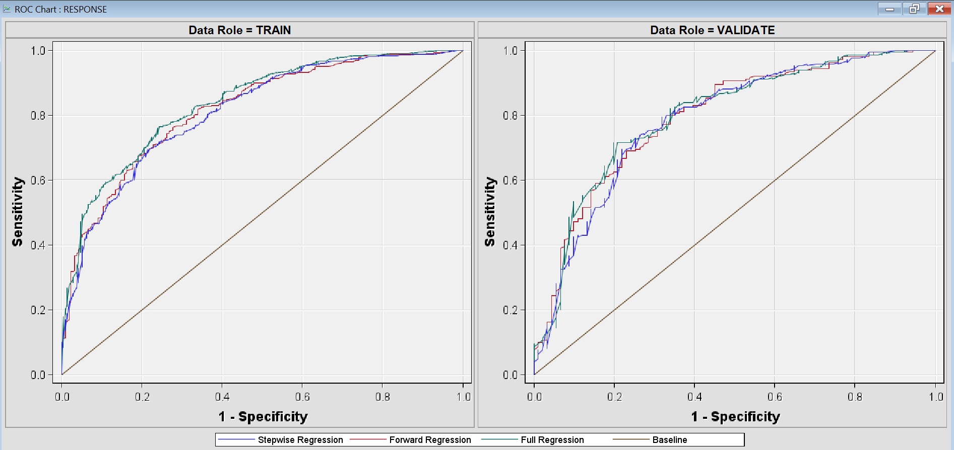

All curves are vey close to each other and fairly even curve with 50% area under curve as it seems.

Excel plot (Exported validation data points and use formulas as per attached sheet):

1. Use SAS EM to build the decision tree model to predict a good Credit Rating.
   1. Vary depth (6 and 10) and number of branches (2 and 4) in the examined models. Compare these four models. Select the best model. Explain your choice.

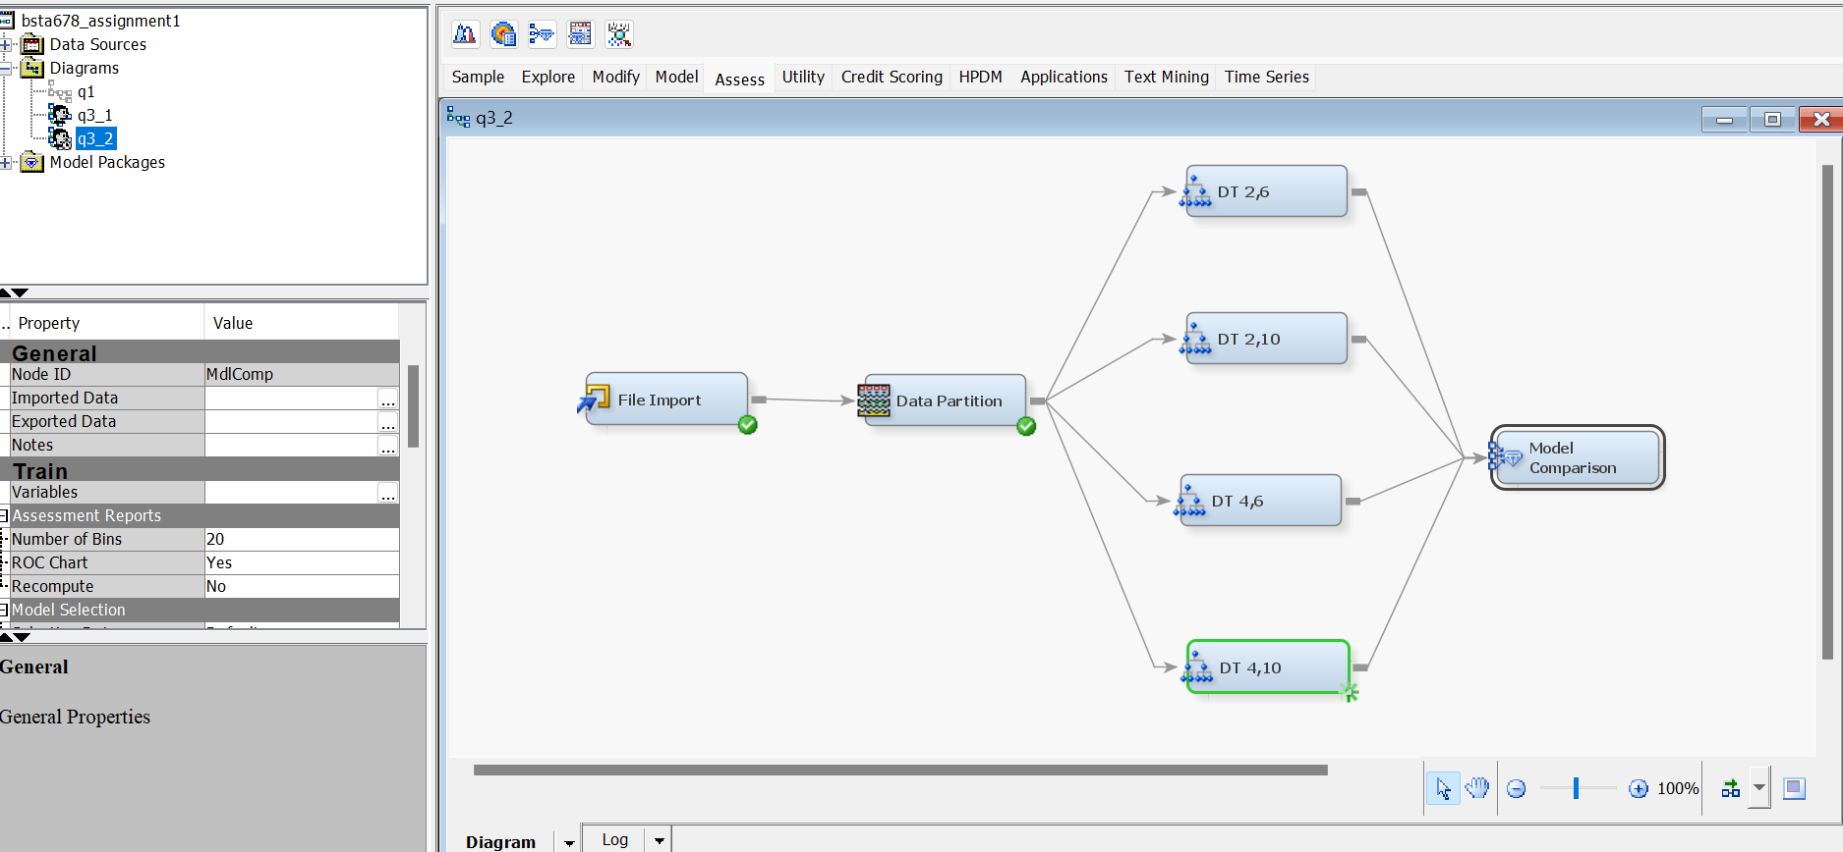

(example setting for max branch 2, and maximum depth 10 node: DT 2,10 in the q3_2 diagram)

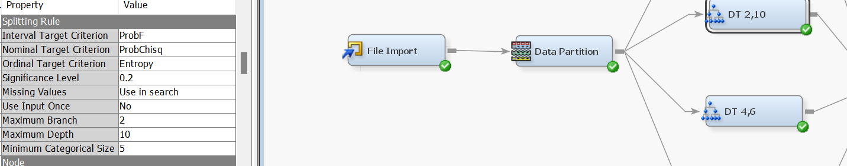

Example setting for model comparison – either misclassification rate or average square errors in selection statistic)

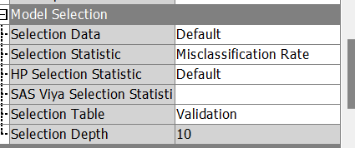

Output:

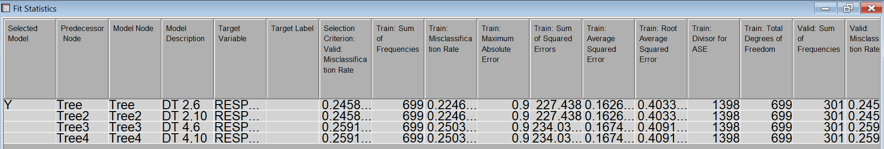

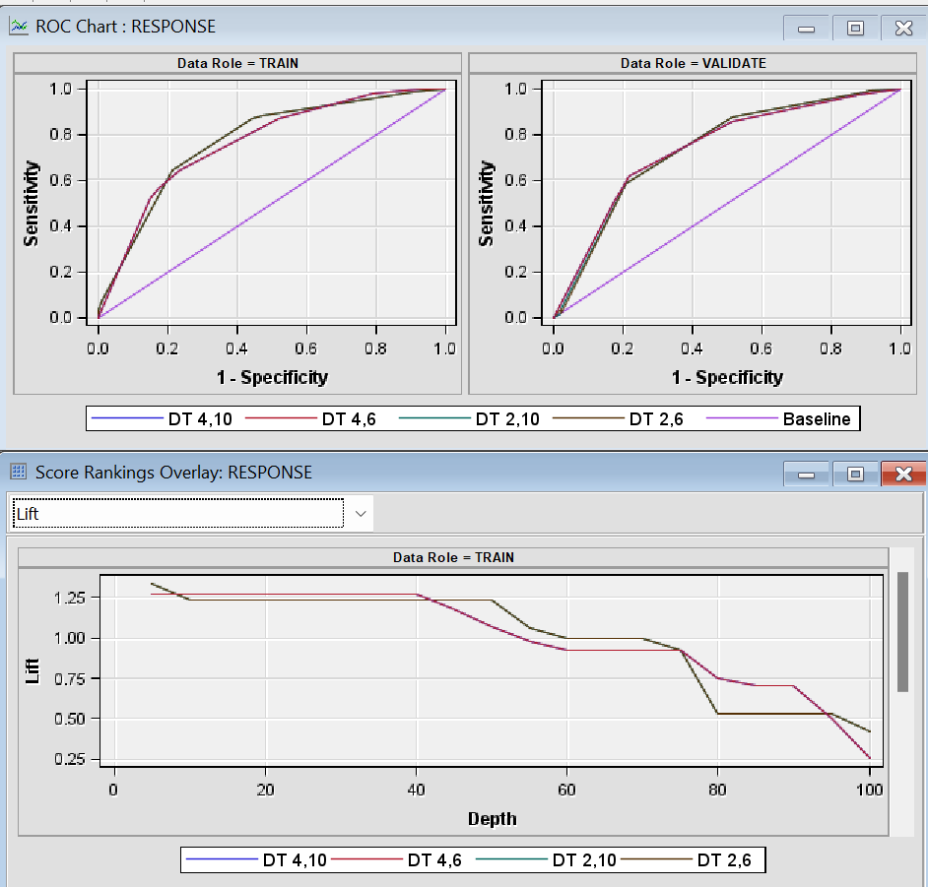

Best model comparison shows tree with branch 2 and depth 6,10 both have lowest misclassification rates and average squared errors. DT 2,6 and DT 2,10 both yield same results and hence anyone may be taken as best model for simplicity we consider DT 2,6 which has lesser given height than the DT 2,10 model setting.

* 1. Is your selected model overfitting? Explain.

One way to check is open results of selected best model and see the difference between training set error rates / misclassification rates vs validation set values for same.

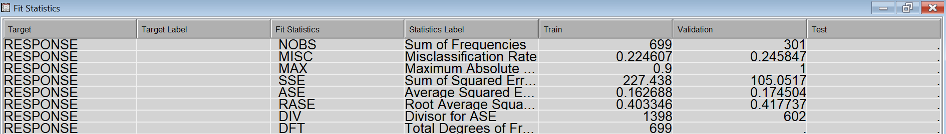

So the selected model may be regarded as being overfit (since these values are actually not so close enough)

ASE jumps from 0.16 in training set to 0.17 in validation set while misc rate jumps from 0.22 to 0.24 , if there were a very minutely small difference in 4th or later decimal places we may disregard it as overfitting completely with full confidence, but here there are some traces of model being overfitted.

1. Use SAS EM to build an Ensemble model based on your best logistic regression and decision tree models. Which model of the three models would you select and why?

We drag and drop the nodes for best models from each section 1,2 and join it as input for ensemble node.

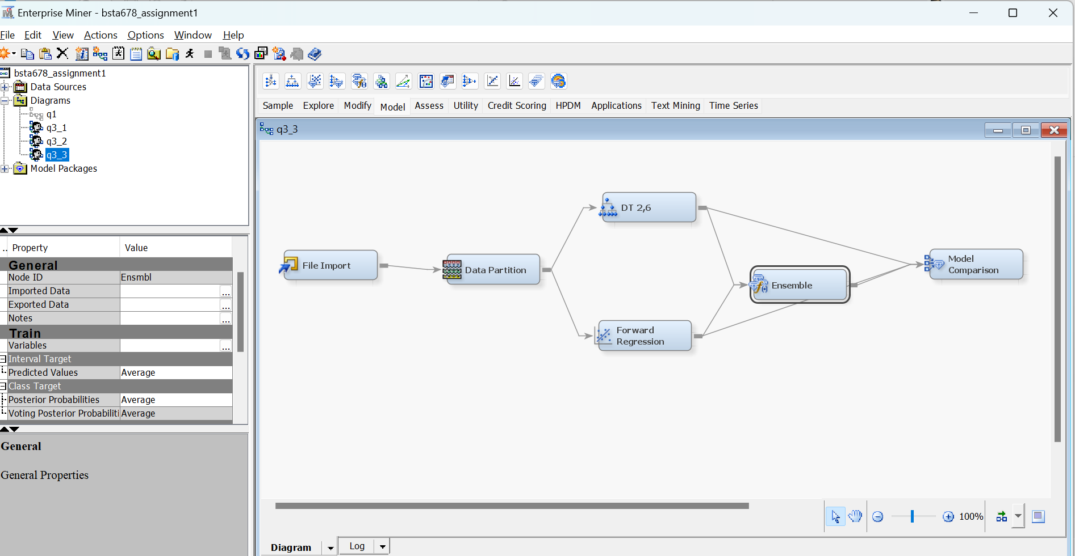

Output of model comparison (based in MISC on validation set) on all three models thus is:

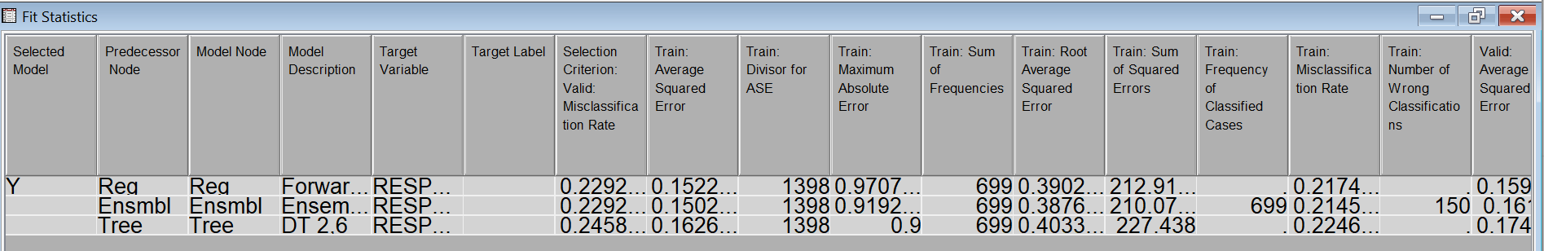

Again, there is a no clear winner, although based on main criteria (for this binary output data type) which is misclassification rate we have a tie between best of logistic regression model (which is forward selection) and ensemble model created as a combination of best Reg and DT models.

If I need to choose one, I will not go ahead with Forward Modelling Regression Rather Ensemble one since it also has a lower Average squared error, and other error values are lower. It is also pertinent to see whether the chosen model is overfit or not compared to the one we leave behind.

Ensemble:

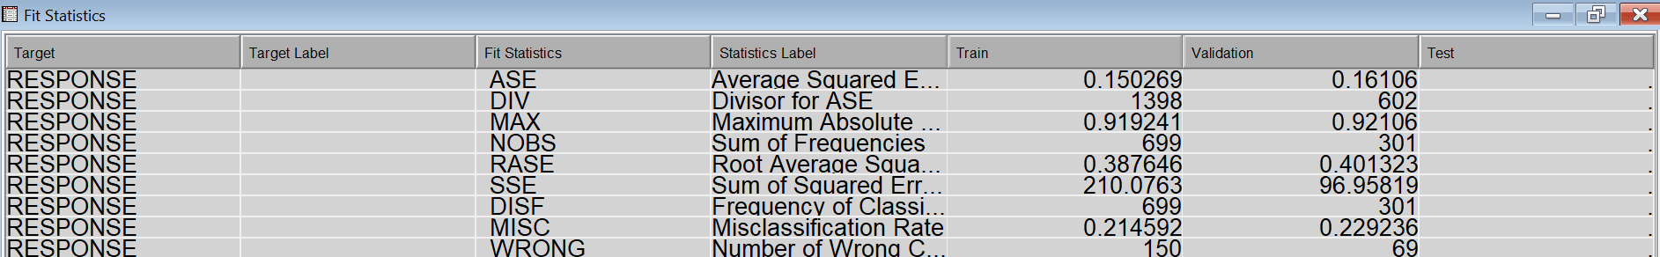

Forward Logistic Reg:

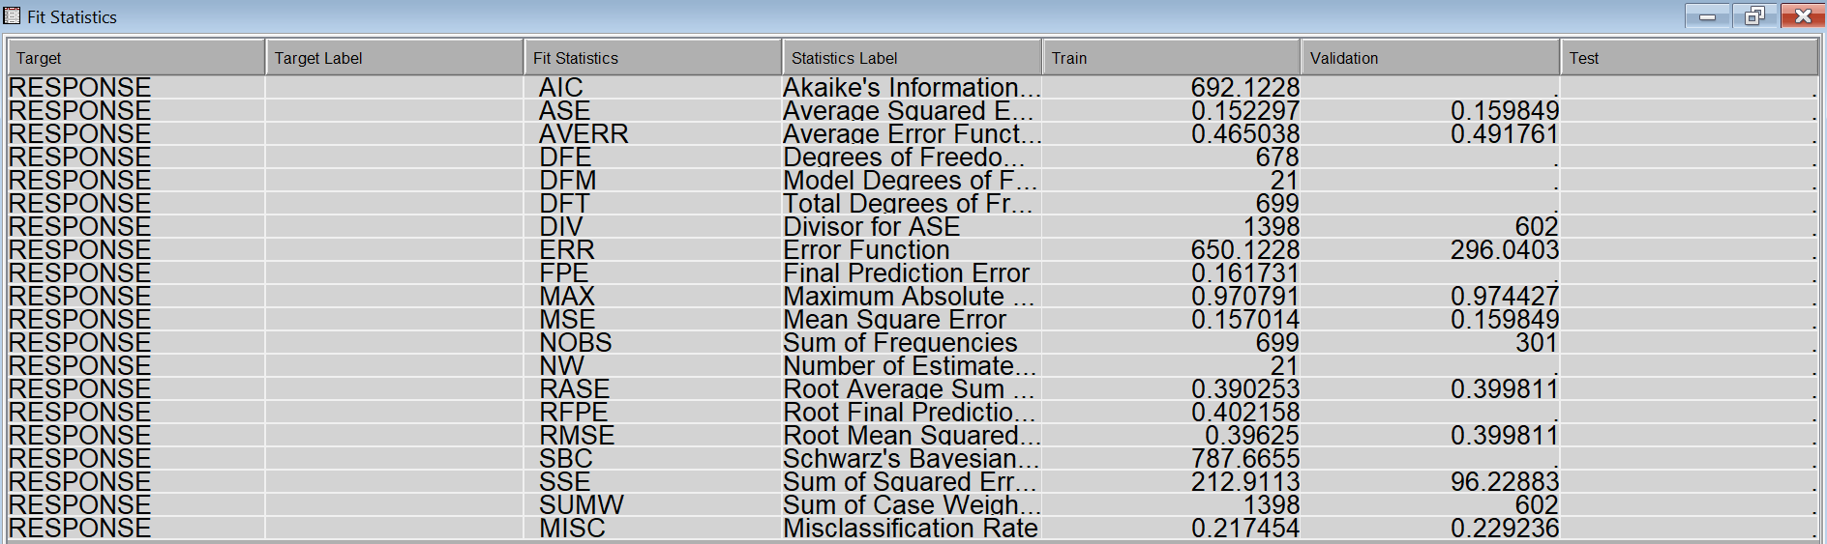

Here the individual fit statistics shows that ensemble model clearly differs in validation set compared to training set misclassification, and other error rates much more than the regression model so chosen.

Hence we may reject ensemble model only on overfitting grounds and that better predictor overall winner is the best of logistic regression model (i.e. forward selection)

* 1. How does Ensemble model work?

Ensemble learning is a combination of several machine learning models in one problem. Ensemble methods are techniques that create multiple models and then combine them to produce improved results. Ensemble methods in machine learning usually produce more accurate solutions than a single model would. These models are known as weak learners. The intuition is that when you combine several weak learners, they can become strong learners. Each weak learner is fitted on the training set and provides predictions obtained.

* 1. What is your Ensemble model lift in the first decile? Interpret it.

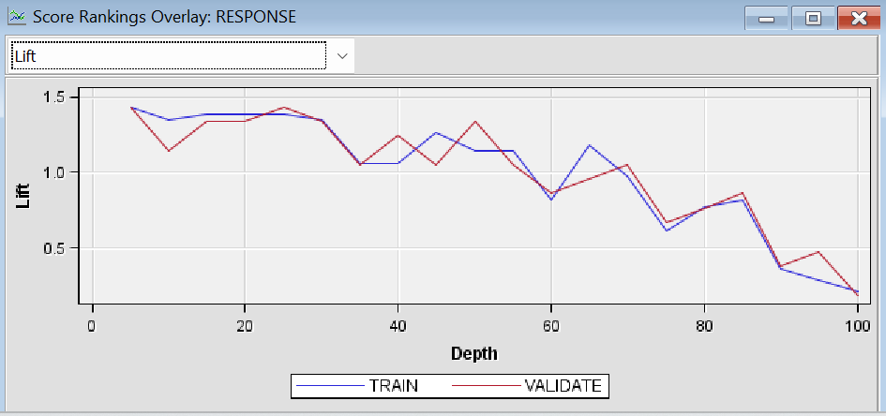

It is 1.337778 (Validate) which means at top20% of data there is a chance of 1.34 times the probability of an event than in the whole validation set

1. Define each model performance measure and calculate it in Excel for the top 30% of your best model.

To clarify we click on three dots on the exported data for Forward Selection Logistic Regression (q3_1 - Forward selection Regression) node and on the validation set click browse export to excel. From this excel sheet we work on top 30% or 30/100 * 300 rows starting from 2 (second row since 1st is a header row) So, data from A1 to AO91

1. Misclassification Rate – the percentage of classification that were incorrectly predicted.

0.2292

1. Sensitivity – the ability to correct predict actual positives; calculated as the number of true positives correctly predicted from all actual positives.

0.9190

1. Specificity - the ability to correctly predict actual negatives; calculated as the number of true negatives correctly predicted from all actual negatives.

0.4286

1. TPR – is the percent of actual positives predicted to be positive; calculated as correctly predicted positives over total actual positives.

0.7878

1. TNR - is the percent of actual negatives predicted to be negative; calculated as correctly predicted negatives over total actual negatives.

0.4286

1. FPR - is the percent of actual negatives predicted to be positive; calculated as incorrectly predicted positives over total actual negatives.

0.5714

1. FNR - is the percent of actual positives predicted to be negative; calculated as incorrectly predicted negatives over total actual positives.

0.0810

1. ROC coordinates - illustrates the trade-off between captured response fraction (sensitivity) and the false positive fraction (1-specificity). Each point on the ROC chart corresponds to a specific fraction of cases, ordered by their predicted value. The horizontal axis is 1 minus specificity, and the vertical axis is sensitivity.

Horizontal axis: 0.5714

Vertical axis: 0.9190

1. Actual Rate among Predicted – the proportion of observation predicated as positive that are positive, equivalently the precision.

0.7878

1. Lift - measures effectiveness of a model; evaluate the performance of classification model =precision/rate of positive event.

1.3137

1. Gain - this metric is reported in the Output window (under "Statistics Table") of the "Model Comparison" node, based on ((% of events in decile / random % of events in decile)-1).

32.3

Question 4

Use UniversalBank2.csv dataset to build a model that predicts taking a Personal Loan (=1). Import it into SAS EM.

Copy/paste your EM results into this Word document, as needed.

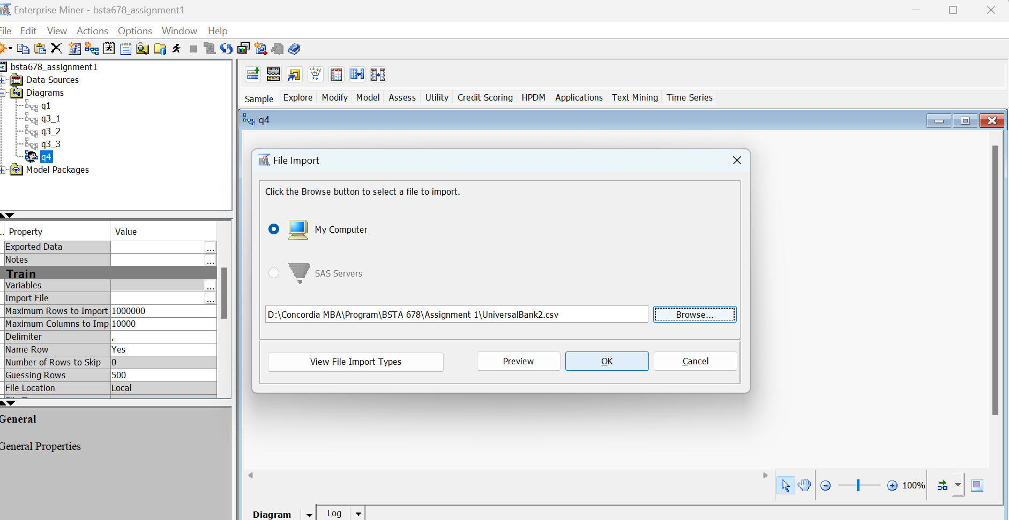

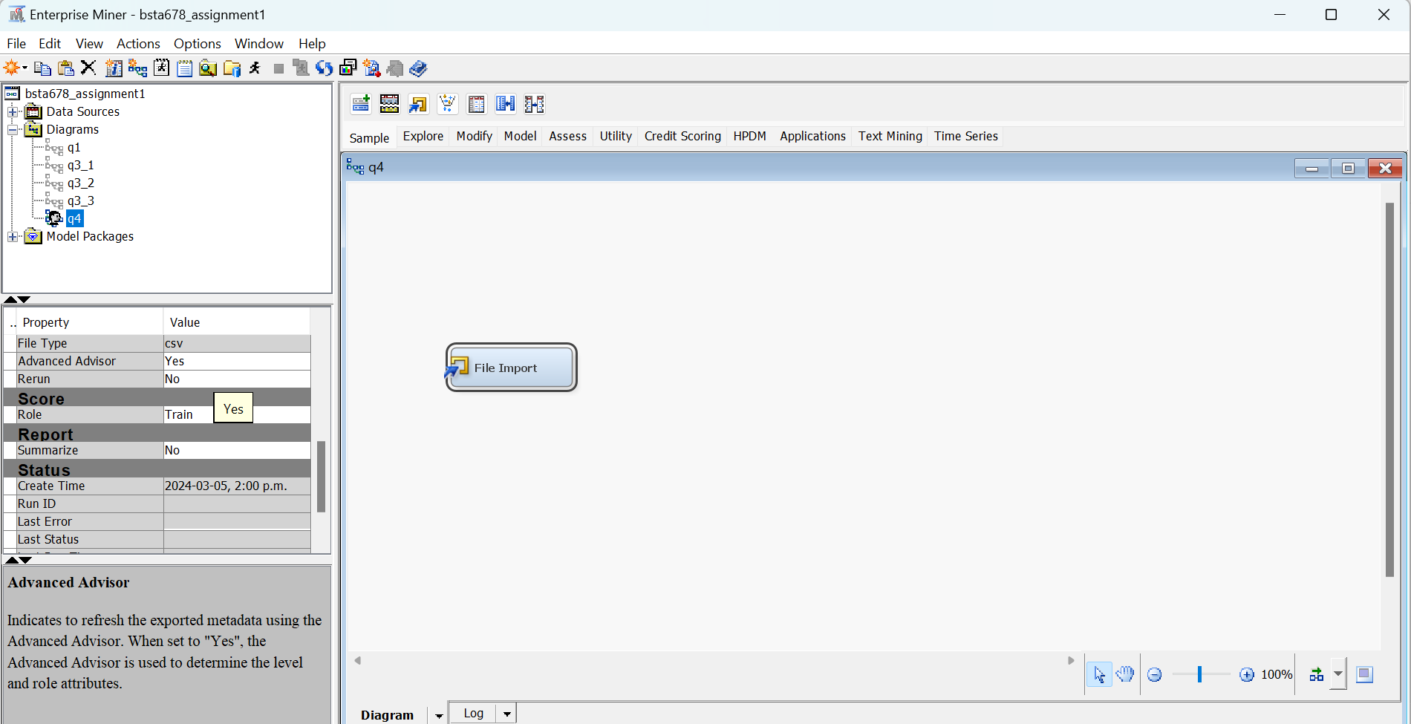

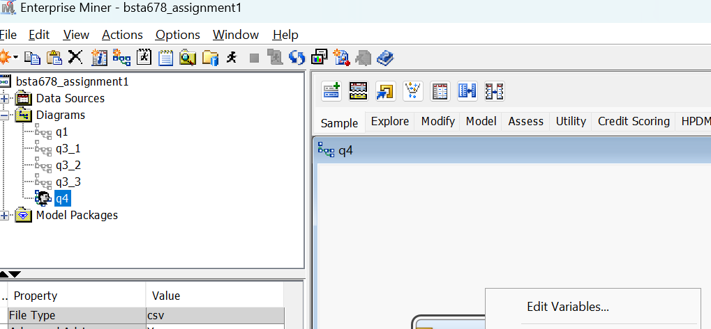

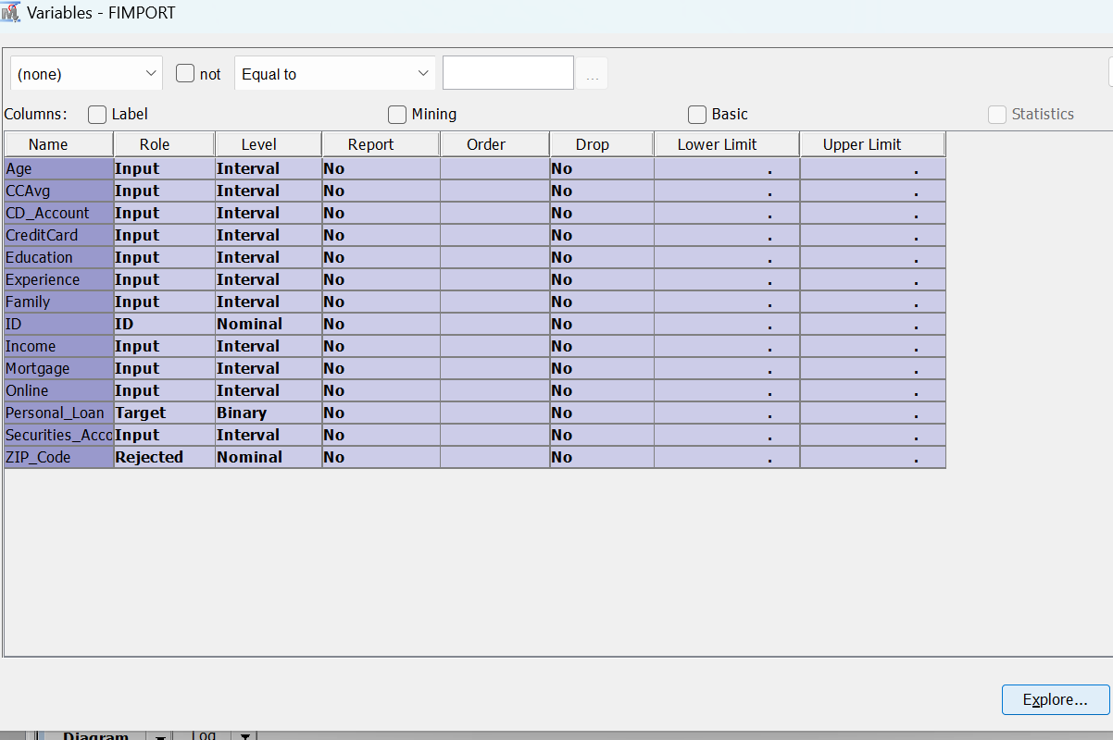

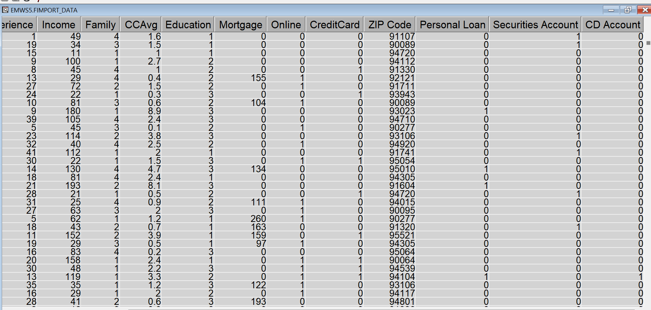

1. Adjust roles and levels of variables.

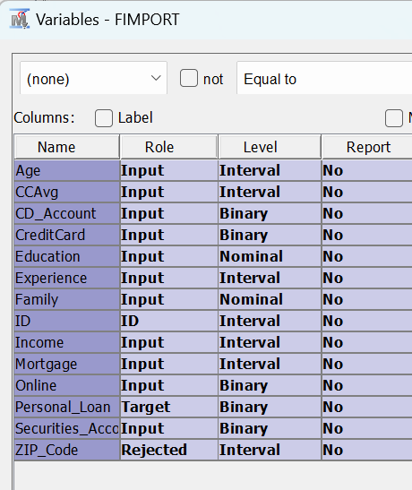

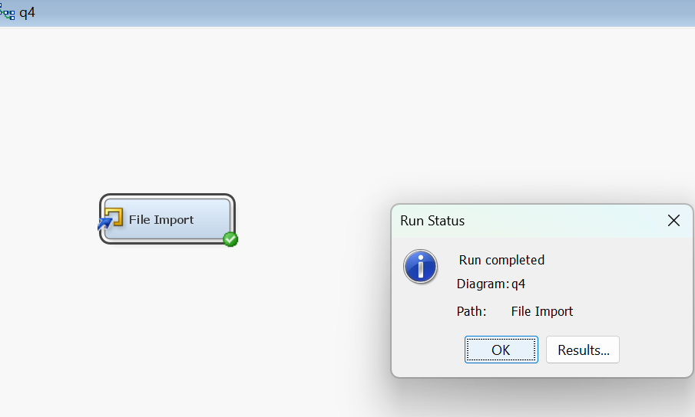

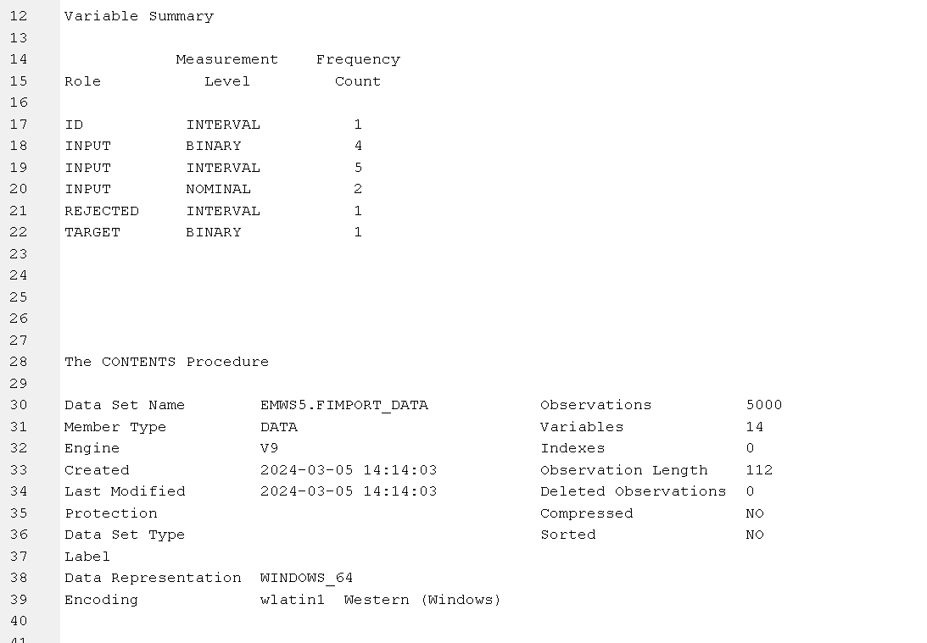

1. Pre-process the data and describe your findings.
   1. Partition data

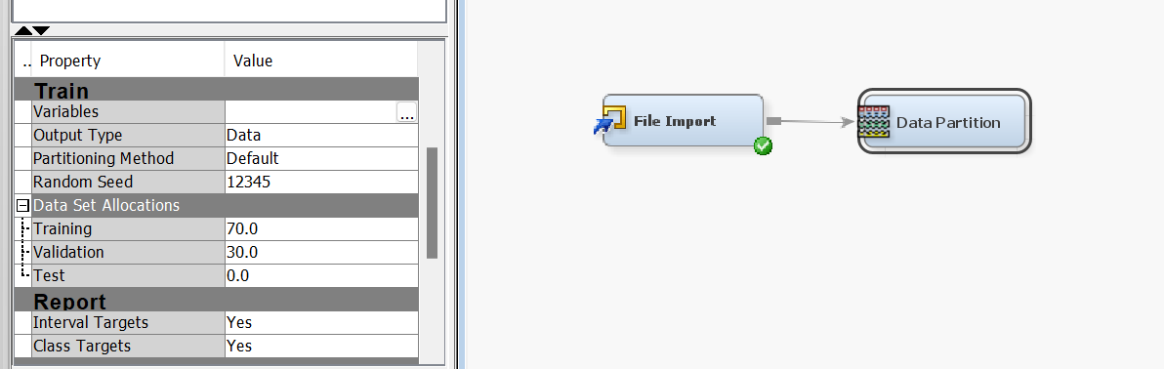

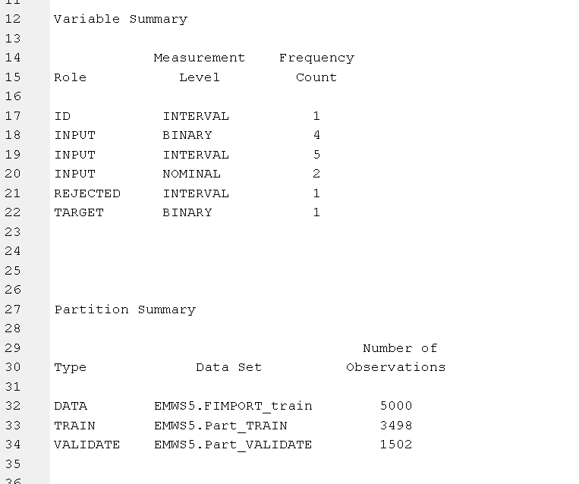

* 1. Explore Inputs and their relationship with the Target

We use StatExplore first:

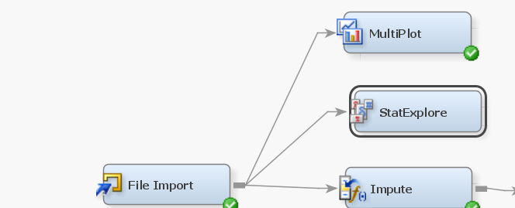

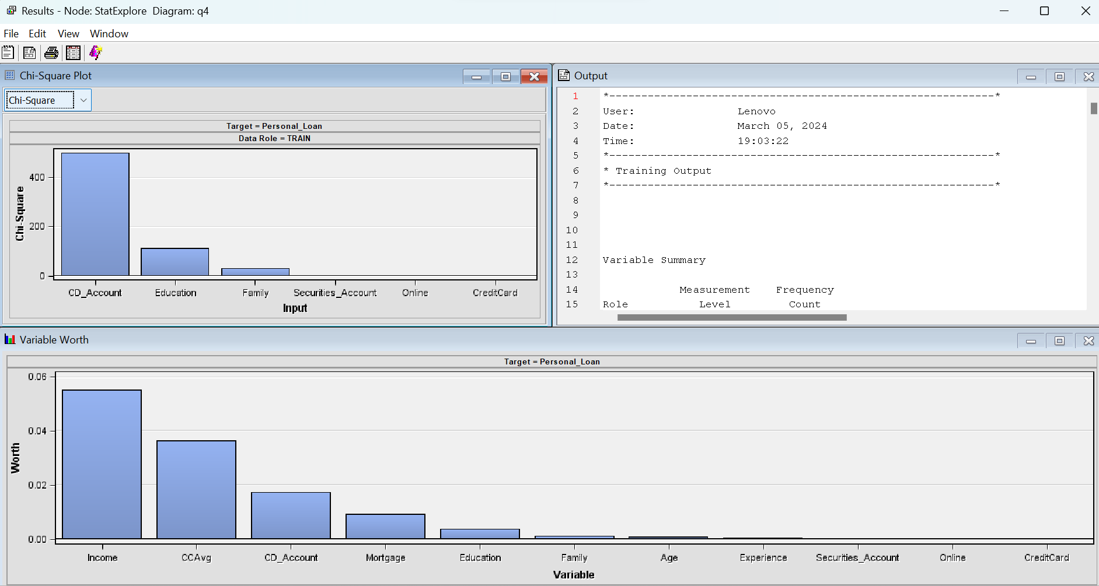

Income has maximum relationship with the Target variable. Followed by CCAvg, CD_Account, mortgage and so on

Further we back it up with multiplot:

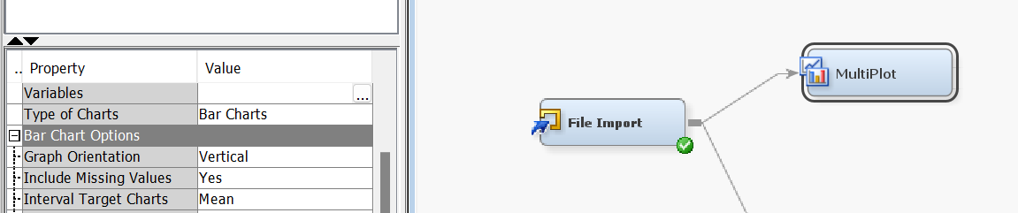

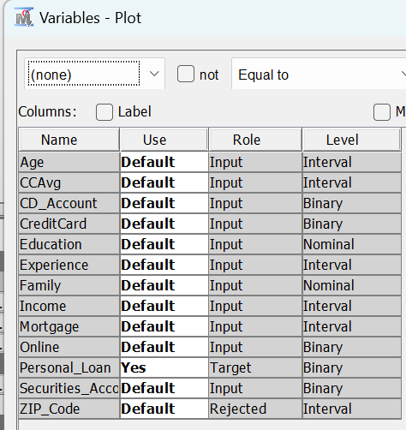

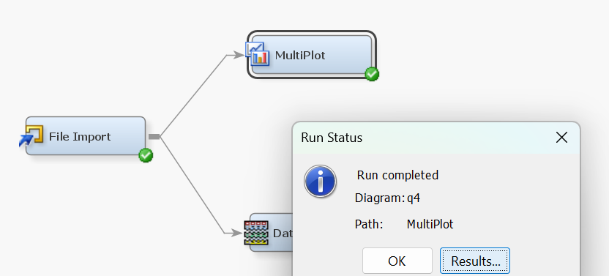

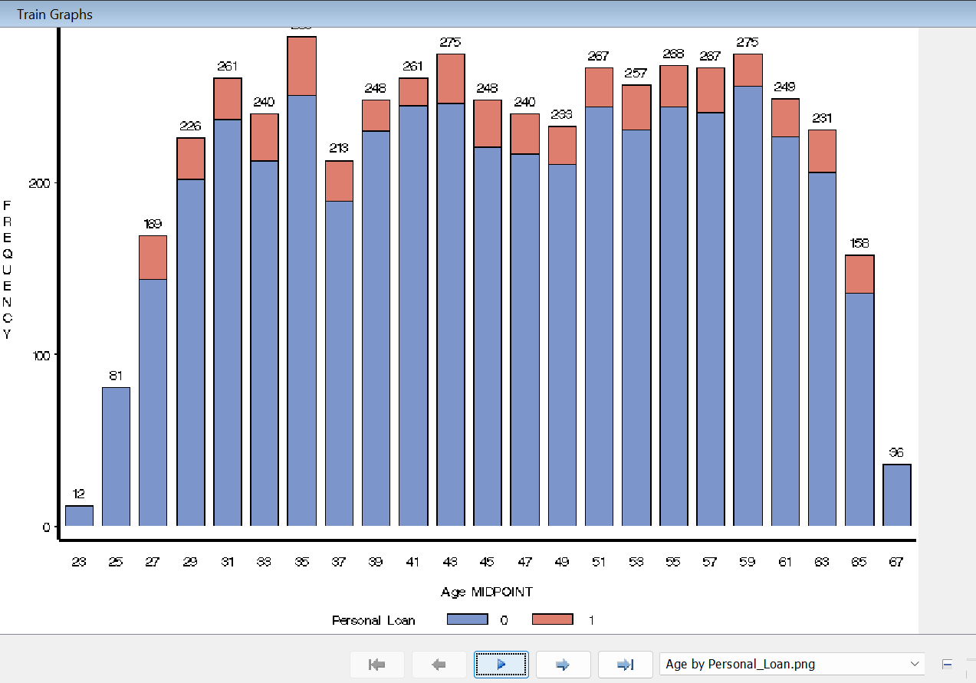

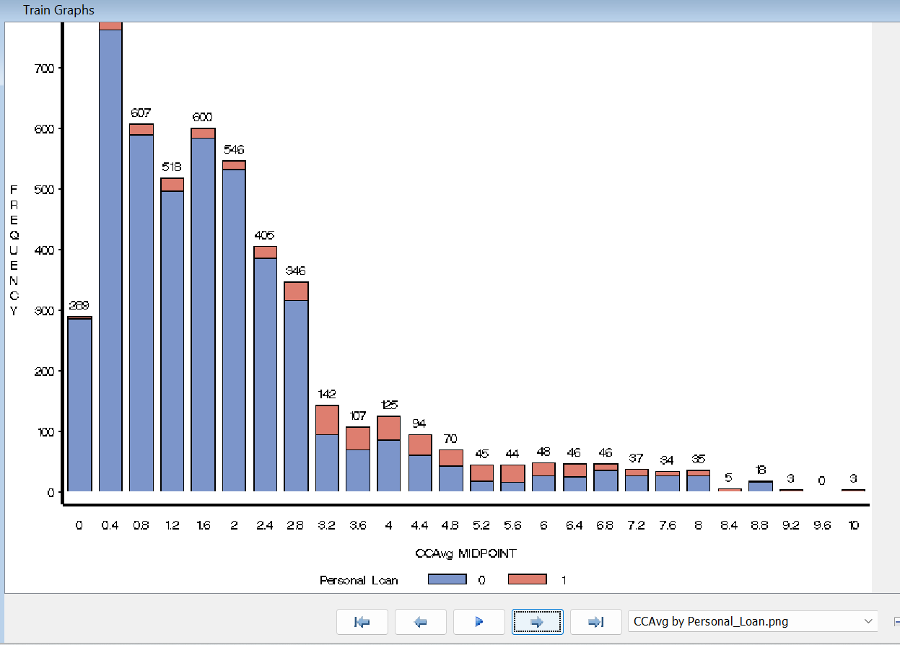

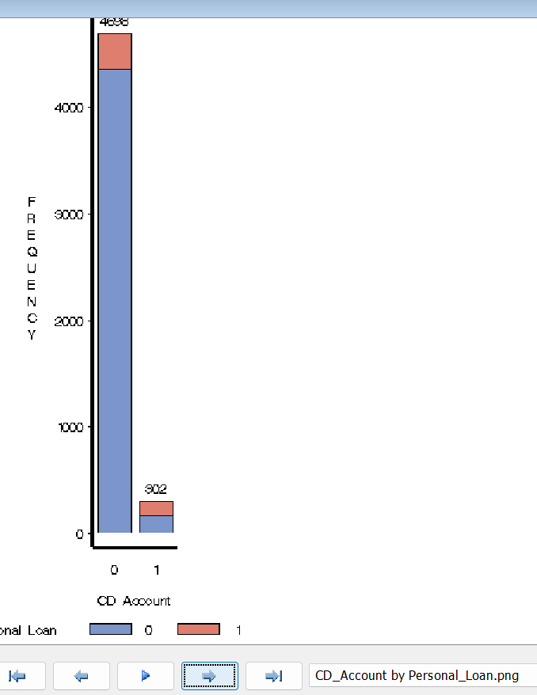

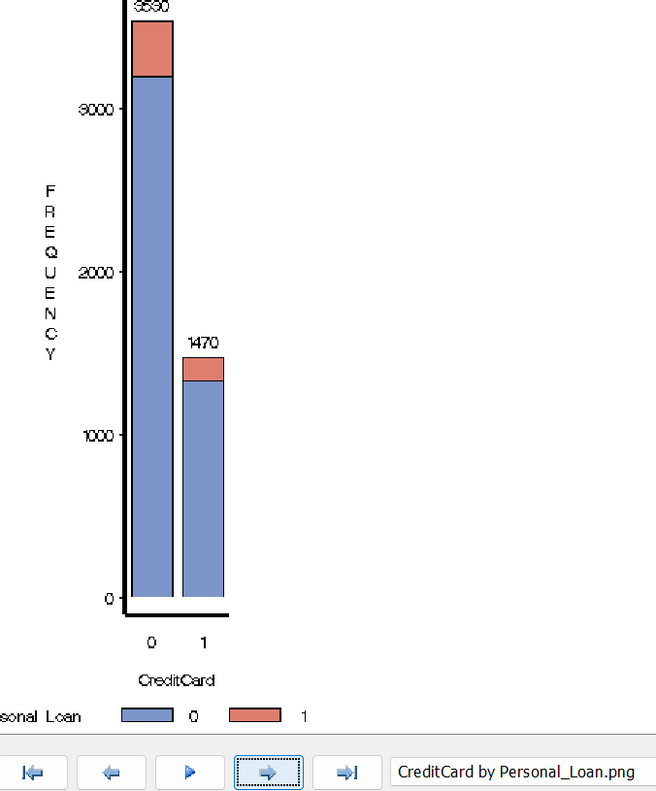

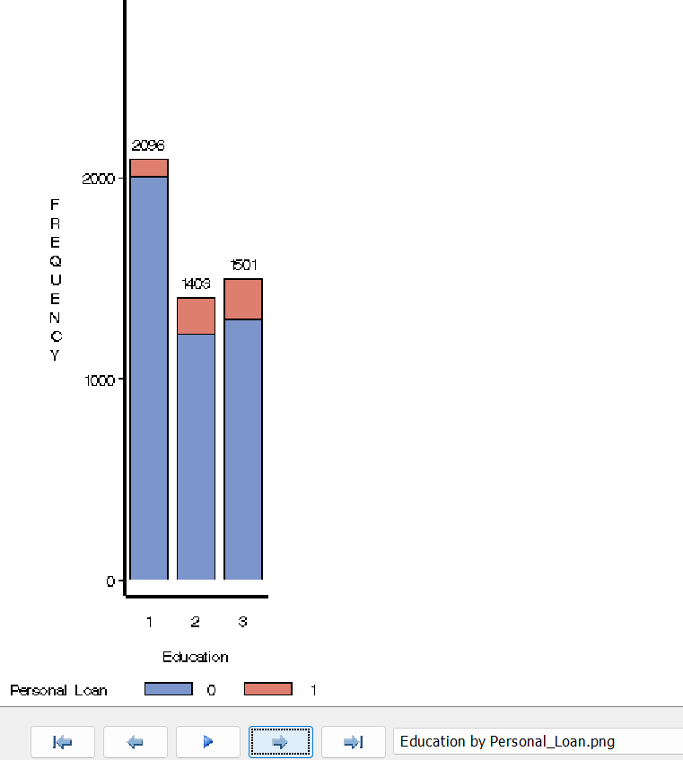

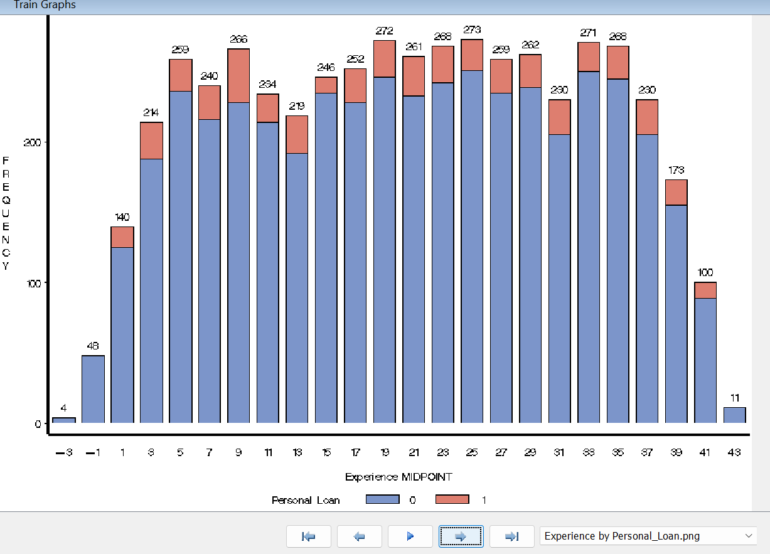

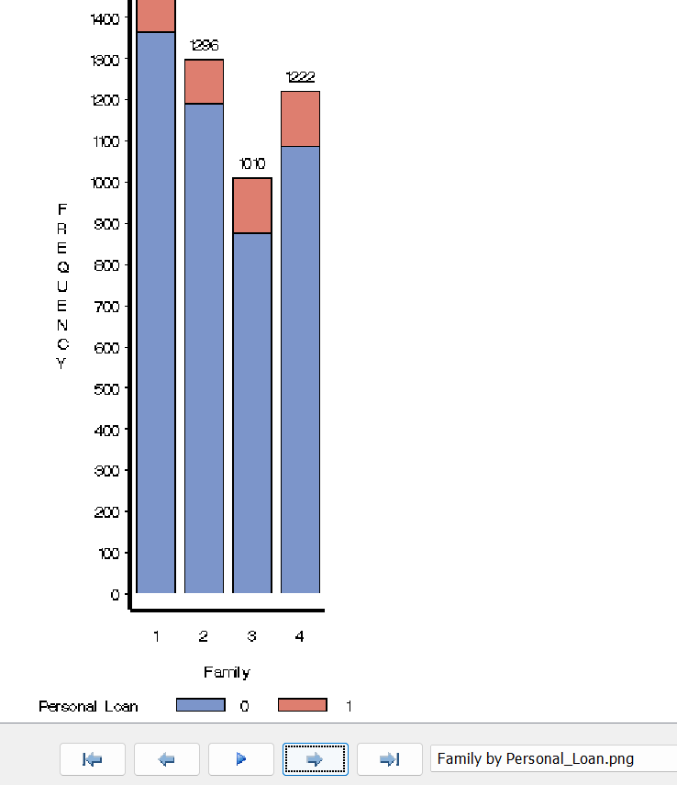

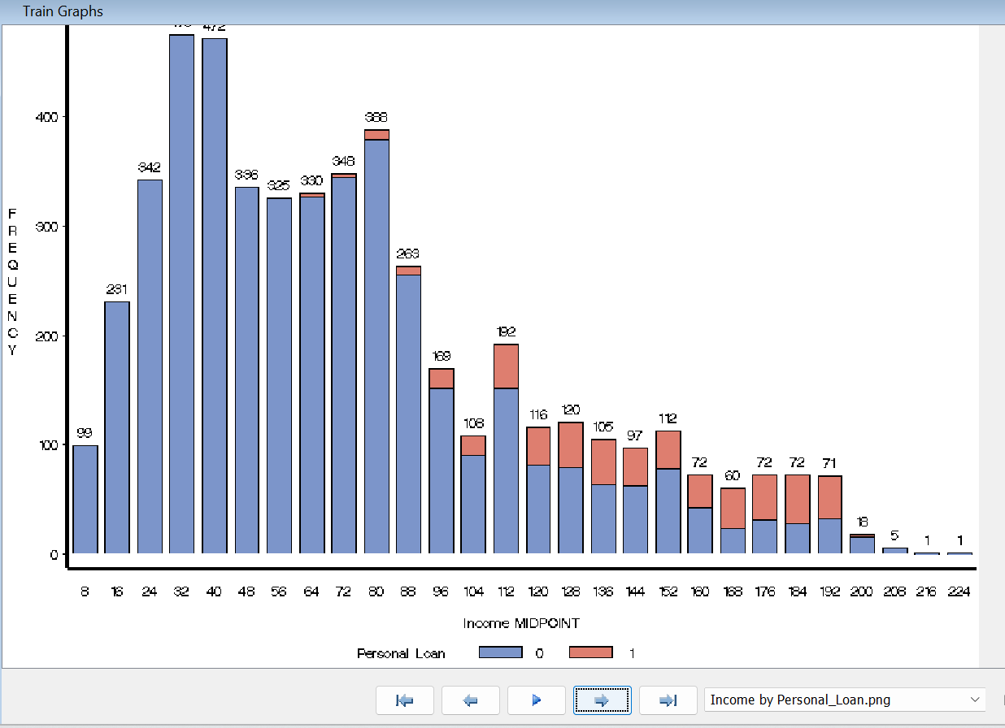

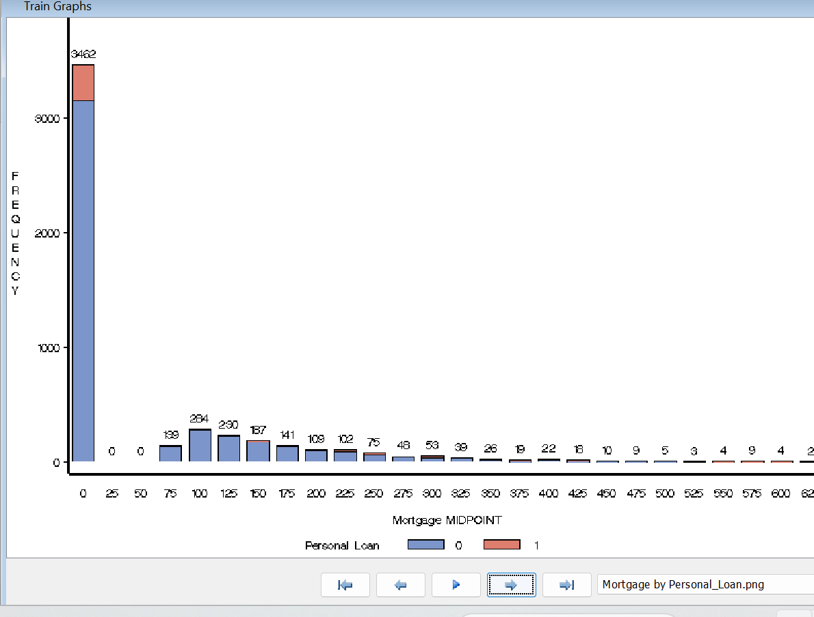

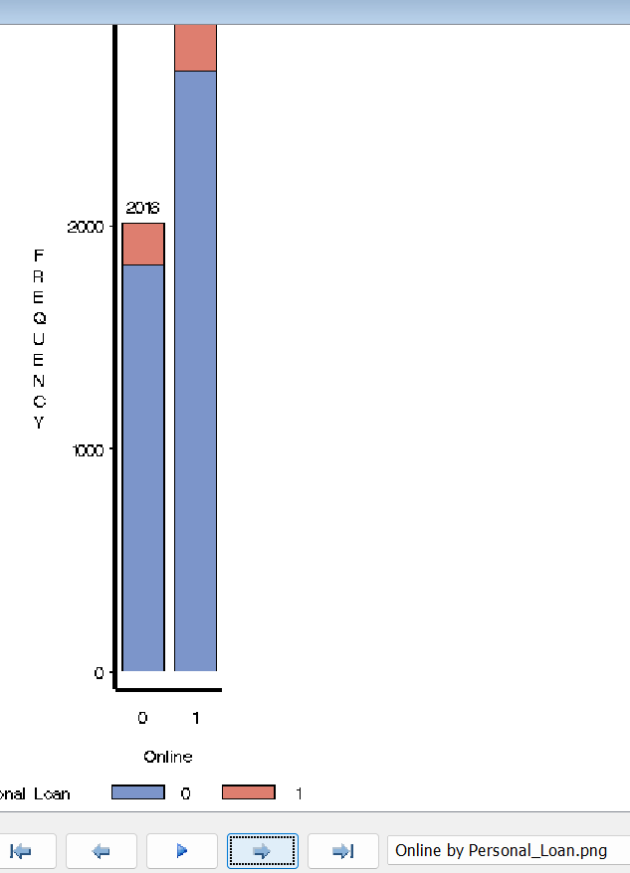

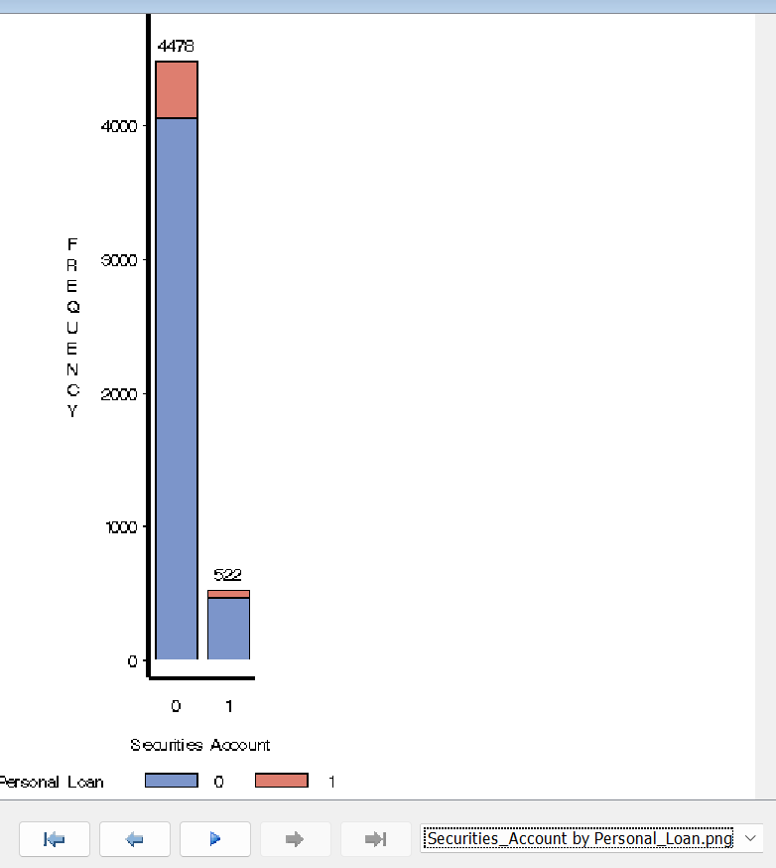

* 1. Impute missing values. Justify.

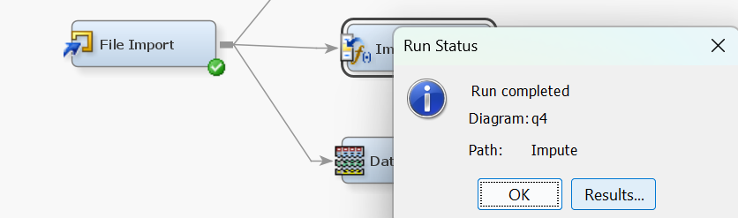

Imputation preserves all cases by replacing missing data with an estimated value based on other available information. Once all missing values have been imputed, the data set can then be analysed using standard techniques for complete data. Impute lets us work on datasets with missing values or to remove redundancy from data points before it enters our data partitioning and further advanced models.

* 1. Transform inputs as needed.

Here most of the data is of the binary coefficient 0 i.e. false. There is little to no outlier variables.

To deal with outliers, the Transform node can be used. This will help normalize the distribution to address the outliers and the skewness of the dataset. I avoided this node which may transform any input to make much of a difference rather we can choose to partition data based on 50-50 chances of being in class 0 or class 1 respectively.

1. Apply Variable Selection prior to model building. Following steps from 2., build two models for Personal Loan taking.

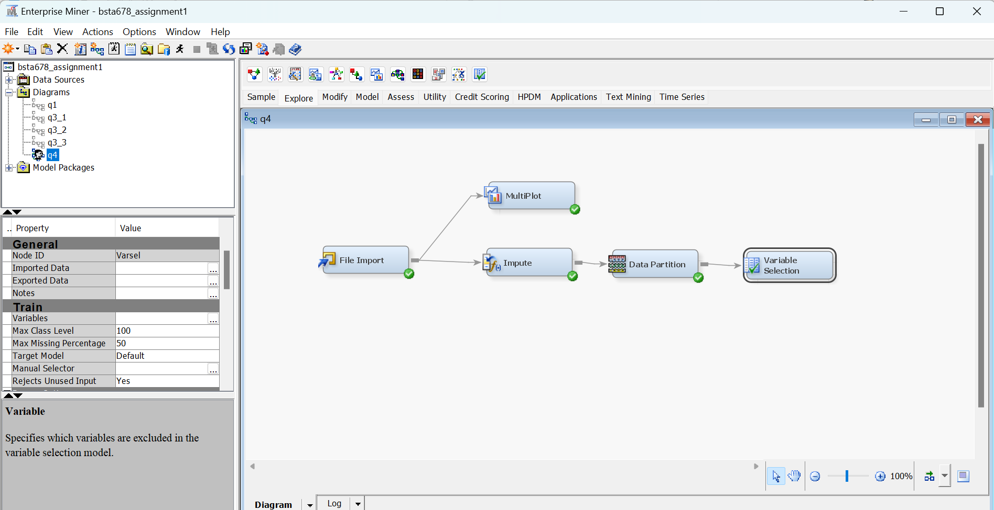

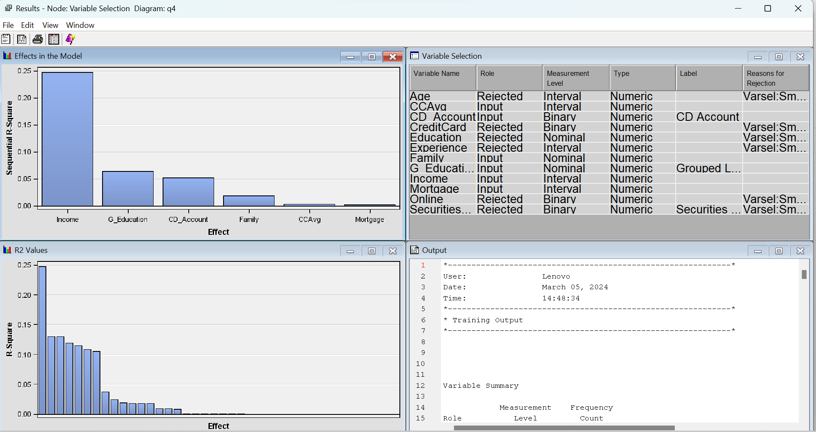

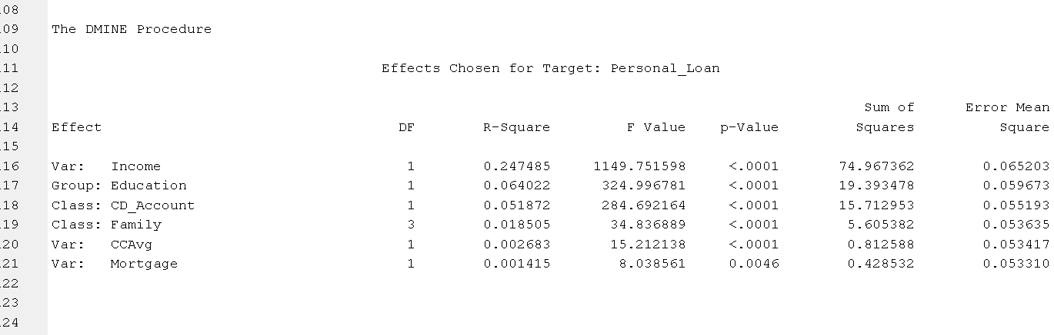

* 1. Logistic Regression

Full logistic regression model:

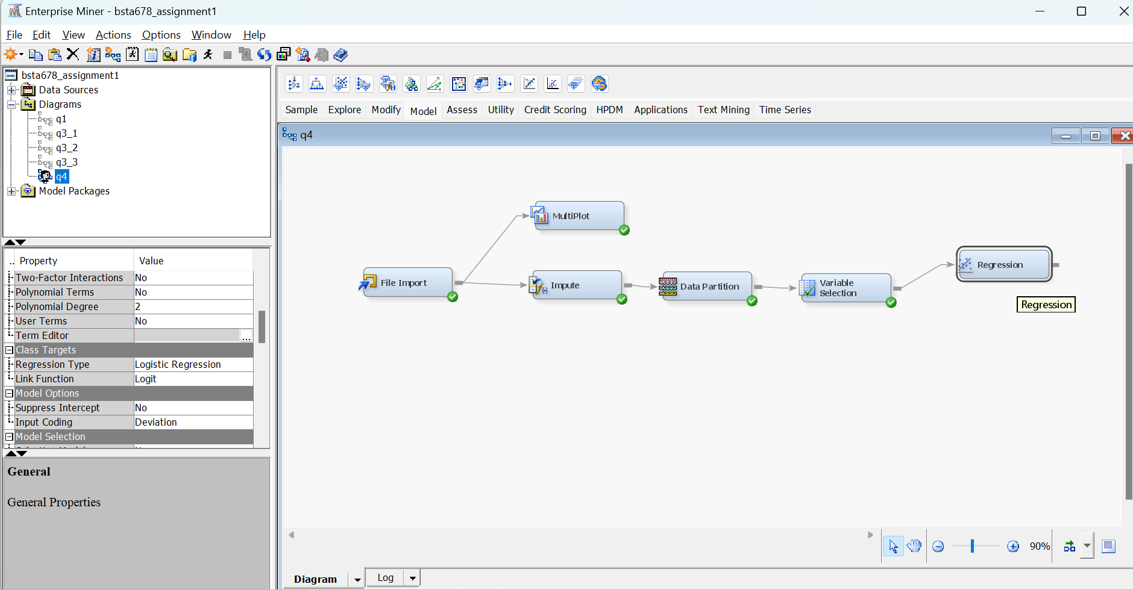

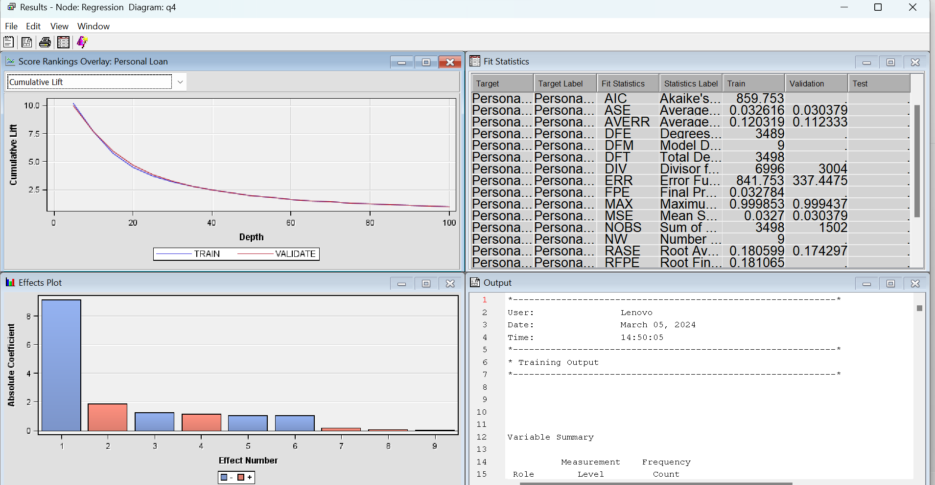

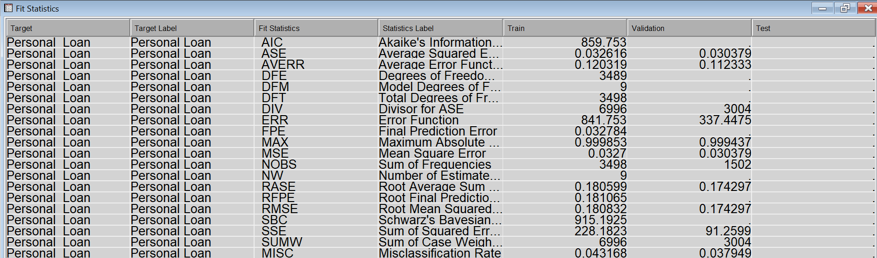

* 1. Decision Tree interactively

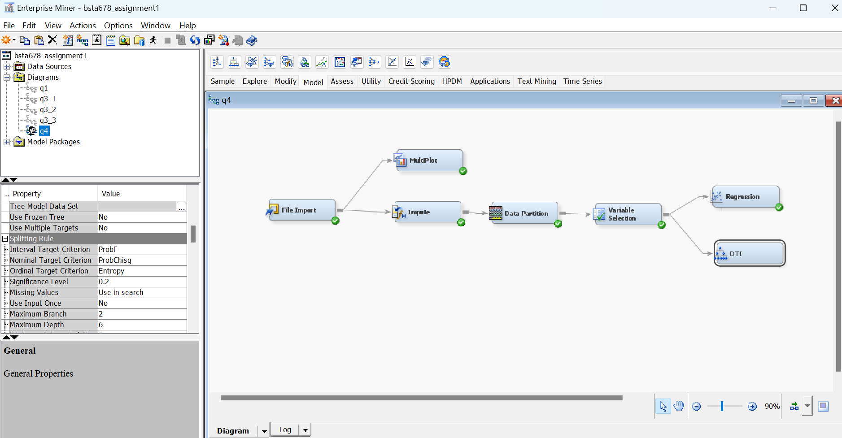

After dragging down the decision tree node from model of SAS EM, we click on three dots in Train toolbar besides “Interactive”

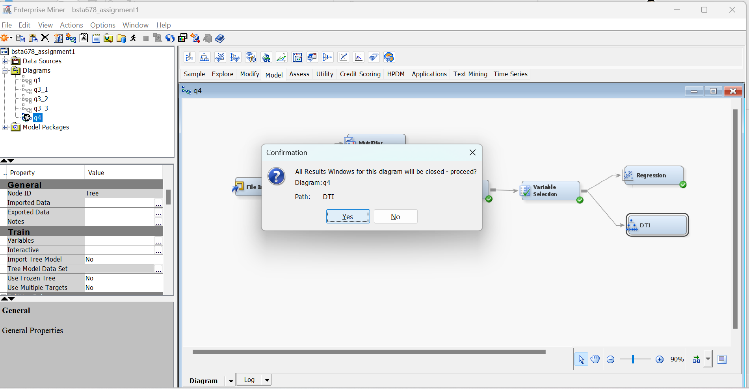

After acknowledging this as “Yes” we build from:

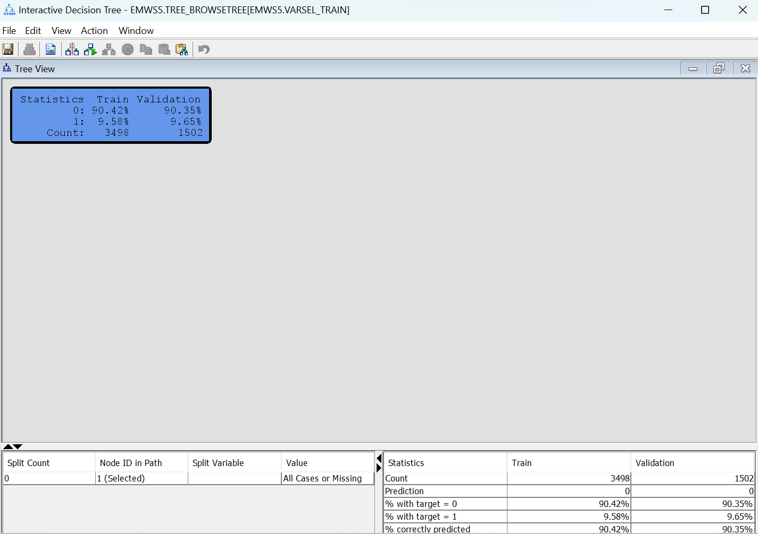

This is the root or parent node, before splitting to further leaf/branch

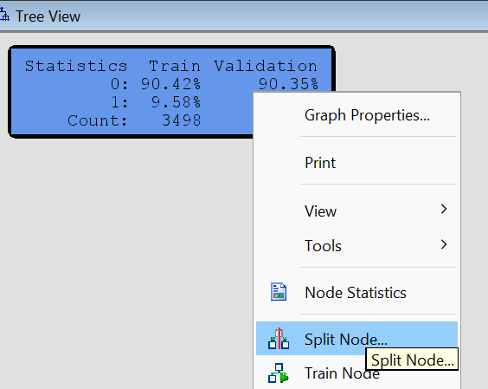

This table pops up

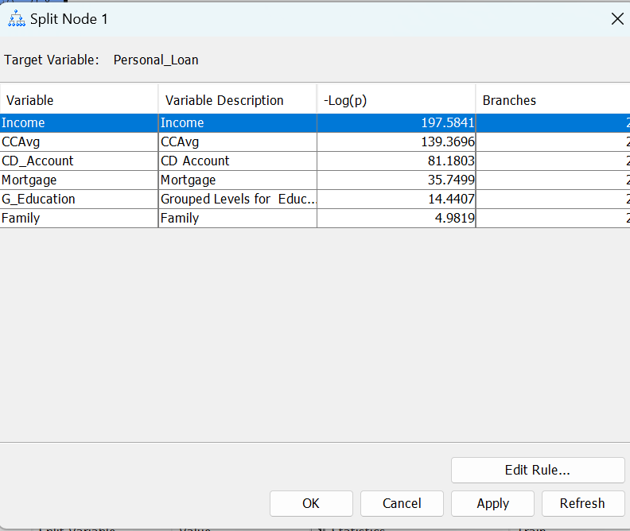

Bigger means better for the max log p value, so we apply the first split as-

With income selected as highlighted in the ss above select edit rule:

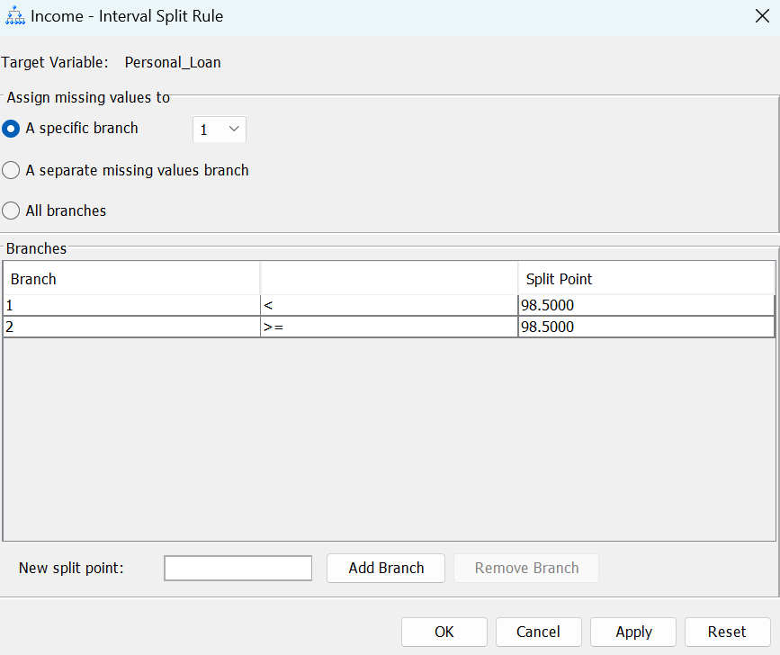

It splits at 98.5 from training data and in 2 branch as kept at default and click on apply and ok .. ok

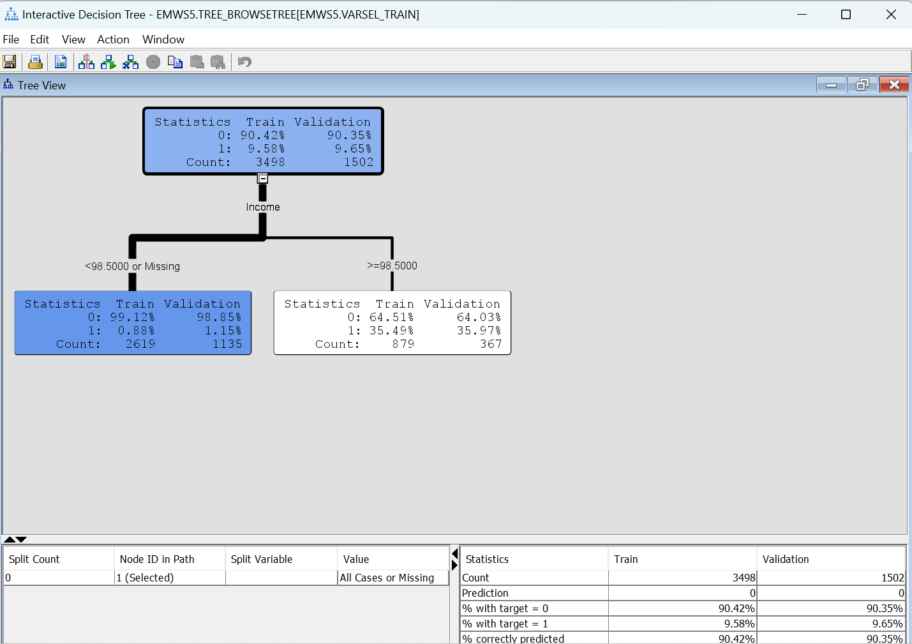

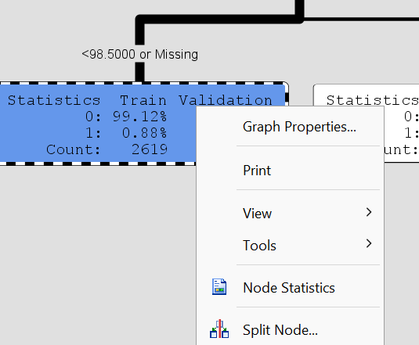

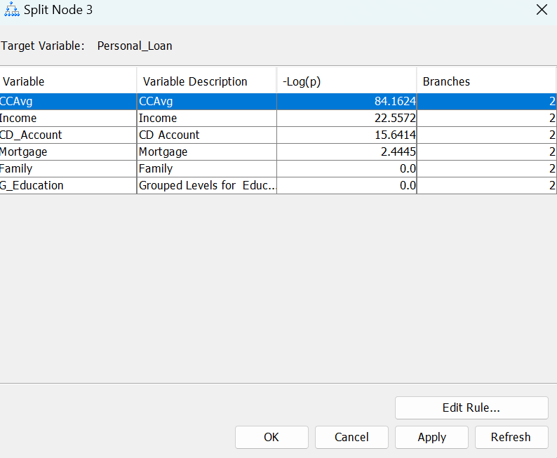

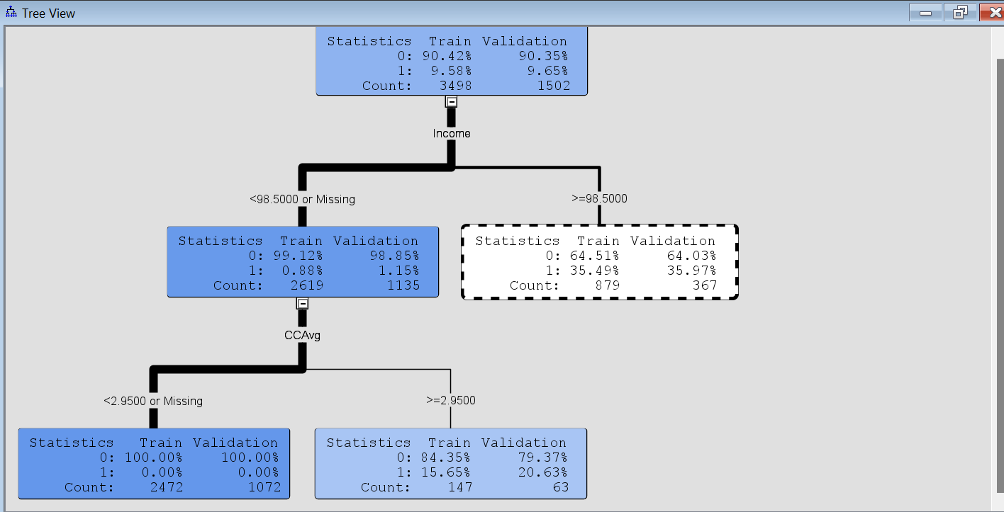

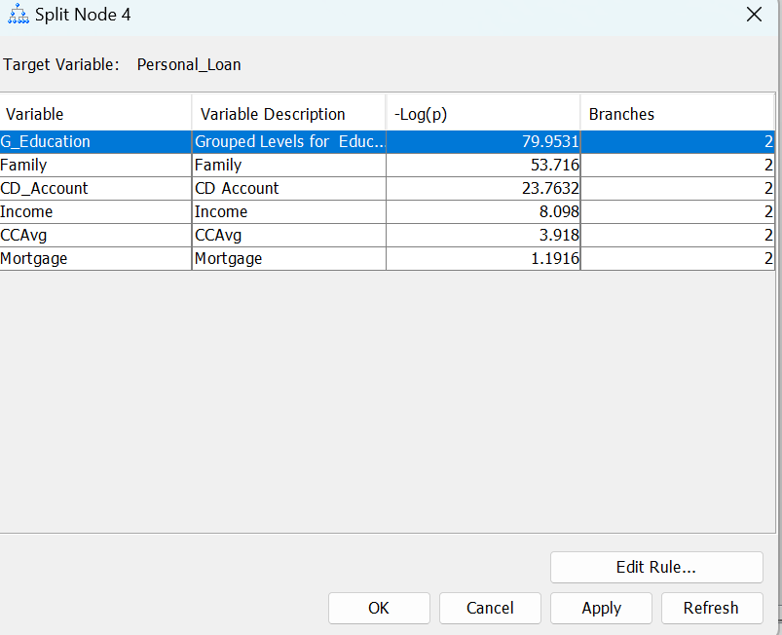

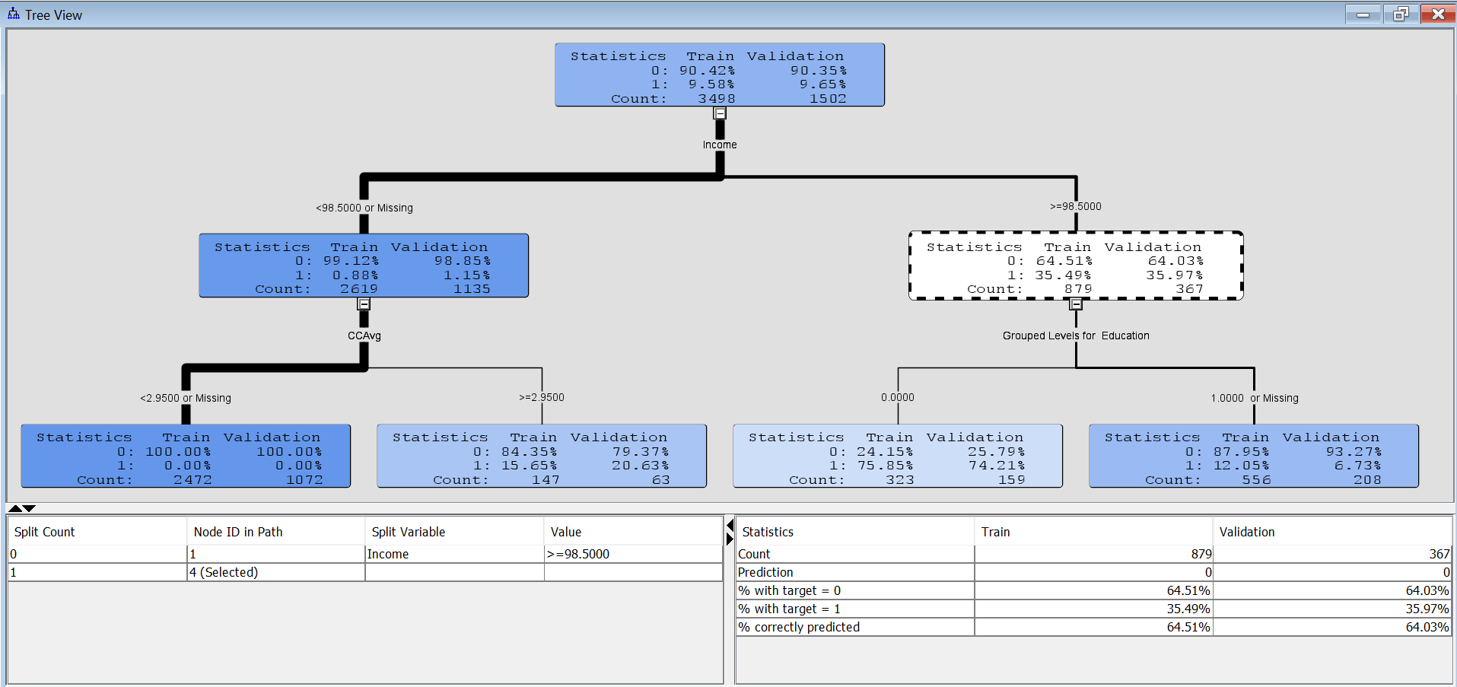

Since it is an interactive model, we update this tree to certain complexity also see where 0 and 1 split (% wise in train & val) is seen clearly or boxes turn blue (100-0 or vice versa) and white(50-50) to certain extent

Now, we can use train node on the root node to get a maximal tree - click view 🡪 fit to page :

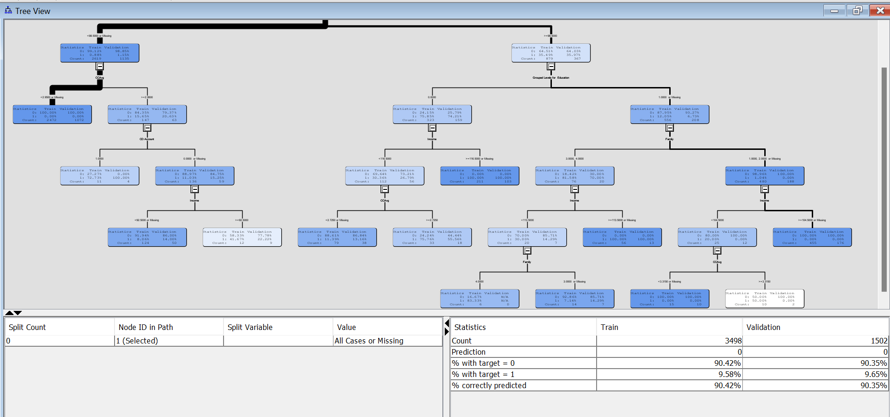

View 🡪 Subtree assessment plots:

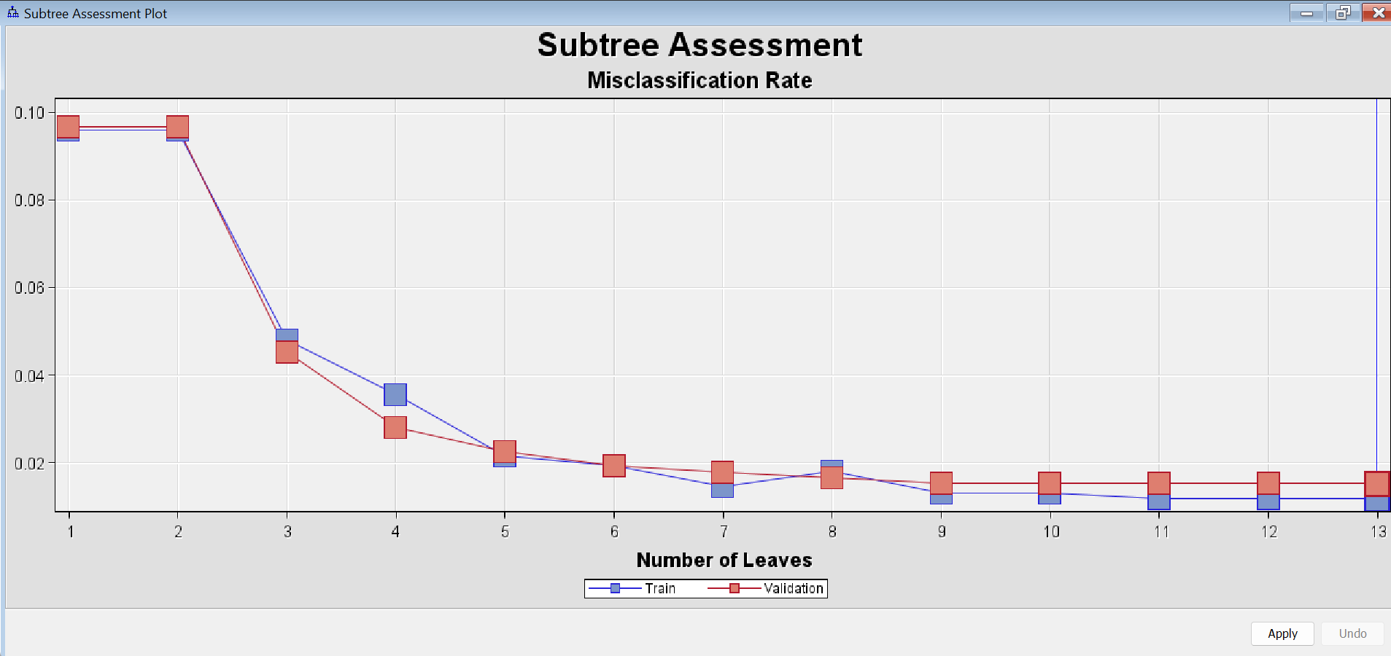

For no overfitting we see lowest misclassification rate for least number of leaves(complexity) in validation data line.

Now having constructed a maximal tree from training data we need to save the tree, close the interactive mode and select use frozen tree as yes.

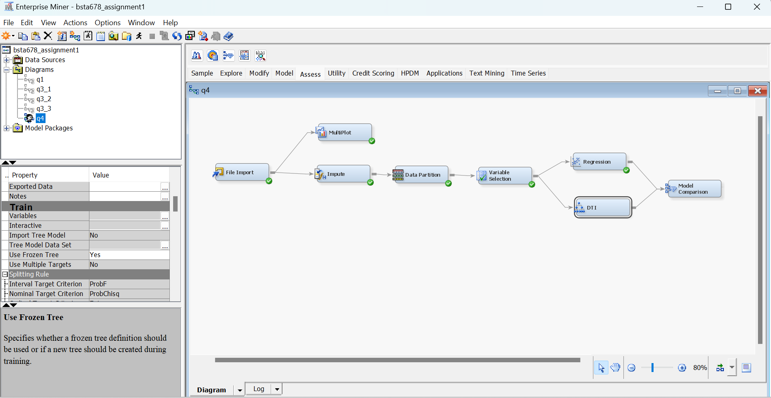

This freezes lots of options on DT node settings, while allowing us to run the node with saved interactive maximal tree, node

This becomes our interactive Decision Tree model – rename to “DTI”

And we can now run:

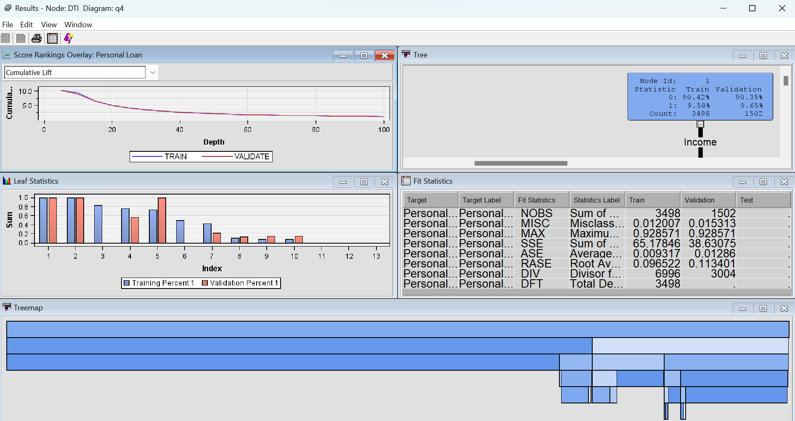

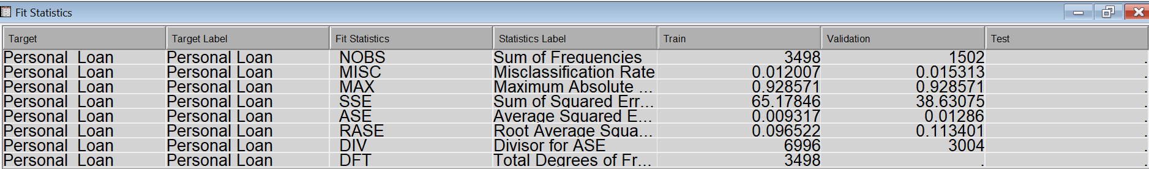

1. Select the best model and justify your choice.

Logistic Regression (Full model):



Decision Tree Interactively (Maximal Tree):



Model Comparison:

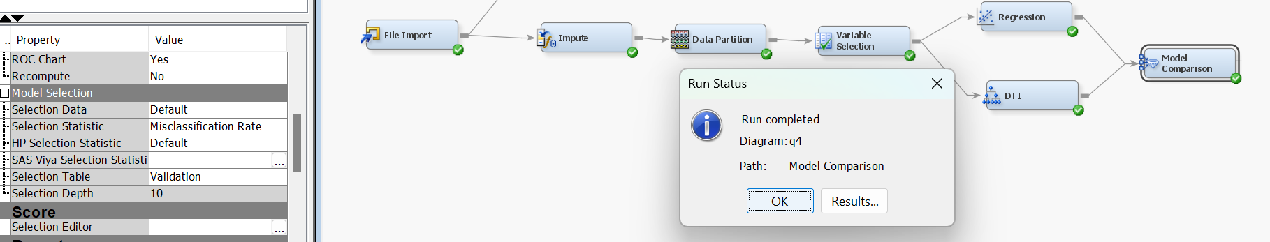

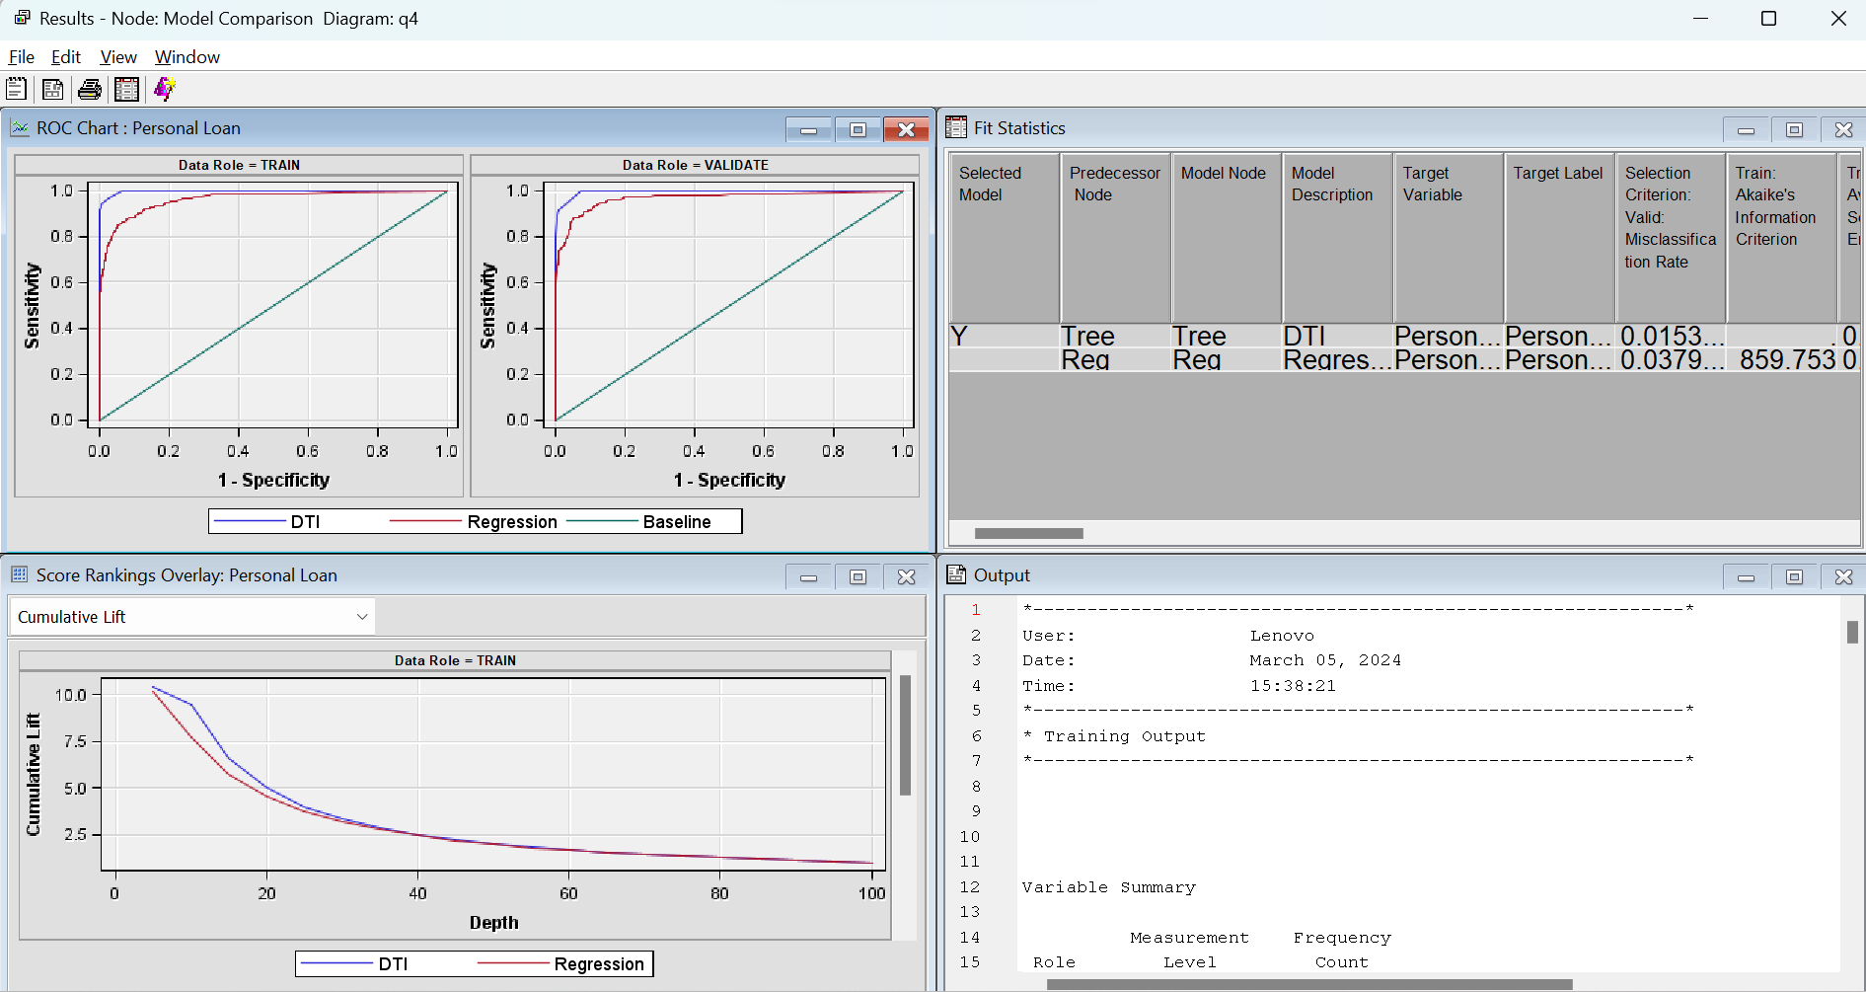

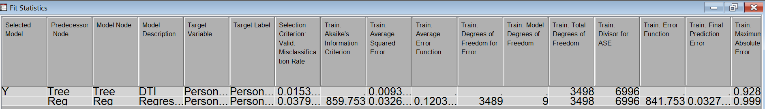

**We choose Decision Tree (DTI) as our best model based on least misclassification rate and ASE.**

1. 1) in Excel calculate the below metrics for the top 5% of your selected model. Copy your results into Word document.
   1. Misclassification Rate

0.0152

* 1. Sensitivity

0.8973

* 1. Specificity

0.9941

* 1. TPR

0.9848

* 1. TNR

0.8981

* 1. FPR

0.0053

* 1. FNR

0.0099

* 1. ROC coordinates

x-axis (horizontal): 0.0059

y-axis (vertical): 0.8973

* 1. Actual Rate among Predicted

0.9423

* 1. Lift

9.3081

* 1. Gain

807.3271

1. in Excel construct the following curves for the selected model. Copy your results into Word document.
   1. individual and cumulative: Lift versus best Lift
   2. individual and cumulative: % Response versus best % Response
   3. individual and cumulative: % Captured Response versus best % Captured Response
   4. ROC

We use model comparison output data and filter for our chosen model (DTI) i.e. for entire selection criteria